[COLLEGE LOGO]
[COLLEGE NAME]

PERSONALIZED E-LEARNING COURSE RECOMMENDATION SYSTEM
LearnPathIQ: a hybrid, explainable course recommendation system with learning-path guidance
A project report submitted in partial fulfilment of the requirements for the award of the degree of
BACHELOR OF TECHNOLOGY
in
COMPUTER SCIENCE AND ENGINEERING
Submitted by
PITTALA AKHILA | 23K91A05J3
MUNDALA SANDHYA | 23K91A05G5
MULA THANUJ REDDY | 23K91A05G4
MAJJIGAPU JAGADESHWAR REDDY | 23K91A05E1

Batch C7 (CSE-C)
Under the esteemed guidance of
K GAYATHRI
[DESIGNATION]
DEPARTMENT OF COMPUTER SCIENCE AND ENGINEERING
[COLLEGE NAME]
[CITY]
Academic year [ACADEMIC YEAR]

CERTIFICATE
[COLLEGE LOGO]
[COLLEGE NAME]
This is to certify that the project report entitled "Personalized E-learning Course Recommendation System" is a bonafide record of the work carried out by PITTALA AKHILA (23K91A05J3), MUNDALA SANDHYA (23K91A05G5), MULA THANUJ REDDY (23K91A05G4), MAJJIGAPU JAGADESHWAR REDDY (23K91A05E1), in partial fulfilment of the requirements for the award of the degree of Bachelor of Technology in Computer Science and Engineering, during the academic year [ACADEMIC YEAR], under my supervision.

Project Guide | Head of the Department | Principal
K GAYATHRI | [HOD NAME] | [PRINCIPAL NAME]
[DESIGNATION] | Department of Computer Science and Engineering | [COLLEGE NAME]

External Examiner: [NAME AND SIGNATURE]
Place: [CITY]
Date: [DATE]

DECLARATION
We hereby declare that the project report entitled "Personalized E-learning Course Recommendation System", submitted to the Department of Computer Science and Engineering, [COLLEGE NAME], in partial fulfilment of the requirements for the award of the degree of Bachelor of Technology in Computer Science and Engineering, is a record of original work carried out by us under the guidance of K GAYATHRI, [DESIGNATION]. The results embodied in this report have not been submitted to any other university or institution for the award of any degree or diploma.

PITTALA AKHILA 23K91A05J3
MUNDALA SANDHYA 23K91A05G5
MULA THANUJ REDDY 23K91A05G4
MAJJIGAPU JAGADESHWAR REDDY 23K91A05E1

Place: [CITY]
Date: [DATE]

ACKNOWLEDGEMENT
We express our sincere gratitude to our project guide, K GAYATHRI, [DESIGNATION], for valuable guidance, encouragement and constructive suggestions throughout this project.
We thank [HOD NAME], Head of the Department of Computer Science and Engineering, for providing the facilities and support needed to complete this work, and [PRINCIPAL NAME], Principal, [COLLEGE NAME], for the encouragement given to us.
We thank the project coordinators and all faculty and staff members of the department for their help, and our families and friends for their constant support.
We also acknowledge the authors of the base paper and of the companion papers whose ideas shaped this work, the creators of the Open University Learning Analytics Dataset, which the base paper uses, and the developers of the open-source software on which the project is built (Python, FastAPI, SQLAlchemy, scikit-learn, XGBoost, React and Vite).

PITTALA AKHILA
MUNDALA SANDHYA
MULA THANUJ REDDY
MAJJIGAPU JAGADESHWAR REDDY

ABSTRACT
Learners face far more online courses than they can compare, platform lists tend to reward engagement rather than learning, and a new learner has no history from which to recommend. This project builds LearnPathIQ, a personalised course recommendation system. A learner registers, fills in a profile and receives a ranking of a 24-course catalogue. The ranking is a hybrid score of eight interpretable terms: TF-IDF content similarity, skill fit, topic interest, goal fit, rating, a behavioural term built from the learner's own events, a predicted success probability and an engagement score. Every card shows its match percentage and up to three reasons, and each logged event (start, quiz, complete, dismiss) changes the next ranking at once. Up to six courses are arranged into a staged learning path.
A learner-success model (logistic regression, selected by validation AUC over random forest and XGBoost) reaches a test AUC of 0.6028 (six-seed mean 0.614). A one-versus-rest T-learner estimates the benefit of five learning actions, and an offline policy evaluation is reported with its effective sample size (9.1 of 2,640 rows), so it is read as weak evidence and not as proof of gain. All of these models are trained on a reproducible synthetic data set that imitates the Open University Learning Analytics Dataset; the real data were not used. On ten hand-written learner personas the hybrid reaches a precision at 3 of 0.733 against 0.20 for popularity, but it does not beat plain content matching (0.800).
The system is a FastAPI, SQLAlchemy and SQLite service with a React interface. 5 automated tests, a 33-check smoke test and a responsive check pass, and a ranking takes 32.8 ms on average on the test machine. Collaborative filtering across learners, the base paper's reinforcement-learning agent, a prerequisite graph and a study with real learners were not done and are listed as limitations and future work.
Keywords: personalised learning, course recommendation, hybrid recommendation, content-based filtering, learning path, uplift modelling, off-policy evaluation, explainable recommendation, FastAPI, React.

TABLE OF CONTENTS
CERTIFICATE i
DECLARATION ii
ACKNOWLEDGEMENT iii
ABSTRACT iv
TABLE OF CONTENTS v
LIST OF FIGURES ix
LIST OF TABLES xi
LIST OF ABBREVIATIONS xiii
CHAPTER 1: INTRODUCTION 1
1.1 Domain overview 1
1.2 Background and motivation 1
1.3 Problem statement 1
1.4 Need for the system 2
1.5 Objectives 2
1.6 Scope 3
1.7 Contributions 3
1.8 Limitations and assumptions 4
1.9 Organisation of the report 5
CHAPTER 2: LITERATURE SURVEY 6
2.1 Overview 6
2.2 Base paper analysis 6
2.3 Companion papers kept with the batch 7
2.4 Related work by theme 7
2.5 Datasets and algorithms used in the surveyed work 9
2.6 Strengths and limitations of the surveyed approaches 9
2.7 Research gap 10
2.8 Positioning of this project 10
CHAPTER 3: FEASIBILITY STUDY 11
3.1 Technical feasibility 11
3.2 Economic feasibility 11
3.3 Operational feasibility 12
3.4 Schedule feasibility 12
3.5 Legal and ethical considerations 12
3.6 Advantages and constraints 13
CHAPTER 4: SYSTEM REQUIREMENTS AND ANALYSIS 14
4.1 Existing system and its limitations 14
4.2 Proposed system and its advantages 14
4.3 Functional requirements 14
4.4 Non-functional requirements 15
4.5 Hardware requirements 16
4.6 Software requirements 16
4.7 User roles 16
4.8 Data requirements 17
4.9 Use cases 17
4.10 Traceability of requirements to tests 18
CHAPTER 5: SYSTEM DESIGN 19
5.1 Architecture 19
5.2 High-level workflow 20
5.3 Data flow diagrams 21
5.4 UML diagrams 24
5.5 Database design 28
5.6 Module design 29
5.7 API design 29
5.8 User interface design 30
CHAPTER 6: METHODOLOGY AND SOFTWARE IMPLEMENTATION 32
6.1 Overall methodology 32
6.2 Data 32
6.3 Learner-level split and success models 34
6.4 Estimated benefit of a learning action (T-learner) 34
6.5 Offline policy evaluation and what is not implemented 35
6.6 Fairness audit 35
6.7 Content-based scoring 36
6.8 Hybrid ranking, behaviour and explanations 36
6.9 Technology stack 38
6.10 Backend implementation 39
6.11 Training script and saved artefacts 39
6.12 Frontend implementation 40
6.13 Security and error handling 40
6.14 Installation and execution 40
CHAPTER 7: SYSTEM TESTING 41
7.1 Testing strategy 41
7.2 Automated tests (pytest) 41
7.3 System smoke test 42
7.4 User-interface and responsive check 42
7.5 Recommendation behaviour 43
7.6 Input validation and security checks 44
7.7 Performance 45
7.8 A defect found during testing 46
7.9 Traceability to the objectives 46
7.10 What was not tested 46
CHAPTER 8: RESULTS AND OUTPUT SCREENS 47
8.1 Experimental setup and data 47
8.2 Success-prediction performance 47
8.3 Stability across seeds and the information ceiling 50
8.4 Threshold and parameter analysis 51
8.5 Recommendation quality on a persona check 53
8.6 Adaptation to learner feedback 54
8.7 Estimated action benefit 54
8.8 Offline policy evaluation 55
8.9 Fairness audit 56
8.10 Performance and testing 57
8.11 Comparison with the base paper 57
8.12 Output screens 58
8.13 Limitations of the results 64
CHAPTER 9: CONCLUSION 65
9.1 Summary 65
9.2 Objectives against outcomes 65
9.3 Key findings 65
9.4 Practical applications 66
9.5 Honest summary of what is missing 67
CHAPTER 10: FUTURE SCOPE 68
10.1 Real data 68
10.2 Better recommendation models 68
10.3 Policy learning and evaluation 68
10.4 Learning paths 68
10.5 Evaluation with learners 69
10.6 Fairness 69
10.7 Engineering 69
REFERENCES 70
APPENDIX A: IMPORTANT CODE 72
A.1 Score terms (`app/recommender.py`) 72
A.2 Learner state and success model (`app/recommender.py`) 73
A.3 Action scores: T-learner at prediction time (`app/recommender.py`) 73
A.4 The hybrid ranking function (`app/recommender.py`) 74
A.5 Synthetic data and the learner-level split (`scripts/train_pipeline.py`) 75
A.6 Model comparison and T-learner training (`scripts/train_pipeline.py`) 75
A.7 Offline policy evaluation (`scripts/train_pipeline.py`) 76
A.8 Password hashing, tokens and sign-in (`app/security.py`, `app/api_routes.py`) 77
A.9 Recommendation route (`app/api_routes.py`) 77
APPENDIX B: INSTALLATION AND USER GUIDE 78
B.1 Requirements 78
B.2 One-click start 78
B.3 Manual start 78
B.4 Using the application 78
B.5 Retraining the models 79
B.6 Running the tests and checks 79
B.7 Troubleshooting 79
APPENDIX C: ADDITIONAL SCREENS 80

LIST OF FIGURES
Figure 1: Use-case diagram of LearnPathIQ 17
Figure 2: System architecture of LearnPathIQ 19
Figure 3: High-level workflow of one learner session 20
Figure 4: Data flow diagram, level 0 (context diagram) 21
Figure 5: Data flow diagram, level 1 22
Figure 6: Data flow diagram, level 2: process 3.0 expanded 23
Figure 7: UML class diagram (ORM classes and the recommender module) 24
Figure 8: Sequence diagram: requesting recommendations and logging feedback 25
Figure 9: Use-case diagram 26
Figure 10: Flowchart of the core algorithm: rank_courses() 27
Figure 11: Entity-relationship diagram of the SQLite database 28
Figure 12: The online ranking procedure (flowchart repeated from Chapter 5) 32
Figure 13: Logged action counts and label balance of the synthetic data 33
Figure 14: Correlation of each feature with success (left) and the logistic-regression coefficients (right) 34
Figure 15: Weights of the eight terms in the hybrid score 37
Figure 16: The dashboard in the dark theme at 1440 x 900 pixels, one of the screens covered by the check 43
Figure 17: Mean and 95th-percentile latency of the API routes 45
Figure 18: Test AUC, F1 and Brier score of the three success models 48
Figure 19: Confusion matrices of the three models on the test split at threshold 0.5 48
Figure 20: ROC curves of the three models on the test split (artifacts/plots/roc_curve.png, drawn by the training script) 49
Figure 21: Absolute logistic-regression coefficients of the eight features (artifacts/plots/feature_importance.png) 49
Figure 22: Test AUC of the three models for each of the six seeds 50
Figure 23: Ceiling check: adding the hidden assessment score lifts AUC to about 0.8 51
Figure 24: Mean P@3 after removing each term of the hybrid score 52
Figure 25: P@1, P@3, P@5 and MRR of the three rankers on the persona check 53
Figure 26: Estimated action benefit before and after six events (left) and the scores of the three tracked courses (right) 55
Figure 27: Observed success rate, mean predicted probability and F1 by age band and gender 56
Figure 28: Sign-in screen with the statement that suggestions ship with their reasons 59
Figure 29: Public course catalog: 24 courses with category, level, duration, rating and search and filter controls 59
Figure 30: Learner profile form filled in during onboarding (education, skill level, learning style, weekly hours, interests, topics, goals, preferences, age band) 60
Figure 31: Dashboard after 12 events: learning status (Highly engaged, score 75%), estimated success 43%, 12 interactions, 2 quizzes, the recommended next action and recent activity 60
Figure 32: Ranked recommendations: match percentage, estimated success, a three-part explanation, the suggested action and the View, Start and Dismiss buttons 61
Figure 33: Staged learning path: beginner courses first, each step with match percentage and estimated benefit, and the next best action 61
Figure 34: Insights: engagement, estimated success and risk, strengths, attention points and the estimated benefit of each of the five actions 62
Figure 35: Course detail for Machine Learning Basics with the "Why it is recommended" panel (57% match, estimated success 43%, suggested action) and the progress buttons 62
Figure 36: Model analytics, Diagnostics tab: confusion matrices of the three models on the test split 63
Figure 37: Model analytics, Offline policy tab: IPS 0.009, SNIPS 0.665 and doubly robust 0.435 with the statement that this is not a live A/B result 63
Figure 38: Summary of the success-model comparison on the held-out test split 66
Figure 39: Summary of the persona check: popularity, content-only and hybrid rankers 66
Figure 40: Landing page in the light theme: headline, call to action and live catalogue statistics 80
Figure 41: Registration form: name, e-mail, password and confirmation, with validation messages 80
Figure 42: Activity page, recommendation history: forty logged recommendations, each with its match percentage and the reasons given at the time 81
Figure 43: Dashboard in the dark theme: engagement, success estimate, event counts, next action and top recommendations 81

LIST OF TABLES
Table 1: Abbreviations used in this report xiii
Table 2: Status of the six objectives 2
Table 3: Organisation of this report 5
Table 4: Comparison of the surveyed work with this project 8
Table 5: Datasets and algorithms across the survey 9
Table 6: Strengths and limitations by family of method 9
Table 7: Technical building blocks and the evidence that each works 11
Table 8: Cost items 11
Table 9: Project phases and outputs 12
Table 10: Advantages and constraints 13
Table 11: Functional requirements 14
Table 12: Non-functional requirements 15
Table 13: Hardware requirements 16
Table 14: Software requirements 16
Table 15: User roles 16
Table 16: Data used by the system 17
Table 17: Main use cases 17
Table 18: Requirement coverage by the tests 18
Table 19: The four tiers 19
Table 20: Tables of the SQLite database 28
Table 21: Modules and responsibilities 29
Table 22: REST endpoints 30
Table 23: Screens 30
Table 24: The synthetic data set 33
Table 25: Success models on the held-out test split (seed 42) 34
Table 26: The eight terms of the hybrid score 36
Table 27: Event weights of the behavioural boost 37
Table 28: Backend and tooling (versions measured in the project environment) 38
Table 29: Frontend dependencies declared in frontend/package.json 38
Table 30: Controls 40
Table 31: Test layers and results of the final run 41
Table 32: The automated tests 41
Table 33: Smoke-test checks 42
Table 34: Persona check (10 personas, 24 courses) 43
Table 35: The ten personas and the hybrid's top three 44
Table 36: Effect of six events on the ranking 44
Table 37: Validation and access-control cases that were run 44
Table 38: API latency in milliseconds (loopback, development machine) 45
Table 39: Objectives and the evidence collected 46
Table 40: Dataset and split used in the shipped run (seed 42) 47
Table 41: Test-split results of the three success models (threshold 0.5) 47
Table 42: Test metrics over 6 seeds (mean +- standard deviation) 50
Table 43: Test AUC with and without the hidden assessment score (seed 42) 50
Table 44: Logistic regression on the test split at different thresholds 51
Table 45: Drop-one-term ablation of the hybrid score (mean over 10 personas) 52
Table 46: Precision@k and MRR over 10 personas 53
Table 47: Persona-by-persona result (hybrid vs content-only P@3) 54
Table 48: Effect of six events on three tracked courses 54
Table 49: Estimated benefit of each action for the persona of Section 8.6 55
Table 50: Offline policy value estimates on the test split 55
Table 51: Success model by group (test split) 56
Table 52: API latency in milliseconds 57
Table 53: Automated checks 57
Table 54: Base paper and this project 57
Table 55: The six objectives and their outcome 65
Table 56: Walk-through 78

LIST OF ABBREVIATIONS
Table 1: Abbreviations used in this report
Abbreviation | Expansion
AI | Artificial Intelligence
API | Application Programming Interface
AUC | Area Under the ROC Curve
CB | Content-Based (filtering)
CF | Collaborative Filtering
CSV | Comma-Separated Values
DB | Database
DFD | Data Flow Diagram
DR | Doubly Robust (estimator)
ER | Entity-Relationship
ESS | Effective Sample Size
F1 | Harmonic mean of precision and recall
HTTP | Hypertext Transfer Protocol
IPS | Inverse Propensity Scoring
JSON | JavaScript Object Notation
LR | Logistic Regression
ML | Machine Learning
MOOC | Massive Open Online Course
MRR | Mean Reciprocal Rank
OPE | Off-Policy Evaluation
ORM | Object-Relational Mapping
OULAD | Open University Learning Analytics Dataset
P@k | Precision at k
REST | Representational State Transfer
RF | Random Forest
RL | Reinforcement Learning
ROC | Receiver Operating Characteristic
SNIPS | Self-Normalised Inverse Propensity Scoring
SPA | Single-Page Application
SQL | Structured Query Language
TF-IDF | Term Frequency - Inverse Document Frequency
UI | User Interface
UML | Unified Modeling Language
VLE | Virtual Learning Environment
XGB | XGBoost (extreme gradient boosting)

CHAPTER 1: INTRODUCTION

1.1 Domain overview
Online learning platforms now publish more courses than any learner can compare. A learner who wants to "learn data science" meets dozens of titles whose levels, prerequisites, workloads and outcomes differ, and has little reliable way to judge which one fits. The base paper for this project notes that completion rates in massive open online courses are often below ten per cent and that disengagement and dropout are widespread [1]. A course that does not match a learner's level or goal is one of the plain reasons for that.
The field that addresses the choice problem is the recommendation system. A content-based method matches a course's description to what the learner says they want; a collaborative method predicts preferences from the behaviour of similar learners; a hybrid combines both [14], [17]. Educational data mining adds a second question that ordinary shopping recommendation does not face: whether the learner will succeed in the course, and which learning action would help most at this moment [4], [11]. The domain of this project is therefore machine learning applied to personalised e-learning, at the meeting point of recommendation, learner modelling and learning analytics.

1.2 Background and motivation
Two lines of recent work frame the project. The first moves from predicting who will fail to prescribing what to do about it: the base paper [1] estimates the effect of candidate learning actions with uplift modelling, evaluates policies offline with inverse-propensity estimators and audits fairness by age and gender. The second line studies the recommendation step itself, for example semantic matching of student interest statements to course descriptions with contrastive learning [2] and collaborative filtering that uses time-to-event information such as time to dropout [3].
The motivation of this project is to put the main ideas of both lines into one inspectable application that a learner can actually use. A learner states their background, skill level, interests and goals; the system ranks a catalogue, explains each suggestion, records what the learner does next and re-ranks, and also reports honestly how good its models are. The authors are students and the work was done on a single desktop with open-source software, so the emphasis is on a complete, explainable and measurable pipeline rather than on a new algorithm.

1.3 Problem statement
• Learners face too many options and no reliable way to judge which suits them.
• Platform recommendations tend to optimise engagement rather than learning outcome.
• New learners receive poor recommendations because no interaction history exists (the cold-start problem).
• Courses are recommended one by one, with no regard for the order in which they should be taken.
The problem addressed here is: given a learner's profile and, when it exists, their interaction history, rank the courses of a catalogue by how well they fit, explain each suggestion, estimate the learner's chance of success and the most useful next action, and arrange the best courses into a short learning path, all through a web interface a non-expert can use.

1.4 Need for the system
A hybrid recommendation engine is needed because each single signal fails alone. Matching text alone ignores the learner's level and what they did yesterday; popularity alone ignores the learner; behaviour alone gives nothing to a new learner. Combining profile text, skill fit, topic interest, goal fit, rating and behaviour gives a ranking that works from the first minute and adapts as events arrive.
There is also a need for transparency. A list of titles with no reason cannot be trusted or corrected. Here every card shows its match percentage, the estimated success probability, the suggested action and up to three reasons, and a model-analytics screen shows how the models were trained and how weak some of the evidence is. Open, inspectable software of this kind lets students and researchers study the whole pipeline, reproduce its numbers and extend it.

1.5 Objectives
The project was proposed with the six objectives below. The table that follows records, objective by objective, what was achieved; Chapter 8 gives the evidence.
1. Build learner profiles capturing interests, current skills, goals and completed courses.
2. Construct a course catalogue with topic, level, prerequisite and outcome metadata.
3. Implement collaborative filtering over learner interaction history.
4. Implement content-based matching between learner profile and course metadata.
5. Combine both into a hybrid recommender and order the output into a coherent learning path.
6. Evaluate using precision, recall and learner feedback on recommendation relevance.
Table 2: Status of the six objectives
No. | Status | What was done or missing
1 | Achieved | A profile form with ten fields (education, skill level, interests, preferred topics, goals, course preferences, learning style, weekly hours, age band, gender) is stored per learner. Completed courses are not a form field: they are recorded as complete events in the interaction log.
2 | Achieved | 24 hand-written courses in 9 categories, each with topic, level, duration, difficulty, prerequisites, outcomes, tags, resource type and rating. Prerequisites are stored as text and shown to the learner; they are not used to order the path.
3 | Not achieved | There is no real log of many learners' course histories, so no collaborative filtering across learners was built. The behavioural term in the score is per learner: it reflects only the signed-in learner's own events.
4 | Achieved | TF-IDF cosine similarity between the learner's profile text and each course's text, plus skill-level, topic-interest and goal-match terms.
5 | Achieved | An eight-term hybrid score ranks the catalogue and the best six courses are ordered into a staged path by skill level and then by score. Caveat: the path is not built from a prerequisite graph, and the hybrid is content-led, not collaborative.
6 | Partly achieved | Success-model AUC and F1 were measured, and a ten-persona check gives precision at 3 of 0.73 for the hybrid. No precision, recall or relevance rating from real learners was collected, and no user study was run.

1.6 Scope
In scope.
• Learner accounts and a stored learner profile, and a 24-course catalogue with rich metadata that can be searched by text, category and level.
• A hybrid ranking of the whole catalogue for one learner, with the eight score terms, a match percentage and up to three plain-language reasons on every card.
• A feedback loop: nine interaction types (view, open, start, content, quiz, forum, save, complete, dismiss) are logged and change the next ranking at once.
• A learner-success estimate and an estimated benefit for five learning actions (quiz, content, forum, homepage, continue course), shown as a suggested next action.
• A staged learning path of up to six courses, an insights page, an activity and history log, and a model-analytics area with the offline policy evaluation and a fairness audit by age band and gender.
• A FastAPI and SQLAlchemy back end with eighteen JSON routes and the original server-rendered interface, a React front end, an automated test suite, a smoke test and a responsive-layout check.
Out of scope.
• Collaborative filtering across learners, and any model trained on real learner-course histories. No such data were available.
• The Open University Learning Analytics Dataset itself. The success and action models are trained on a reproducible synthetic data set that imitates its structure; no result is a claim about real learners.
• The base paper's Actor-Critic reinforcement-learning agent and its causal regularisation. This project borrows only the uplift (T-learner), off-policy evaluation and fairness-audit ideas.
• A prerequisite graph or knowledge-tracing model. Learning paths are ordered by skill level and score.
• A live experiment: no A/B test, no user study and no collection of real learner feedback.
• Production concerns: a managed identity provider, a multi-node database, caching, monitoring, containers on a cloud service and load beyond a single machine.

1.7 Contributions
1. A working hybrid course-recommendation engine with eight interpretable score terms and a plain-language explanation on every card, compared in a persona check with a popularity baseline (precision at 3 of 0.20) and a content-only baseline (0.80), with a drop-one-term ablation.
2. A learner-success model chosen by validation AUC among logistic regression, random forest and XGBoost, with a six-seed repeat study and a ceiling check that shows where the weak signal comes from.
3. A one-versus-rest T-learner that turns the same learner state into an estimated benefit for five learning actions, and an offline policy evaluation (IPS, SNIPS and doubly robust) reported with its effective sample size, so the weakness of the evidence is visible.
4. A feedback loop that is measurable: in a recorded example, six events raise the score of the course being studied from 0.4867 to 0.5514 and push a dismissed course from rank 3 to rank 4.
5. A full-stack deliverable: FastAPI, SQLAlchemy and SQLite, a React interface with twelve screens, 5 passing automated tests, a 33-check smoke test, a responsive check at three widths and two themes, and measured response times.
6. A candid account of what is missing: real data, collaborative filtering, a prerequisite graph, real feedback and a live experiment.

1.8 Limitations and assumptions
Assumptions.
• The learner types free-text interests and goals in English; the TF-IDF step uses English stop words and no stemming.
• The 24-course catalogue is a fair stand-in for a real platform's catalogue. Its levels (15 Beginner, 6 Intermediate, 2 All levels and 1 Advanced) and ratings (4.3 to 4.7) were written by the authors.
• The synthetic data reproduce the shape of an online-learning log (weekly clicks, quizzes, forum posts, assessment scores, an outcome) closely enough to demonstrate the pipeline. They are not evidence about real learners.
• A single trusted user group on one machine: accounts and tokens are a convenience for the demonstration, not an identity system.
• The machine has Python 3.11 or newer, Node.js 20 or newer and a modern browser; all data stay in one local SQLite file.
Limitations.
• Synthetic training data. Every model metric comes from the generator in scripts/train_pipeline.py. The real OULAD data were never downloaded or used, so there is no external validity.
• Modest predictive power. The selected logistic-regression success model reaches a test AUC of 0.6028 (six-seed mean 0.614). Adding the hidden assessment score would lift it to 0.80, so the weak signal belongs to the generated data and the deployed features, not to a coding error.
• Weak policy evidence. The offline policy evaluation gives IPS 0.0088, SNIPS 0.6652 and doubly robust 0.4355, but its effective sample size is 9.1 of 2,640 test rows. It is not evidence that the action policy helps.
• No collaborative filtering and no real feedback. Objective 3 was not met and objective 6 only in part: precision and recall against real learner feedback were not measured.
• The hybrid does not beat content-only matching on the persona check (precision at 3 of 0.733 against 0.800). The extra terms add skill fit, goal fit and behavioural adaptation, not a measured gain in relevance.
• Unstable action advice. The estimated benefit of each action can change sign after a few events, and the suggested action depends on the learner's state only, so every card of one learner shows the same suggested action.
• Demonstration-grade engineering. One SQLite file, no cache (recommendations are recomputed on each request), token authentication meant for local use, and a stored token that does not expire in the database.
• Not an educational authority. The system suggests courses; it does not certify skills or predict real exam results.

1.9 Organisation of the report
Table 3: Organisation of this report
Chapter | Content
1 Introduction | Domain, motivation, problem, objectives and their status, scope, contributions, limitations.
2 Literature Survey | The base paper in depth, two companion papers, related work by theme, datasets and algorithms, research gap.
3 Feasibility Study | Technical, economic, operational and schedule feasibility, advantages and constraints.
4 System Requirements and Analysis | Existing and proposed system, functional and non-functional requirements, hardware, software, users and data.
5 System Design | Architecture, workflow, data-flow diagrams, UML, database, modules, API and screen design.
6 Methodology and Software Implementation | Data, the hybrid score, the success and action models, offline evaluation, application, security, installation.
7 System Testing | Strategy and results of unit, integration, functional, security, performance and edge-case tests.
8 Results and Output Screens | Model results, recommender checks, comparison with the base paper, output screens, failure analysis, objectives versus outcomes.
9 Conclusion | Summary, objectives achieved, findings, applications, known limitations.
10 Future Scope | Improvements, features, deployment and research directions.
Appendices | A: important code; B: installation and user guide; C: additional screens.

CHAPTER 2: LITERATURE SURVEY

2.1 Overview
This chapter surveys the work behind the project. It begins with the base paper [1] and the two companion papers kept with this batch [2], [3], then groups related work by theme: content-based recommendation, collaborative and graph methods, learner modelling and dropout, causal and policy methods, and learning paths. Five items were recorded in the batch literature survey; for items 2, 3 and 4 only the title and year are known, so they are listed as recorded and nothing beyond the title is claimed for them. The chapter ends with the datasets and algorithms used and the research gap that the project addresses.

2.2 Base paper analysis
Reference. C. P. Isiwu, L. C. Nnadi and Y. Watanobe, "From prediction to prescription: A Causal-AI for personalized learning path optimization in MOOCs," IEEE Access, vol. 14, pp. 29105-29118, 2026 [1].

2.2.1 Problem and idea
Predictive models for massive open online courses can say who is likely to fail but not what to do about it. The paper moves "from prediction to prescription": it estimates the effect of each candidate learning action on the outcome, and uses those estimates to steer a reinforcement-learning agent towards actions with a causal benefit.

2.2.2 Method
The framework is a nine-stage pipeline: data integration, preprocessing into weekly learner-state panels, definition of an action space (for example resource review, quiz and forum), a supervised baseline (XGBoost) with feature importance, causal effect estimation with uplift or T-learner models, policy generation by choosing the action with the largest estimated effect under fairness and workload constraints, off-policy evaluation, reinforcement-learning optimisation with an Actor-Critic agent regularised by the causal estimates, and personalised weekly recommendations. The observed action in each learner-week is a proxy: the dominant activity type by clicks. Rewards are sparse and terminal (1 for a pass). Policies are scored offline with inverse propensity scoring (IPS), self-normalised IPS (SNIPS) and doubly robust (DR) estimators [5].

2.2.3 Data and results reported
The authors use the Open University Learning Analytics Dataset, OULAD [4]: 32,593 enrolments, about 1.7 million learner-week observations and 25,516 learners over 22 module-presentation combinations. The reported results are:
• A baseline XGBoost predictor with AUC 0.795 and Brier score 0.074.
• Heavy-tailed uplift distributions, meaning a minority of learner-weeks respond strongly to an action.
• A logged pass rate of 0.589 and a Greedy-Uplift policy value of about 0.619 by SNIPS (interval 0.613 to 0.625). The IPS estimate (9.956) is far from the SNIPS estimate (0.643), which the paper itself treats as a sign that SNIPS is the safer number.
• Sensitivity to the regularisation weight: SNIPS about 0.603 with no causal term and 0.625 to 0.642 with it.
• A value-based fitted Q-iteration baseline with IPS about 0.0039 and SNIPS about 0.0010, far below the logged policy.
• A subgroup audit: for example SNIPS of 0.139 for older learners, which the authors take as a call for fairness-aware extensions.

2.2.4 Strengths and limits
• Strengths: a clear causal framing; a large real data set; offline evaluation with three estimators and conservative reading of them; a fairness audit; an honest statement that all evidence comes from one data set.
• Limits: evaluation is offline and simulated, so no learner was ever shown a recommendation; the observed action is a proxy for the intervention; the paper delivers a research pipeline, not a learner-facing application; and it does not recommend courses from a catalogue.
• Relevance to this project: the uplift (T-learner) step, the three offline estimators and the age and gender audit are reproduced at small scale here; the Actor-Critic agent and the causal regularisation are not.

2.3 Companion papers kept with the batch
Semantic matching. Khreis, Nasr and Hilal [2] fine-tune a BERT encoder with a self-supervised contrastive objective and an isotropy regulariser, because raw BERT embeddings of course descriptions are all similar to each other. A student's free-text interest statement and the course descriptions are embedded in one space and the top-N nearest courses are returned. It targets the cold-start problem through content, on more than 500 engineering courses, and shows the strength of text matching. It uses no learner behaviour.
Time-to-event collaborative filtering. Gharahighehi, Ghinis, Venturini, Cornillie and Vens [3] observe that MOOC enrolments often end in dropout, and add survival analysis (time to dropout, time to completion) to collaborative filtering. On three public data sets the approach beats collaborative filtering that uses enrolments alone. It shows that outcome and timing information improves course recommendation, but it needs a large interaction log, which this project does not have.

2.4 Related work by theme

2.4.1 Content-based recommendation
Term-weighting with TF-IDF [14] remains the simplest way to compare a learner's text with course descriptions and is the content term of this project. The batch survey also records EduGuide [23], a hybrid of TF-IDF, cosine similarity and course ratings with machine learning for personalised online learning. It is close in spirit to the content part of LearnPathIQ and, like it, relies on text and ratings; what it lacks, and what LearnPathIQ adds, is the learner's behaviour, a success estimate and an action suggestion.

2.4.2 Collaborative and graph methods
Collaborative filtering predicts a learner's preferences from similar learners. LightGCN [17] simplifies graph convolution over the learner-item graph and has been applied to course recommendation; the batch survey lists a 2025 conference paper that applies LightGCN to learning-behaviour data [25]. These methods need many recorded interactions and do not serve a new learner or a new course, which is why the batch objectives ask for a hybrid.

2.4.3 Learner modelling and dropout
Early work predicts dropout from clickstream features with logistic regression and later with deep networks, as summarised by the base paper [1]. Yu et al. [11] set out a broad vision of AI-powered personalisation in MOOCs, from optimisation of learning paths to virtual tutors. This project uses the same kind of weekly learner-state features (clicks, quizzes, forum posts, completions, engagement, weekly hours, skill level) for a success model.

2.4.4 Causal and policy methods
Uplift modelling estimates the difference in outcome between treated and untreated cases [8]; meta-learners such as the T-learner fit one outcome model per arm and subtract them [16]. The doubly robust estimator combines an outcome model with importance weights to evaluate a policy offline [5]; the formal ideas of causal effects come from [6], [7]. Reinforcement learning treats learning as a sequence of states, actions and rewards [18]; hierarchical RL has been applied to course recommendation [9].

2.4.5 Learning paths and generation
Adaptive learning-path navigation combines knowledge tracing with reinforcement learning [19]; neural networks have been used to sequence programming exercises [10]; and retrieval-augmented generation has been proposed to ease the cold-start problem in MOOCs [20]. These works assume either rich knowledge-tracing data or a language model, neither of which this project uses.

2.4.6 Surveys recorded in the batch
The batch survey also lists a 2025 paper on personalised course recommendation with machine learning [24] and a 2026 literature review of course recommendation for personalised e-learning [26]. For both, only the title and year were recorded; the authors and the venue of the first are not known, so they are cited as recorded and not summarised.
Table 4: Comparison of the surveyed work with this project
Work | Approach | Data | Reported result | Limitation
Isiwu et al. [1] (base paper) | Uplift (T-learner) effects of learning actions + Actor-Critic RL with causal regularisation; off-policy evaluation; fairness audit | OULAD: 32,593 enrolments, about 1.7 million learner-week rows, 25,516 learners | XGBoost AUC 0.795, Brier 0.074; Greedy-Uplift SNIPS about 0.619 against a logged pass rate of 0.589 | One data set; simulated, not live, evaluation; no learner-facing application
Khreis et al. [2] | BERT embeddings fine-tuned by contrastive learning with isotropy regularisation; top-N retrieval for free-text interest statements | More than 500 engineering courses at one university; synthetic student queries | Better embedding separation and retrieval than vanilla BERT (as reported by the authors) | Content only, no learner history or outcome model; one university's engineering catalogue
Gharahighehi et al. [3] | Collaborative filtering improved with survival analysis of time-to-event (dropout, completion) | Three public MOOC data sets | Better than plain collaborative filtering on two measures (as reported) | Needs a large interaction log; cold-start learners not addressed
Sujay et al. [23] | TF-IDF vectors and cosine similarity combined with course ratings in a weighted hybrid score | A Coursera course data set (descriptions, levels, skills, ratings) | Not recorded in the batch survey | Content and rating only; no learner behaviour or outcome model
He et al. [17] | LightGCN: simplified graph convolution over the learner-item graph | Standard recommendation benchmarks | Higher recall and NDCG than earlier graph methods (as reported) | Needs many interactions; no profile text; no explanation
Batch survey item 2 [24] | Machine-learning course recommendation (title and year only) | Not recorded | Not recorded | Authors and details not recorded in the batch survey
Batch survey item 3 [25] | LightGCN with learning-behaviour data (title and year only) | Not recorded | Not recorded | Authors and details not recorded in the batch survey
Batch survey item 4 [26] | Literature review of course recommendation for personalised e-learning (title and year only) | Not applicable (review) | Not applicable | Authors and details not recorded in the batch survey
This project (LearnPathIQ) | Eight-term hybrid score (TF-IDF, skill, topic, goal, rating, behaviour, success, engagement); T-learner action benefit; offline policy evaluation; fairness audit | 24 hand-written courses; synthetic OULAD-like learner log (2,200 learners x 12 weeks) | Success-model test AUC 0.6028; persona precision at 3 of 0.73 | Synthetic data; no collaborative filtering across learners; no RL agent; no user study

2.5 Datasets and algorithms used in the surveyed work
Table 5: Datasets and algorithms across the survey
Item | Seen in | Used here?
OULAD (demographics, VLE clicks, assessments) | Base paper [1], [4] | No. A synthetic data set with the same kind of weekly features replaces it.
Course descriptions and ratings (Coursera-style) | EduGuide [23] | No. A 24-course catalogue was written for the project.
TF-IDF and cosine similarity | [23], [14] | Yes: the content term of the score.
Contrastive BERT embeddings | [2] | No.
Collaborative filtering, LightGCN, survival analysis | [3], [17], [25] | No: no cross-learner history exists.
XGBoost, random forest, logistic regression | [1], [12], [15], [13] | Yes: the success model compares the three.
T-learner uplift | [1], [16], [8] | Yes: logistic regressions per action arm.
IPS, SNIPS, doubly robust off-policy evaluation | [1], [5] | Yes, with an effective-sample-size warning.
Actor-Critic reinforcement learning | [1], [18] | No.
Fairness audit by age and gender | [1] | Yes: reporting only.

2.6 Strengths and limitations of the surveyed approaches
Table 6: Strengths and limitations by family of method
Family | Strengths | Limitations
Content-based (TF-IDF, embeddings) | Works for new learners and new courses; easy to explain | Ignores outcomes and behaviour; keyword mismatch for TF-IDF
Collaborative and graph | Learns taste from many learners; no need for course text | Cold start; needs a large log; hard to explain
Outcome and survival models | Use success or dropout, not only clicks | Need outcome labels and timing; prediction alone gives no action
Uplift and offline policy evaluation | Estimate what an action would change; safe pre-deployment checks | Rely on assumptions about confounding; estimates can be unstable
Reinforcement learning | Optimises a sequence of actions over time | Needs large logs and careful evaluation; hard to deploy

2.7 Research gap
The batch survey identifies the gap as combining collaborative and content-based signals in a deployable platform that also handles the cold-start learner. Read together with the base paper, the gap has three parts:
1. Most prescriptive work stops at a research pipeline; there is little open, learner-facing software that ranks a catalogue, explains each suggestion and records feedback.
2. Content-based course recommenders ignore whether the learner is likely to succeed, while outcome models ignore what the learner is reading; few combine them in one score.
3. Offline policy evaluation is easy to over-read. A deployable system should report how reliable its own estimate is, for example through the effective sample size.

2.8 Positioning of this project
LearnPathIQ addresses the gap at small scale and states what it leaves open. It combines a text term with skill, topic, goal, rating, behavioural, success and engagement terms in one explainable score, serves a new learner from the first profile, adapts to events immediately and reports the weakness of its own evidence. It does not claim to beat the surveyed work: its models are trained on synthetic data (success-model test AUC 0.6028, against 0.795 for the base paper on real OULAD data), its offline policy value rests on an effective sample size of 9.1, and on a ten-persona check the hybrid (precision at 3 of 0.733) does not beat plain content matching (0.800). Collaborative filtering, the reinforcement-learning agent and a user study remain open.

CHAPTER 3: FEASIBILITY STUDY

3.1 Technical feasibility
The project needs a web service, a small database, a text-similarity step, three standard classifiers and a browser interface. All of these exist as mature open-source libraries, and none needs a graphics card, so the technical question is whether they can be combined into one working system on ordinary hardware. The project answers it by doing so.
Table 7: Technical building blocks and the evidence that each works
Need | Chosen technology | Evidence from this project
Web service and routes | FastAPI 0.115.6, Uvicorn 0.34.0, Pydantic 2.10.4 [21] | 18 routes answer correctly in the test suite and the smoke test
Persistence | SQLAlchemy 2.0.36 over SQLite [22] | six tables created and used by all routes
Text similarity | scikit-learn 1.5.2 TF-IDF and cosine similarity [13], [14] | ranking of 24 courses in 32.8 ms on average
Success and action models | scikit-learn logistic regression and random forest, XGBoost 2.1.3 [12], [15] | one full training run takes about 6.0 s on the test machine
Front end | React 19 and Vite with a proxy to the API | 11 screens pass the responsive check
Security helpers | passlib 1.7.4 (pbkdf2_sha256), Python secrets | login, logout and rejection of bad tokens tested

The risk that matters is not the software but the data. A recommendation engine needs learner histories, and none were available. The project therefore generates a synthetic data set and says so everywhere. This makes the pipeline technically feasible and demonstrable but leaves open whether the same models would work on real learners.

3.2 Economic feasibility
The cost of the system is almost entirely the authors' time. Every component is open-source under a permissive licence (MIT, BSD, Apache-2.0 or the Python licence), no paid API or cloud service is used, and all data stay on the local machine.
Table 8: Cost items
Item | Cost basis | Remark
Software licences | None | All libraries are open-source
Data | None | Synthetic data generated locally; the real OULAD data (CC BY 4.0) were not used
Hardware | Existing desktop | 12th Gen Intel(R) Core(TM) i5-12500, 15.7 GB RAM, no GPU used
Cloud and API fees | None | Nothing is hosted; the application runs locally
Effort | Student time | Four students and one guide; no payroll figure is recorded
Maintenance | Not budgeted | Library versions are pinned in requirements.txt to keep the build repeatable

No rupee or dollar figure is given for effort because none was recorded. If the system were hosted, the first costs would be a small server and a managed database; they are not estimated here.

3.3 Operational feasibility
The users are learners, who need no training beyond a sign-up form and a short profile form; and a developer, who runs two commands. The interface was checked at three widths and two themes, and every recommendation explains itself, which lowers the effort needed to trust it. Starting the system takes one script, and the first run trains the models (the project README budgets one to three minutes; a measured training run takes seconds).
Operational weak points are stated plainly. Recommendations are recomputed on each request with no cache, SQLite allows one writer at a time, tokens are not expired in the database, and the models were trained on synthetic data and would need retraining on real logs before any real use.

3.4 Schedule feasibility
The calendar dates of the project are not recorded in the project files, so the plan is given as ordered phases rather than dates. Each phase produced a measurable output that later phases used.
Table 9: Project phases and outputs
Phase | Work | Output
1 | Study the base paper, set objectives and problem statement | Batch documents 2 to 6
2 | Write the catalogue and the synthetic data generator | data/catalog/courses.json, scripts/train_pipeline.py
3 | Train and compare the success models; fit the T-learner; run offline policy evaluation and the fairness audit | models/*.joblib, artifacts/metrics/model_metrics.json
4 | Build the ranker, the database layer and the JSON routes | app/recommender.py, app/api_routes.py, app/models.py
5 | Build the server-rendered interface, then the React interface | app/templates/, frontend/
6 | Test and measure | 5 tests, 33 smoke checks, responsive check, latency and persona experiments
7 | Write the documents and presentations | Batch documents 7 to 19

3.5 Legal and ethical considerations
• Data licence. The OULAD data, which the base paper uses, are released under CC BY 4.0 and require attribution; the synthetic data used here carry no third-party licence.
• Personal data. The system stores a name, an e-mail address, a password hash and profile fields. Age band and gender are collected only for the fairness audit, which is reporting only and never used to rank.
• Fairness. The audit shows that the 55-and-over group has a lower F1 (0.305) than the 0-to-35 group (0.415). This is reported openly and no mitigation was attempted.
• Claims. Estimated benefits are not proven causal effects, and the offline policy values are not live results; the interface and documents say so.

3.6 Advantages and constraints
Table 10: Advantages and constraints
Advantages | Constraints
Works from the first profile (no history needed) | Trained on synthetic data; no external validity
Explains every recommendation with parts and reasons | No collaborative filtering across learners
Adapts at once to learner events without retraining | Action advice can change sign after a few events
Reports its own weaknesses (effective sample size, fairness gaps) | Offline policy evidence is weak (effective sample size 9.1)
Runs on one ordinary desktop with open-source software | Single-node SQLite, no cache, demonstration-grade tokens

CHAPTER 4: SYSTEM REQUIREMENTS AND ANALYSIS

4.1 Existing system and its limitations
A learner today meets one of three situations. On a course platform they search a catalogue by keyword and category and sort by rating or popularity. On a platform with a recommendation feature they receive a list tuned mostly to engagement. In a research setting, such as the base paper, a pipeline predicts risk and evaluates policies offline but never reaches a learner.
• Keyword search and popularity lists treat every learner alike: a beginner and an advanced learner see the same ranking.
• Engagement-tuned lists reward clicks, not learning outcome, and give a new learner little because no history exists.
• Single-course suggestions ignore the order in which courses should be taken.
• Research pipelines are not interactive and give no explanation that a learner can read.
• Closed platforms do not let a student inspect how scores are made.

4.2 Proposed system and its advantages
LearnPathIQ is a locally deployed web application. A learner registers, fills a profile and immediately receives a ranked list of the 24 courses. Each card shows a match percentage, an estimated chance of success, a suggested next action and the reasons. Events the learner logs change the next ranking, and a staged learning path, an insights page and a model-analytics area complete the product.
• Cold-start ready: the first ranking uses only the profile text, skill level, topics, goals and the catalogue.
• Explainable: the eight score parts and up to three reasons are returned with every card.
• Adaptive: the behavioural boost, the engagement score and the success estimate change with each event.
• Transparent about evidence: the analytics screen shows the data source, the model comparison, the confusion matrices, the policy-evaluation estimates with their effective sample size and the fairness audit.
• Inspectable: the code, the data generator and the experiments are small enough for a student to read and rerun.

4.3 Functional requirements
Each requirement is tied to the route or module that implements it. Priorities follow the MoSCoW scheme (Must, Should, Could).
Table 11: Functional requirements
ID | Requirement | Implemented by | Priority
FR1 | Register with a name, an e-mail address and a password (at least 6 characters, confirmed); reject a duplicate e-mail and a mismatch. | POST /api/auth/register | Must
FR2 | Sign in and out; keep the session in an HttpOnly cookie; report the current user. | POST /api/auth/login, /logout; GET /api/me | Must
FR3 | Create and update a learner profile of ten fields (education, skill level, interests, preferred topics, learning style, goals, course preferences, weekly hours, age band, gender). | GET, PUT /api/profile | Must
FR4 | Browse the catalogue of 24 courses and filter it by text, category and level; open one course with its prerequisites, outcomes and tags; return 404 for an unknown course. | GET /api/courses, /api/courses/{id} | Must
FR5 | Rank the whole catalogue for the signed-in learner and return, for each course, the match score, the eight score parts, the success probability, a suggested action, its estimated benefit and up to three reasons. | GET /api/recommendations?top_n | Must
FR6 | Reload the trained models and recompute the ranking on request. | POST /api/recommendations/refresh | Should
FR7 | Record a learner event (view, open, start, content, quiz, forum, save, complete, dismiss) for a course; reject any other event type. | POST /api/interactions | Must
FR8 | Change later rankings and the engagement level as events accumulate (behavioural boost and engagement score). | recommender.behavioral_boost, engagement_level | Must
FR9 | Arrange the best courses into a staged learning path of up to six steps, with the next best action. | GET /api/learning-path | Must
FR10 | Show insights: engagement level, success probability and risk, estimated benefit of five actions, strengths, areas to attend to and event counts. | GET /api/insights | Should
FR11 | Show the learner's own activity log and the history of recommendations given. | GET /api/activity, /api/history | Should
FR12 | Show model transparency: model comparison, confusion matrices, ROC curve, the stored feature-importance values and plot (absolute coefficients of the selected logistic regression), offline policy evaluation and a fairness audit. | GET /api/metrics, /api/fairness, /static/*.png | Should
FR13 | Report service health and whether the model files are loaded. | GET /api/health | Should
FR14 | Show a dashboard of engagement, success estimate, event counts, the next action and the top recommendations. | React page Dashboard | Should
FR15 | Work at phone, tablet and desktop widths in light and dark themes. | React front end; scripts/check_responsive.py | Could

4.4 Non-functional requirements
Table 12: Non-functional requirements
Quality | Requirement | Verified by
Performance | A ranking of the 24-course catalogue returns in well under 100 ms on a desktop CPU: measured mean 32.8 ms, 95th percentile 42.4 ms (30 requests). | scripts/measure_api.py
Usability | Every screen usable at 360, 768 and 1440 px in light and dark themes without horizontal overflow or console errors. | scripts/check_responsive.py (11 screens)
Reliability | Bad input is answered with a JSON error (401, 400, 404 or 422) and never changes stored data. | tests/test_app.py::test_invalid_inputs
Security | Passwords are stored as pbkdf2_sha256 hashes; session tokens are random (32 bytes, URL-safe) and sent as an HttpOnly, SameSite=Lax cookie; database access goes through the ORM with bound parameters; inputs are validated by Pydantic. | app/security.py, app/schemas.py
Portability | Runs on Windows with Python 3.11 and Node.js 20 or newer; one script (run.bat) starts the back end and the front end. | run.bat, HOW_TO_RUN.md
Maintainability | Ranking, models, routes, ORM and front end are separate modules; behaviour is covered by 5 automated tests and a 33-check smoke test. | tests/, scripts/smoke_test.py
Reproducibility | The training pipeline uses a fixed seed (42) and re-running it reproduces the stored metrics exactly. | scripts/train_pipeline.py, experiments/seed_study.json
Privacy | All data stay in one local SQLite file; no third-party service is called by the application. | app/config.py
Honesty of output | The analytics screen names the data source (synthetic-oulad-like-fallback-v1) and the offline policy evaluation carries its effective sample size. | artifacts/metrics/model_metrics.json

4.5 Hardware requirements
Table 13: Hardware requirements
Item | Minimum (documented in the project) | Machine used for all measurements
Processor | A recent 64-bit CPU; no GPU needed | 12th Gen Intel(R) Core(TM) i5-12500, 6 cores / 12 threads
Memory | 4 GB (8 GB recommended) | 15.7 GB
Disk | About 500 MB free for the Python environment and data | Local SSD
Graphics | None | none used (CPU only)
Network | Not needed after installation; localhost only | Loopback (127.0.0.1)

4.6 Software requirements
Table 14: Software requirements
Component | Version used | Purpose
Operating system | Windows 11 Pro, version 10.0.26200 | Development and measurement
Python | 3.11.9 | Back end and training
FastAPI / Uvicorn | 0.115.6 / 0.34.0 | Web service
SQLAlchemy / Pydantic | 2.0.36 / 2.10.4 | ORM and validation
pandas / NumPy | 2.2.3 / 1.26.4 | Data generation and features
scikit-learn / XGBoost / joblib | 1.5.2 / 2.1.3 / 1.4.2 | Models and storage of fitted models
matplotlib | 3.9.2 | Training plots
passlib | 1.7.4 | Password hashing (pbkdf2_sha256)
pytest | 8.3.4 | Automated tests
Node.js / npm | v24.19.0 / 11.17.0 | Front-end build and dev server
React / Vite / React Router / Recharts | ^19.3.1 / ^8.3.5 / ^7.18.4 / ^3.10.1 | Interface and charts
Browser | Chrome (driven by Playwright for the checks) | Use and automated checks

4.7 User roles
Table 15: User roles
Role | Can do | Cannot do
Visitor (not signed in) | View the landing page, browse and filter the catalogue, open a course, view model analytics, register, sign in | See recommendations, path, insights or any personal data
Learner (signed in) | Edit own profile, receive and refresh recommendations, record events, follow the path, view own activity and history and insights | See another learner's data
Developer / administrator | Retrain the models, rerun experiments and tests, change the catalogue file (outside the interface) | Not available through the web interface: there is no admin screen

4.8 Data requirements
Table 16: Data used by the system
Data | Fields | Source
Learner account | name, e-mail (unique), password hash, creation time | Registration form
Learner profile (1 : 1) | education, skill level, interests, preferred topics, learning style, goals, course preferences, weekly hours, age band, gender | Profile form
Course | id, title, category, topic, skill level, description, duration, difficulty, prerequisites, outcomes, tags, resource type, rating | data/catalog/courses.json (24 courses, 9 categories)
Interaction event | user, course, event type (9 kinds), value, time | Learner actions in the interface
Recommendation log | user, course, score, explanation, time | Written on every ranking
Learner state (for the models) | cum_clicks, recent_clicks, quiz_count, forum_count, completions, engagement, weekly_hours, skill_code | Derived from events and profile; in training from the synthetic generator
Training data | 26,400 learner-weeks (2,200 learners x 12 weeks), success rate 44.0% | synthetic-oulad-like-fallback-v1, seed 42

4.9 Use cases
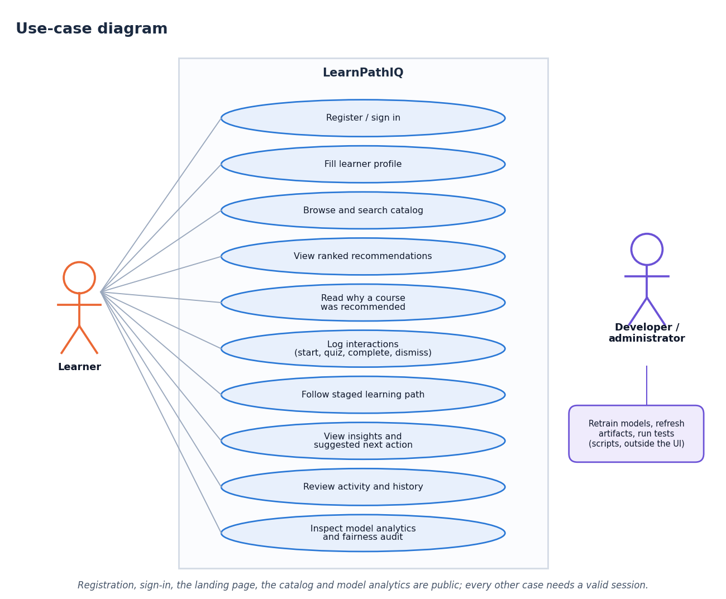
Figure 1: Use-case diagram of LearnPathIQ
Table 17: Main use cases
ID | Use case | Actor | Main flow
UC1 | Register and sign in | Visitor | Enter name, e-mail and password; the account, an empty profile and a token are created and a cookie is set
UC2 | Fill the profile | Learner | Enter education, skill level, interests, topics, goals and weekly hours; save
UC3 | Browse the catalogue | Visitor, learner | Search by text; filter by category and level; open a course
UC4 | View recommendations | Learner | The ranked list appears with match, success estimate, suggested action and reasons
UC5 | Give feedback | Learner | Press start, quiz, complete, save or dismiss; the event is stored and the next ranking changes
UC6 | Follow the learning path | Learner | Read the staged path and the next best action
UC7 | Read insights | Learner | See engagement, success estimate, action benefits, strengths and areas to attend to
UC8 | Inspect model analytics | Visitor, learner | Compare models, read the confusion matrices, offline policy estimates and fairness audit
UC9 | Retrain the models | Developer | Run the training script; reload the models by POST /api/recommendations/refresh or restart

4.10 Traceability of requirements to tests
Table 18: Requirement coverage by the tests
Requirement | Automated test or check
FR1, FR2 | test_auth_profile_recs_interactions (register and token); test_invalid_inputs (bad e-mail and password mismatch give 422); smoke test (register, duplicate e-mail, session restore, logout, 401 after logout, bad password, login)
FR3, FR4 | test_auth_profile_recs_interactions (profile update, catalogue list, course detail); test_invalid_inputs (unknown course gives 404)
FR5, FR6, FR8 | test_auth_profile_recs_interactions (ranking, interaction, refresh); persona and feedback-loop experiments
FR7 | test_invalid_inputs (unknown event type gives 400); smoke test
FR9 to FR13 | test_auth_profile_recs_interactions (learning path, insights, activity, history, metrics, fairness); test_health; test_artifacts_load
FR14, FR15 | Smoke test through the front-end proxy (33 checks); responsive check on 11 screens at 3 widths in 2 themes

CHAPTER 5: SYSTEM DESIGN

5.1 Architecture
The design follows two rules: keep each tier replaceable, and keep the recommendation logic in one module that the routes only call. The original Jinja2 interface and the React interface use the same FastAPI routes and the same database, so the two front ends always agree.
Table 19: The four tiers
Tier | Components | Responsibility
Presentation | React 19 SPA (port 5407); Jinja2 pages (port 8407) | Collect input, show ranked courses, explanations and model transparency
Application | FastAPI routes, Pydantic validation, token authentication | Validate requests, resolve the learner, orchestrate ranking, log feedback
Recommendation | TF-IDF, rule-based terms, logistic-regression success model, uplift models | Score and rank the catalogue
Data | SQLite file, JSON catalogue, joblib artefacts | Persist accounts, events and logs; hold the trained models

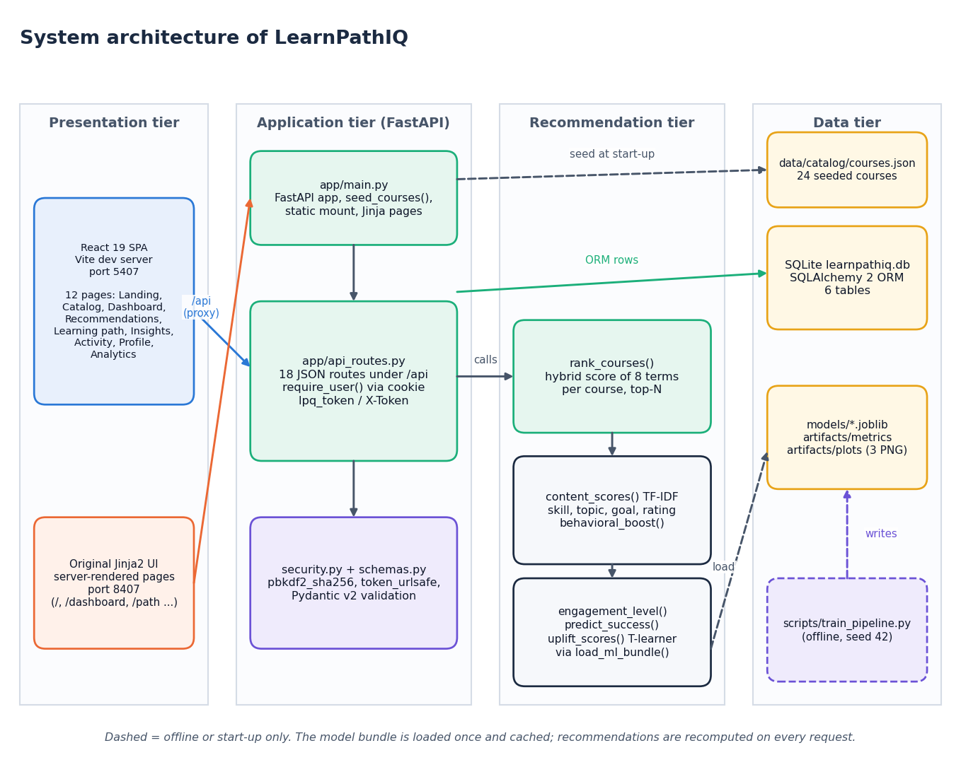
Figure 2: System architecture of LearnPathIQ
The system has four tiers. In the presentation tier the React 19 single-page application (Vite development server, port 5407) and the original server-rendered Jinja2 interface (port 8407) are the two ways a learner reaches the system; the React server proxies /api and /static to the backend so the session cookie stays same-origin. The application tier is the FastAPI service: app/main.py creates the application, seeds the course table, mounts the static folder and serves the Jinja pages, while app/api_routes.py holds the 18 JSON routes under /api and resolves the learner from the lpq_token cookie or the X-Token header; security.py and schemas.py supply password hashing, token generation and request validation. The recommendation tier is app/recommender.py: rank_courses() combines the TF-IDF, skill, topic, goal, rating and behaviour terms with the engagement score, the predicted success probability and the per-action uplift, and the model bundle is read once through load_ml_bundle(). The data tier holds the SQLite file learnpathiq.db (six tables), the 24-course catalogue in data/catalog/courses.json that seeds the course table at start-up, and the trained artefacts (models/*.joblib, artifacts/metrics, artifacts/plots), which the offline script scripts/train_pipeline.py writes. Dashed arrows are start-up or offline only.

5.2 High-level workflow
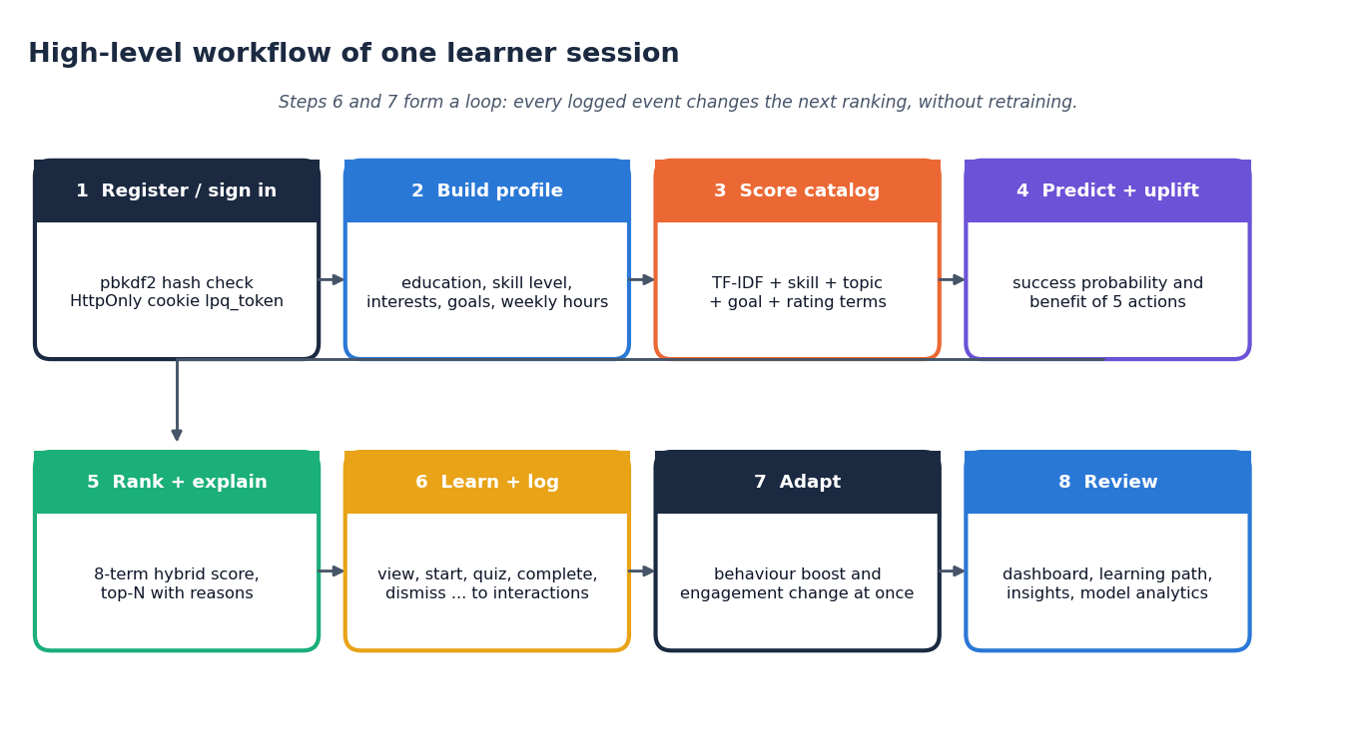
Figure 3: High-level workflow of one learner session
A session has eight steps. The learner registers or signs in (the password is checked against its PBKDF2 hash and an HttpOnly cookie is set), builds a profile (education, skill level, interests, preferred topics, goals, weekly hours), and the system scores the catalogue against it. The learner state is then fed to the success model and the action-benefit models, the eight terms are combined into a ranked list with a short explanation per course, and the learner acts on it (view, start, quiz, complete, dismiss and so on), each action being written to the interactions table. Because the behaviour and engagement terms are recomputed from that table on every request, the next ranking changes at once without retraining; the dashboard, learning path, insights and model analytics screens present the result. Steps 6 and 7 form the feedback loop.

5.3 Data flow diagrams

Level 0
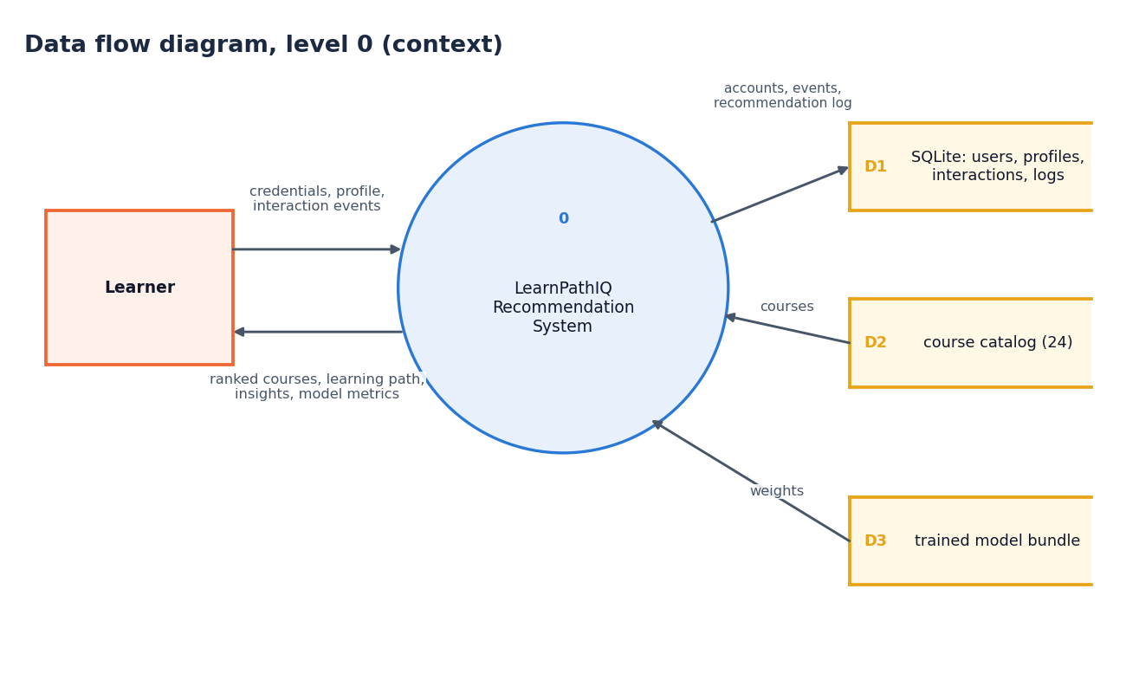
Figure 4: Data flow diagram, level 0 (context diagram)
The context diagram shows LearnPathIQ as a single process with one external entity, the learner. The learner sends credentials, profile data and interaction events; the system returns ranked courses, the learning path, insights and model metrics. Internally the process reads and writes the SQLite store (D1: users, profiles, interactions and the recommendation log), reads the course catalogue (D2) and reads the trained model bundle (D3).

Level 1
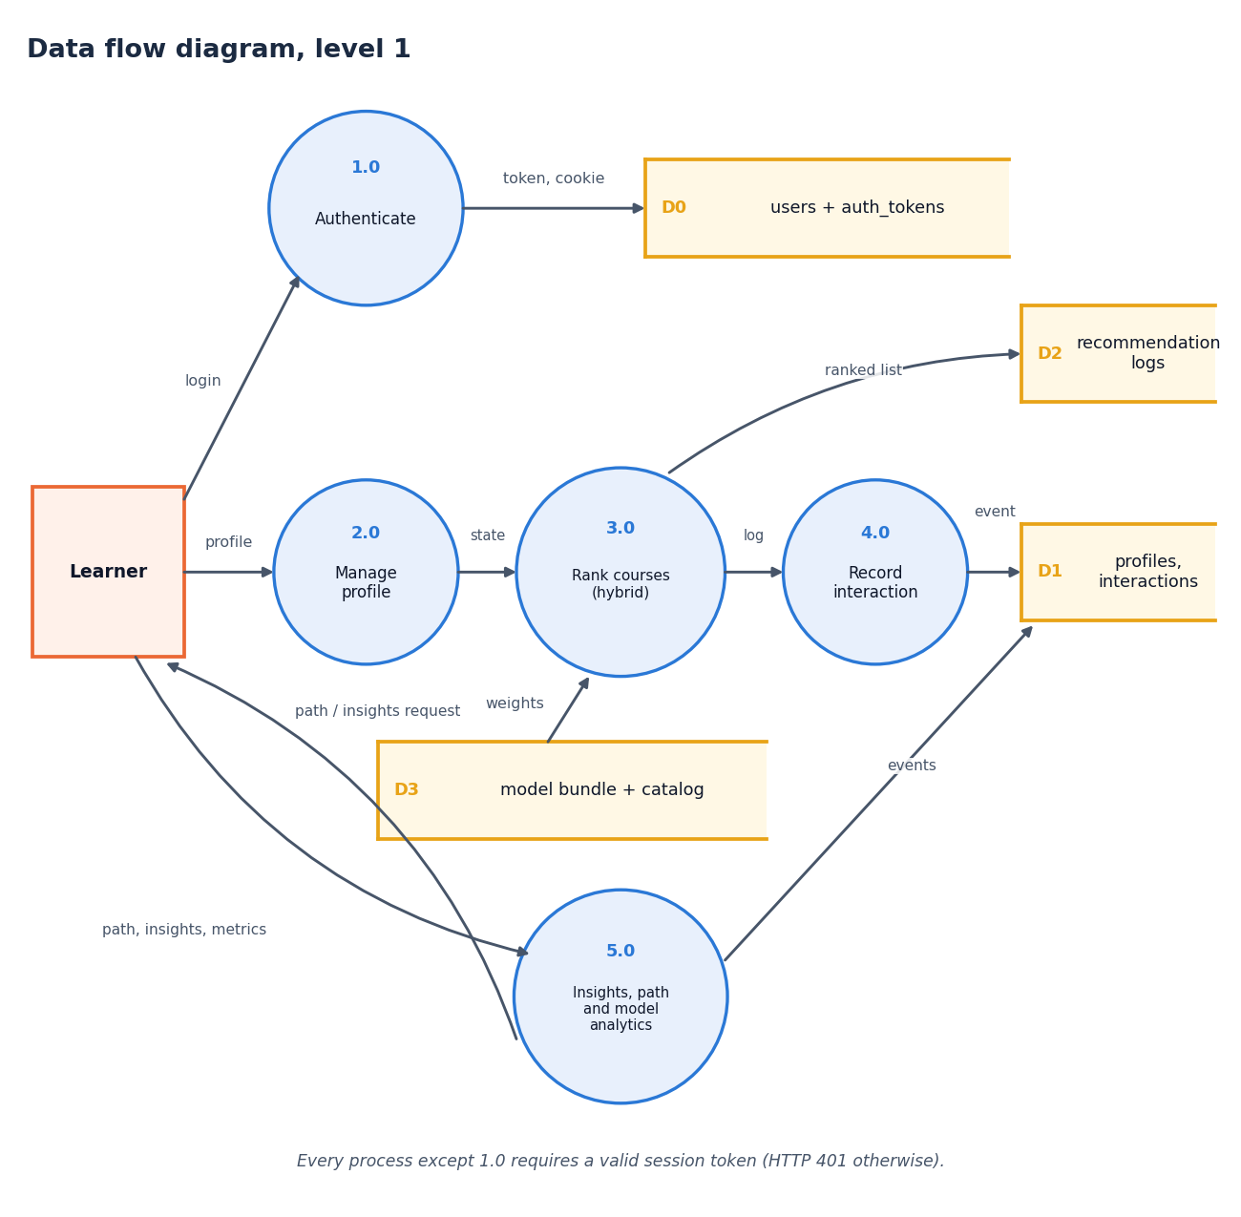
Figure 5: Data flow diagram, level 1
Level 1 has five processes. Authenticate (1.0) checks credentials against the users and tokens store (D0) and issues the token and cookie. Manage profile (2.0) accepts the profile and passes the learner state on to Rank courses (3.0), which reads the model bundle and catalogue (D3) and writes the ranked list to the recommendation log (D2). Record interaction (4.0) writes each event to the profiles and interactions store (D1), and the log from 3.0 feeds it. Insights, path and model analytics (5.0) reads the stored events and returns the learning path, the insights and the model metrics. Every process except 1.0 requires a valid session token and answers HTTP 401 otherwise (the public catalogue and model-analytics routes are the exceptions described in Section 5.7).

Level 2
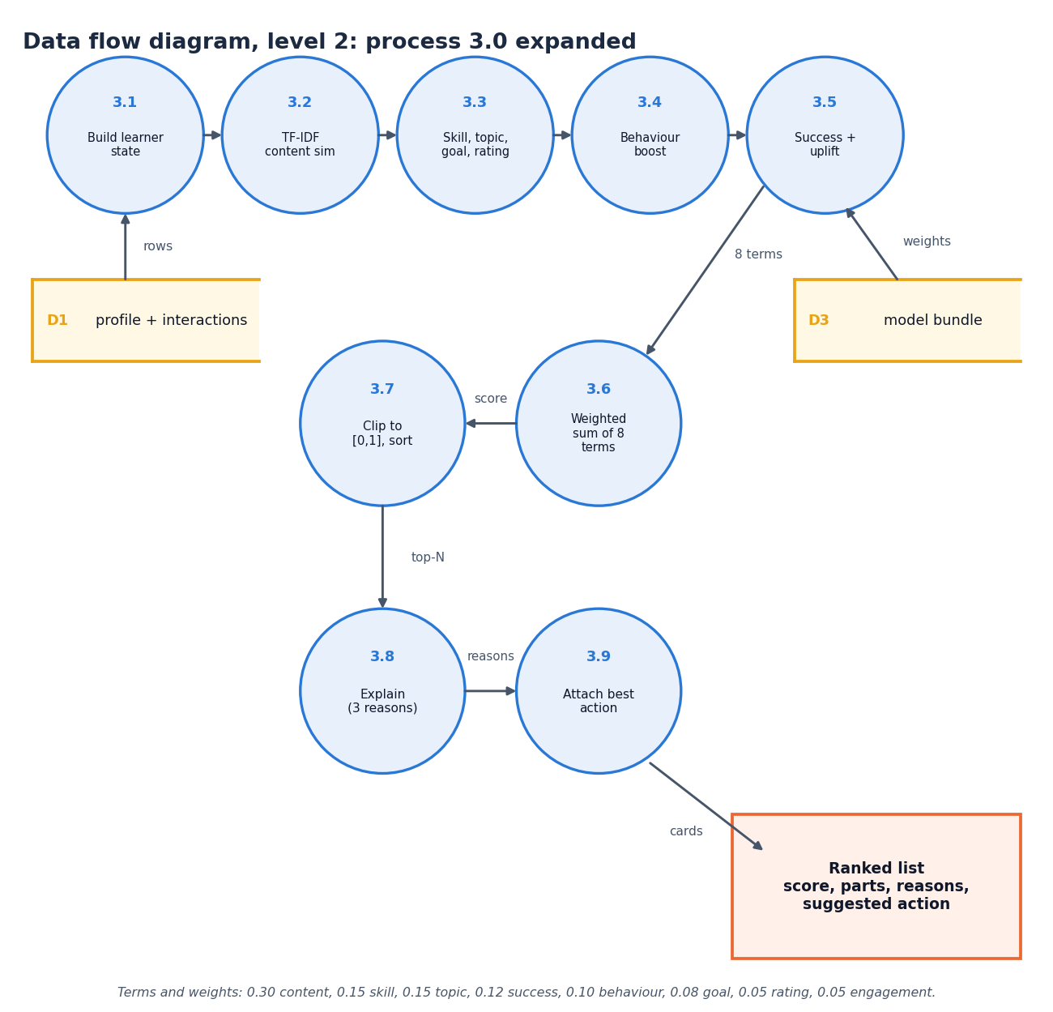
Figure 6: Data flow diagram, level 2: process 3.0 expanded
Level 2 expands the ranking process into nine steps. The learner state is built from the profile and the stored interactions (3.1); the TF-IDF content similarity of the profile against each course text is computed (3.2); the skill-compatibility, topic-interest, goal and rating terms follow (3.3) together with the behavioural boost from earlier events (3.4); the success probability and the per-action uplift come from the model bundle (3.5). The eight terms are combined by a weighted sum (3.6), clipped to [0, 1] and sorted (3.7), up to three reasons are attached to each course (3.8) and the best action (the action with the largest estimated benefit) is attached to every card (3.9). The weights are 0.30, 0.15, 0.15, 0.12, 0.10, 0.08, 0.05 and 0.05.

5.4 UML diagrams

Class diagram
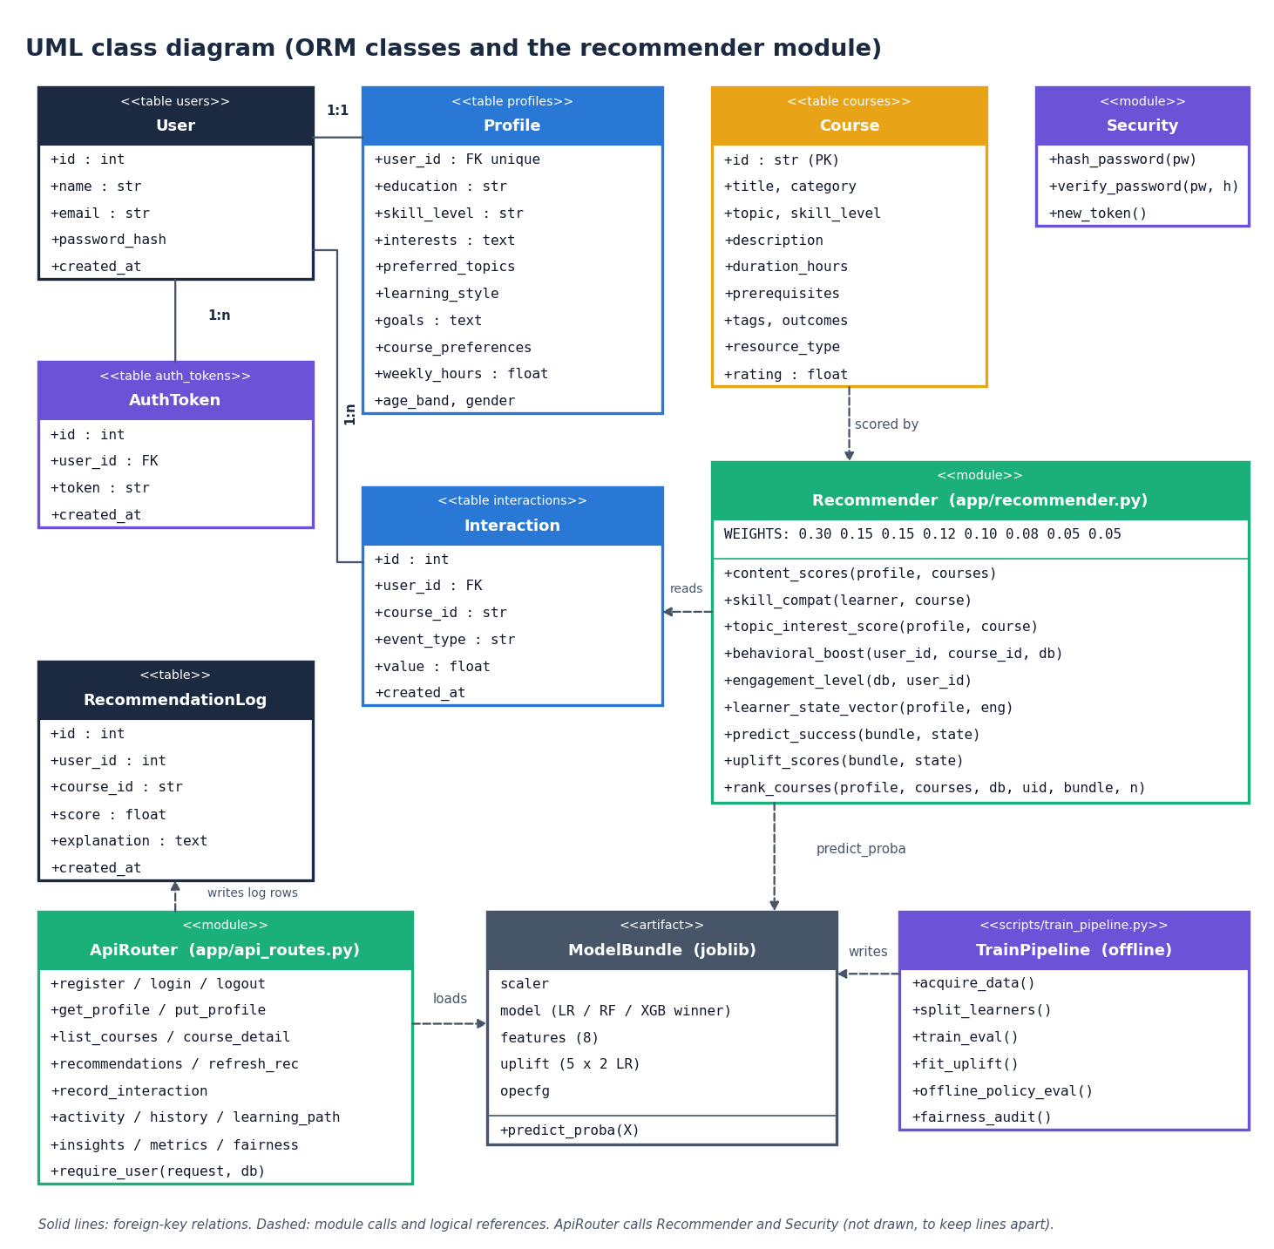
Figure 7: UML class diagram (ORM classes and the recommender module)
The six database tables are mapped by SQLAlchemy classes: User has one Profile and many AuthToken and Interaction rows; Course and RecommendationLog are standalone (the log stores the user and course ids as plain columns). The Recommender module (app/recommender.py) is drawn as a class stereotyped as a module, listing its public functions and the weight vector; it reads Interaction rows, scores Course rows and calls the ModelBundle (the joblib artefact: scaler, selected model, feature list, one-vs-rest uplift models and the policy-evaluation configuration) through predict_proba. ApiRouter (app/api_routes.py) loads the bundle, writes the log rows and uses Security for hashing and tokens; TrainPipeline (scripts/train_pipeline.py) runs offline and writes the bundle. The code base is function-oriented, so modules stand in for classes except in the ORM layer.

Sequence diagram
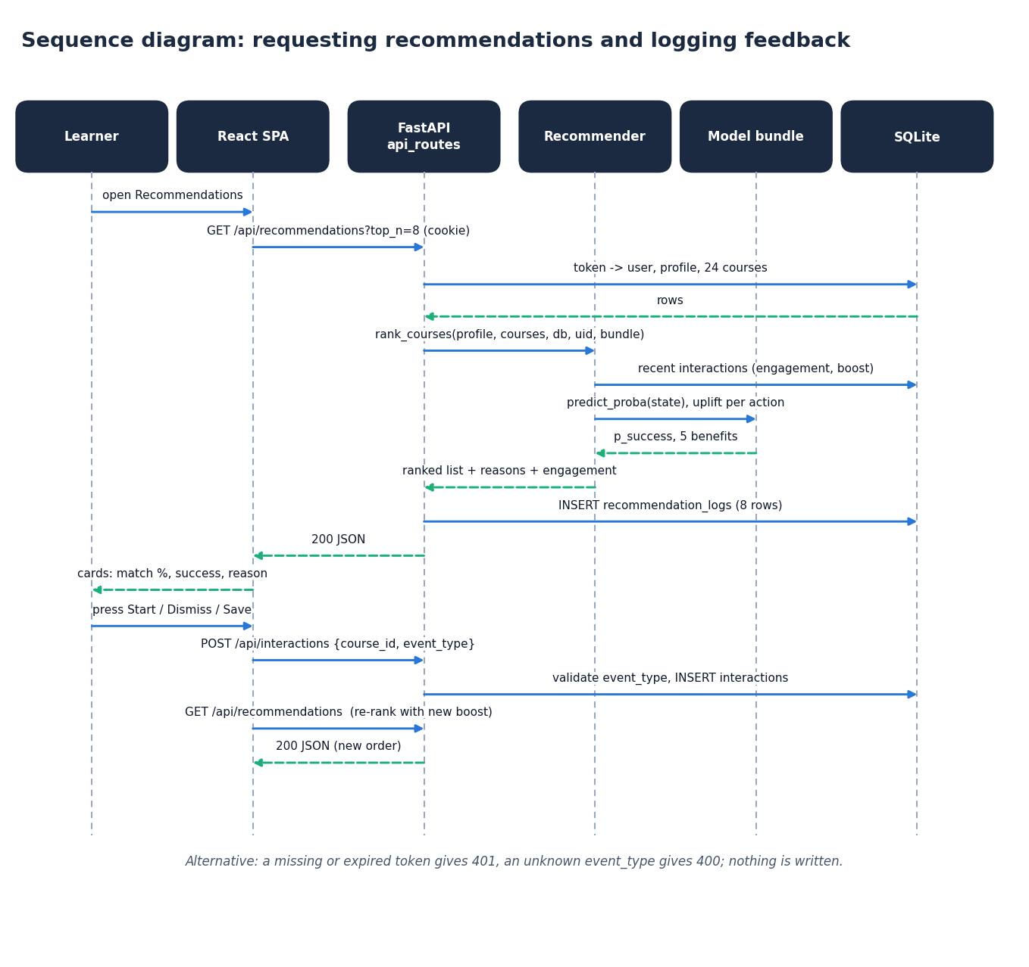
Figure 8: Sequence diagram: requesting recommendations and logging feedback
The sequence follows one pass of the feedback loop. Opening the Recommendations page makes the React app call GET /api/recommendations?top_n=8 with the session cookie. The API resolves the token to a user and loads the profile and the 24 courses from SQLite, then calls rank_courses(). The recommender reads the learner's recent interactions (engagement and boost), asks the model bundle for the success probability and the five action benefits, and returns the ranked list with reasons. The API stores one recommendation_logs row per card and returns the JSON; the page shows the cards. When the learner presses Start, Dismiss or Save, the page posts {course_id, event_type} to /api/interactions; the API validates the event type and inserts the row, and the next GET /api/recommendations returns a list ranked with the new behaviour boost. A missing token gives 401 and an unknown event type gives 400, and nothing is written.

Use-case diagram
Figure 9: Use-case diagram
The learner can register or sign in, fill the profile, browse and search the catalogue, view ranked recommendations and the reasons for each, log interactions (start, quiz, complete, dismiss and so on), follow the staged learning path, read insights and the suggested next action, review the activity log and recommendation history, and inspect the model analytics and fairness audit. The catalogue, the course detail and the analytics routes are public in the code; the profile, recommendation, path, insight, activity and interaction routes require a session. The developer or administrator is a second actor who retrains the models, refreshes the artefacts and runs the tests with scripts outside the web interface.

Core algorithm flowchart
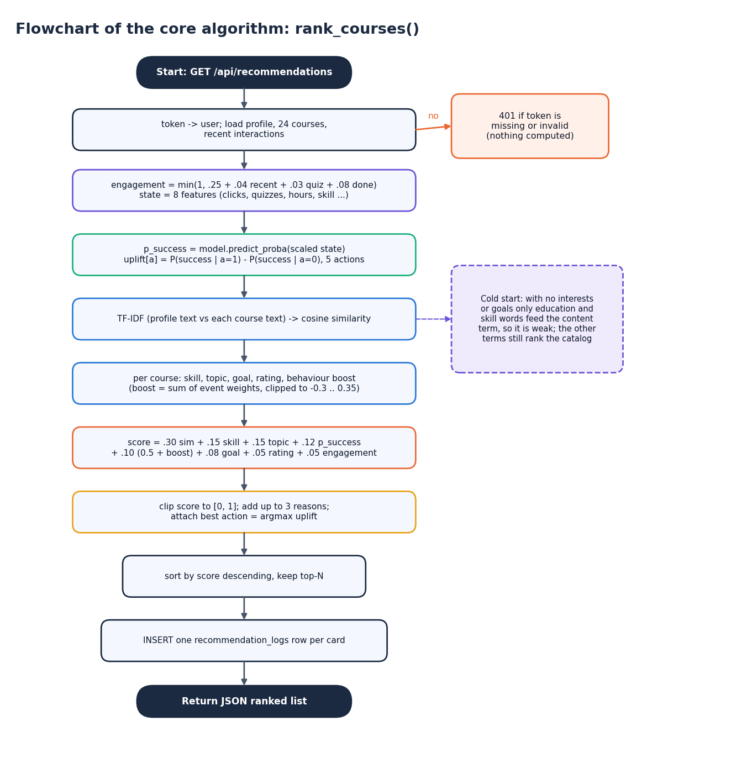
Figure 10: Flowchart of the core algorithm: rank_courses()
The flowchart gives the steps of GET /api/recommendations in order. A missing or invalid token ends the request with 401. Otherwise the profile, the 24 courses and the recent interactions are loaded; the engagement score and the eight-feature learner state are built; the success probability and the per-action uplift are computed; the TF-IDF cosine similarity is computed once for all courses; and for each course the skill, topic, goal, rating and behaviour terms are added to form the weighted score, which is clipped to [0, 1]. Up to three reasons and the best action are attached, the list is sorted and cut to the top N, and one recommendation_logs row is inserted per card before the JSON is returned. With no interests or goals the content term is weak (only the education and skill words feed it) but the other terms still rank the catalogue.

5.5 Database design
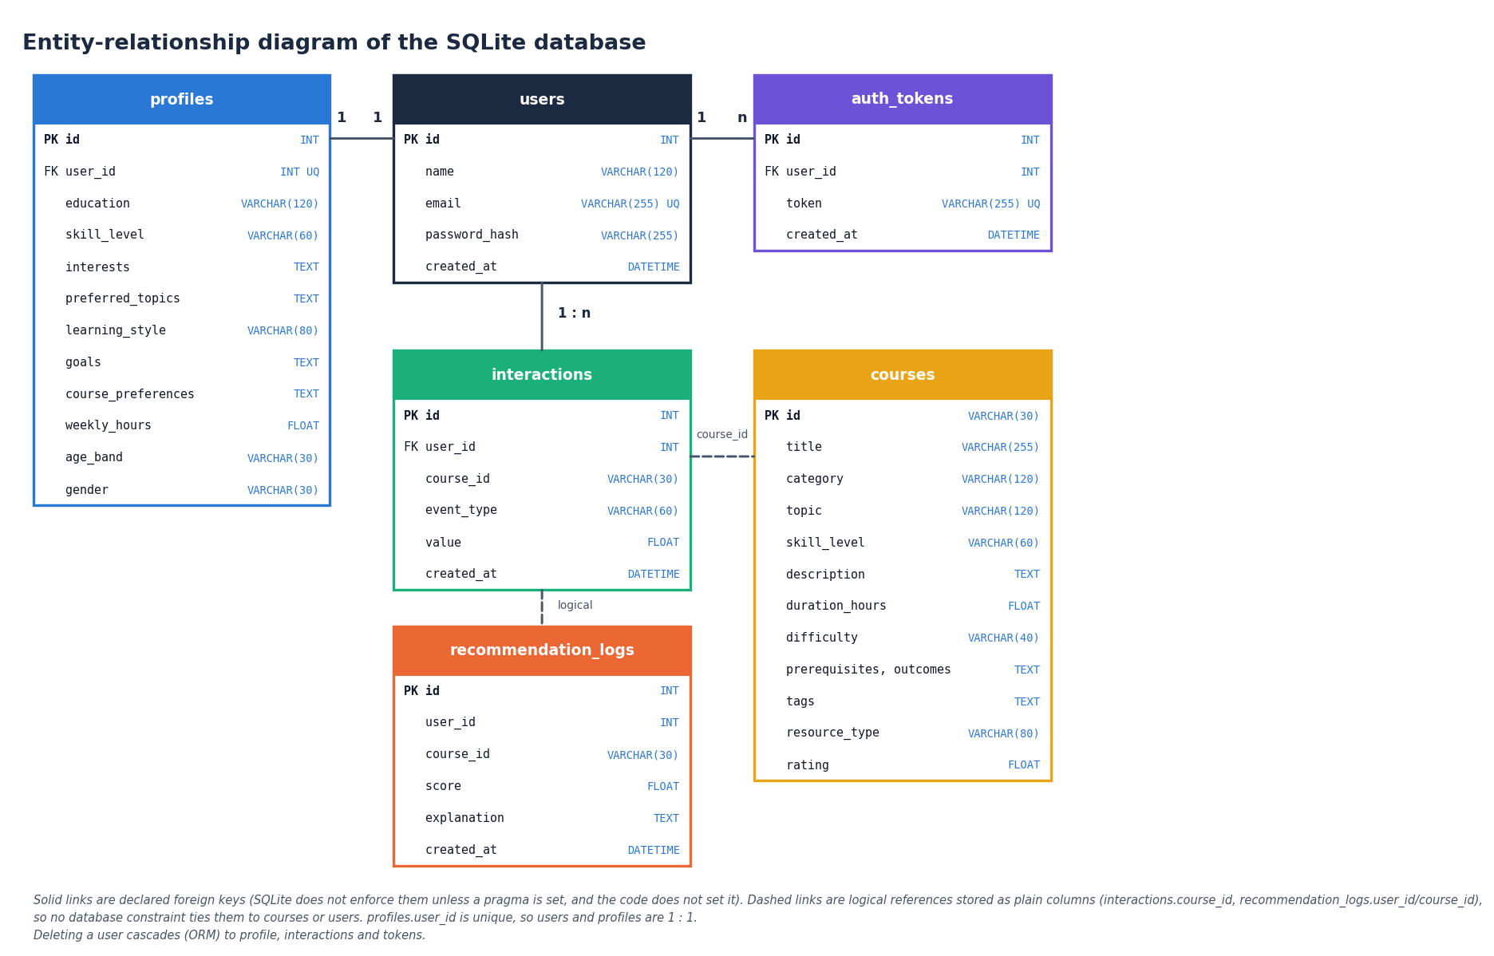
Figure 11: Entity-relationship diagram of the SQLite database
The database has six tables. users is the parent of profiles (one to one, because profiles.user_id is unique), auth_tokens (one to many) and interactions (one to many); these three links are declared foreign keys, and the ORM relationships cascade deletion from a user to its profile, interactions and tokens. courses is referenced by interactions.course_id and recommendation_logs.course_id, and recommendation_logs.user_id refers to a user, but these are plain columns without a declared foreign key, so no database constraint ties them to their parent. SQLite does not enforce declared foreign keys unless a pragma is switched on, and the code does not switch it on.
Table 20: Tables of the SQLite database
Table | Columns | Purpose
users | id (PK), name, email (unique), password_hash, created_at | Learner account; the password is stored only as a PBKDF2-SHA256 hash
profiles | id (PK), user_id (FK, unique), education, skill_level, interests, preferred_topics, learning_style, goals, course_preferences, weekly_hours, age_band, gender, updated_at | One profile per learner; interests and goals are comma-separated text
courses | id (PK, e.g. PY101), title, category, topic, skill_level, description, duration_hours, difficulty, prerequisites, outcomes, tags, resource_type, rating | The 24 seeded courses
interactions | id (PK), user_id (FK), course_id, event_type, value, created_at | Feedback events: view, open, start, content, quiz, forum, save, complete, dismiss
recommendation_logs | id (PK), user_id, course_id, score, explanation, created_at | One row per recommended card, shown on the Activity page
auth_tokens | id (PK), user_id (FK), token (unique), created_at | Opaque session tokens issued at register and login, deleted at logout

The tables are created by init_db() through Base.metadata.create_all, so a fresh checkout needs no migration, and the course table is filled from data/catalog/courses.json the first time the application starts with an empty table. All queries go through the SQLAlchemy ORM, which uses bound parameters, so file names, e-mail addresses and search text are never concatenated into SQL.

5.6 Module design
Table 21: Modules and responsibilities
Module | Responsibility | Key contents
app/main.py | Application entry | creates the FastAPI app, seed_courses(), static mount, Jinja pages /, /register, /login, /onboarding, /dashboard, /recommendations, /course/{id}, /path, /activity, /insights, /analytics
app/api_routes.py | JSON API | 18 routes, get_current_user, require_user, profile_dict, course_dict, cached bundle()
app/recommender.py | Recommendation engine | content_scores, skill_compat, topic_interest_score, behavioral_boost, engagement_level, learner_state_vector, predict_success, uplift_scores, rank_courses, load_ml_bundle
app/models.py, app/database.py | Persistence | six SQLAlchemy classes, engine, SessionLocal, get_db, init_db
app/security.py, app/schemas.py | Security and validation | hash_password, verify_password, new_token; RegisterIn, LoginIn, ProfileIn, InteractionIn
app/config.py | Settings | database URL, secret key, model and artefact folders, read from .env
scripts/train_pipeline.py | Offline training | acquire_data, split_learners, train_eval (models, uplift, policy evaluation, fairness audit, plots)
scripts/run_experiments.py and others | Evidence for the documents | six-seed study, ceiling check, persona evaluation with ablation, feedback-loop probe; measure_api.py, collect_env.py
frontend/src/pages/* | React screens | Landing, Login, Register, Catalog, CourseDetail, Analytics, Dashboard, Recommendations, LearningPath, Insights, Activity, Profile, NotFound
frontend/src/components, lib, styles | UI kit and client logic | layout shells, cards, charts, forms, toasts; api.js, auth.jsx, theme.jsx, useApi.js; design tokens and global CSS
tests/test_app.py, scripts/* | Verification | 5 pytest tests, smoke test, responsive check, screenshot capture

The backend package app/ is 649 lines of Python in total; rank_courses() is the only function the routes need for a ranking and every term it adds comes from a separate helper function.

5.7 API design
The API is JSON over HTTP. Errors use the standard FastAPI body {"detail": "message"}: 400 for a bad event type, a duplicate e-mail or mismatched passwords, 401 for a missing or invalid token or a wrong password, 404 for an unknown course, 422 for a request body that fails Pydantic validation (for example a malformed e-mail address or a name shorter than two characters) and 503 when the training artefacts are missing. The session is a random opaque token (secrets.token_urlsafe(32)) stored in auth_tokens; it is accepted from the HttpOnly cookie lpq_token, the X-Token header or a Bearer header. The catalogue, the course detail, the model metrics and the fairness audit are public by design, because they contain no learner data.
Table 22: REST endpoints
Method | Path | Session | Purpose
POST | /api/auth/register | No | Create account, empty profile and token; sets the cookie
POST | /api/auth/login | No | Verify the password hash; issue a token and cookie
POST | /api/auth/logout | No | Delete the token row and the cookie
GET | /api/me | No | Signed-in user or null
GET / PUT | /api/profile | Yes | Read or update the learner profile
GET | /api/courses?q=&category=&level= | No | Search and filter the catalogue
GET | /api/courses/{id} | No | Course detail; match score, success probability and suggested action when signed in; 404 if unknown
GET | /api/recommendations?top_n= | Yes | Ranked list with the eight term values, reasons, engagement and uplift
POST | /api/recommendations/refresh | Yes | Reload the model bundle and re-rank
POST | /api/interactions | Yes | Log an event; 400 for an unknown event type
GET | /api/activity?limit= | Yes | The learner's latest interaction events
GET | /api/history | Yes | The latest 40 recommendation-log rows
GET | /api/learning-path | Yes | Up to six staged steps and the next best action
GET | /api/insights | Yes | Engagement, success estimate, action benefits, strengths, attention points
GET | /api/metrics | No | Model comparison, confusion matrices, policy evaluation, fairness; 503 if not trained
GET | /api/fairness | No | The fairness audit with a note that it is an audit only
GET | /api/health | No | ok, models_ready, application name
GET | /static/{roc_curve, confusion_matrix, feature_importance}.png | No | The three training plots

The original Jinja2 pages are /, /register, /login, /onboarding, /dashboard, /recommendations, /course/{id}, /path, /activity, /insights and /analytics; each loads its data from the same JSON routes.

5.8 User interface design
The React interface uses a "neo-brutalist grid" visual language: a warm paper background, thick black outlines, hard offset shadows, a visible grid, a heavy display typeface for headings, a sans-serif body face and a monospace face for numbers (fonts from the Fontsource packages). Lime, coral, sky and amber accents carry meaning (for example, lime marks the best next action), and every status is also given as text so that meaning never depends on colour alone. There is a light and a dark theme with a toggle that remembers the choice. The signed-in shell has a sidebar that becomes a drawer on narrow screens, and the public shell has its own header; pages are loaded lazily and show skeleton placeholders while data arrive.
Table 23: Screens
Screen | Content
Landing / | Public introduction with the value proposition, how it works and live catalogue figures
Sign in /login, Register /register | Forms with inline validation messages; a new account is taken to the profile form
Course catalogue /courses | Search and filter by category and level; public, and also available inside the signed-in shell
Course detail /courses/:id | Description, prerequisites, outcomes, tags, the "why recommended" panel, and buttons that log start, content, quiz, discussion and complete events
Model analytics /analytics | Four tabs: model comparison, diagnostics (confusion matrices, ROC curve, feature importance), offline policy evaluation and fairness audit
Dashboard /app | Engagement status, success estimate, next action, recent activity and top recommendations
Recommendations /app/recommendations | Ranked cards with match percentage, success estimate, suggested action and explanation; search, refresh, view, start, dismiss
Learning path /app/path | Up to six staged steps with the reason and action for each, and the next best action
Insights /app/insights | Engagement, success estimate, estimated benefit by action, strengths and attention points, interactions by type
Activity /app/activity | Interaction log and recommendation history
Profile /app/profile | The learner profile form, also shown first after registration
Not found * | A 404 page with a way back

Accessibility was designed in rather than added later: a skip link is the first keyboard stop on every page, focus outlines are visible, the mobile drawer is a dialog that closes with the Escape key, and a reduced-motion setting collapses animation to fades. Chapter 7 reports the automated check of the layout at three widths in both themes.

CHAPTER 6: METHODOLOGY AND SOFTWARE IMPLEMENTATION

6.1 Overall methodology
The method has two phases that meet in one module. In the offline phase the script scripts/train_pipeline.py generates a synthetic, OULAD-like table of learner behaviour, splits it by learner, fits three classifiers that predict whether a learner-week ends in success, fits a pair of logistic regressions per learning action to estimate its benefit, runs an offline policy evaluation and a fairness audit, and saves everything the application needs as joblib and JSON files. In the online phase every request for recommendations runs rank_courses() in app/recommender.py, which combines a content-based score, simple rules, the learner's recent behaviour and the two model outputs into one ranked list with an explanation per course. The structure follows the base paper [1], which couples a success predictor, an uplift estimate of the benefit of each learning action and offline policy evaluation, but it replaces the paper's OULAD data with a synthetic generator and does not implement its reinforcement-learning agent (Section 6.5 and Chapter 10).
Figure 12: The online ranking procedure (flowchart repeated from Chapter 5)

6.2 Data
The training data are synthetic. acquire_data() first sends one short request to the Open University Learning Analytics Dataset page [4] but never reads a file from it; whatever the response, it then generates a table with the same kind of columns, tagged synthetic-oulad-like-fallback-v1. The real OULAD was not downloaded and no number in this report comes from it. The generator is seeded (seed 42), so a re-run reproduces the shipped files exactly.
The table has 2,200 learners observed for 12 weeks, that is 26,400 learner-week rows. For each learner the generator draws an age band (0-35, 35-55 or 55 and over, with probabilities 0.6, 0.3 and 0.1), a gender, an education level, a skill code (0, 1 or 2) and a latent ability that rises with skill and postgraduate education and falls slightly for the oldest band. Each week it draws the number of clicks from ability plus noise, whether the learner took a quiz or posted in the forum, homepage visits, content clicks and an assessment score (60 + 10 x ability + noise, clipped to 0-100); a completion flag is set in week 12 for learners with ability above 0.5.
The label is generated, not observed: a learner-week is a success when the hidden assessment score is at least 50 and a uniform random draw falls below 0.55 + 0.2 x (score - 50) / 50. The label is therefore noisy by construction, and the assessment score is not one of the eight features the deployed model sees. The learning action of a week is the first of quiz, content, forum, homepage or continue-course that applies to that week's behaviour (a quiz if one was taken, otherwise content if content clicks exceed four, and so on), so actions are assigned by a rule on behaviour and not at random.
Table 24: The synthetic data set
Item | Value
Source tag | synthetic-oulad-like-fallback-v1 (real OULAD not used)
Learners x weeks | 2,200 x 12 = 26,400 rows
Success rate | 44.0 %
Logged actions | quiz 8,424, content 5,292, continue_course 5,185, homepage 5,172, forum 2,327
Features given to the models | cum_clicks, recent_clicks, quiz_count, forum_count, completions, engagement, weekly_hours, skill_code
Hidden columns | assessment score (drives the label), age band, gender, education, homepage hits, content clicks

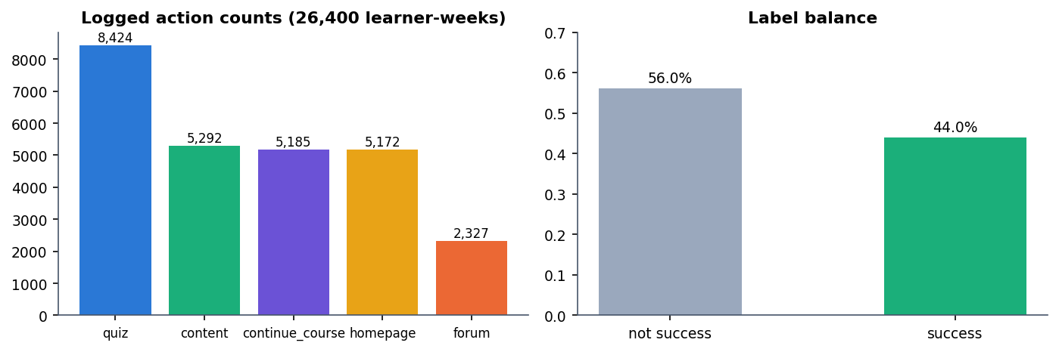
Figure 13: Logged action counts and label balance of the synthetic data
Correlation of each feature with the label is weak (largest: recent_clicks 0.183 and engagement 0.182, forum_count 0.002), which sets the ceiling for any model trained on these features; Chapter 8 shows that adding the hidden assessment score lifts the test AUC from 0.60 to 0.80, so the weak signal is a property of the generated data and not of the models.
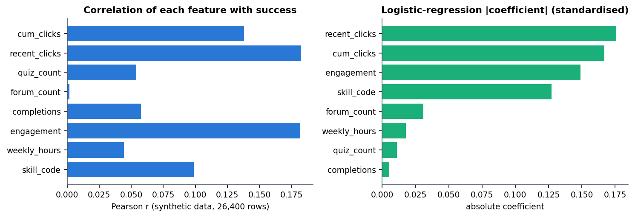
Figure 14: Correlation of each feature with success (left) and the logistic-regression coefficients (right)

6.3 Learner-level split and success models
The rows are split by learner, not by row, so no learner appears on both sides: the learner ids are shuffled with seed 42 and cut 80 / 10 / 10, giving 21,120 training rows (1,760 learners), 2,640 validation rows (220 learners) and 2,640 test rows (220 learners). A StandardScaler is fitted on the training rows only. Three classifiers from scikit-learn [13] and XGBoost [12] are trained:
• Logistic regression (max_iter=1000), the interpretable baseline;
• Random forest [15] with 200 trees;
• XGBoost with 300 trees, maximum depth 5, learning rate 0.05, subsample and column sampling 0.9.
The model with the highest validation AUC is selected and saved; the test split is used only for the reported metrics, at a decision threshold of 0.5. On the shipped run logistic regression wins (validation AUC 0.6035), and Chapter 8 shows that it is selected in four of six data-generation seeds (seed 42 included). The saved file is called xgb_model.joblib for historical reasons; it holds whichever model was selected, which is logistic regression in the shipped build.
Table 25: Success models on the held-out test split (seed 42)
Model | Val. AUC | Test AUC | Accuracy | F1 | Brier
Logistic Regression (selected) | 0.6035 | 0.6028 | 0.5936 | 0.4146 | 0.2378
Random Forest | 0.5550 | 0.5439 | 0.5311 | 0.4463 | 0.2837
XGBoost | 0.6008 | 0.5994 | 0.5955 | 0.4437 | 0.2400

One seed run (data generation, three models, uplift models) takes about 6.0 s on the development machine; the launcher prints "1 to 3 minutes" for the first run, which includes installing and the slower policy-evaluation loop.

6.4 Estimated benefit of a learning action (T-learner)
For each of the five actions (quiz, content, forum, homepage, continue-course) the script fits a T-learner [16]: one logistic regression on the learner-weeks where that action was taken (the treated arm) and one on all the other weeks (the control arm). For a learner state x the estimated benefit is the difference of the two predicted success probabilities. This is the one-versus-rest form of the uplift idea described in the base paper [8], [1]. An action is fitted only when both arms have more than 200 rows and both outcomes; otherwise its benefit is reported as 0.
benefit(a | x) = P(success | x, treated by a) - P(success | x, not treated by a) [two logistic regressions per action] (1)
At run time uplift_scores() evaluates the ten models on the learner's current state; the action with the largest benefit becomes the suggested action of every card, and its benefit is shown as the estimated benefit. Because the actions were assigned by a rule on behaviour in a synthetic log, these numbers are associations learned from that log, not proven causal effects, and the interface says so ("based on observed learning patterns, not proven causal effects"). Two further consequences are measured in Chapter 8: the benefits can change sign after a handful of events, and because the benefit depends only on the learner state the same suggested action appears on every card of one learner's list. If the bundle cannot be loaded, a state-based heuristic supplies the five numbers instead.

6.5 Offline policy evaluation and what is not implemented
Following the evaluation practice of the base paper, the script estimates the value of the policy "give each learner-week the action with the largest estimated benefit" from the logged test rows. A multinomial logistic regression on the learner state estimates the logging policy's propensity of the logged action; propensities are clipped to [0.02, 0.98], and the importance weight is 1 when the target action equals the logged one (otherwise 0), divided by the propensity and capped at 10. Three estimators are reported [5]:
IPS = mean(w r) SNIPS = IPS / mean(w) DR = mean( q(x) + w (r - q(x)) ) ESS = (sum w)^2 / sum(w^2) (2)
Here r is the observed success, q(x) the selected model's predicted success and ESS the effective sample size. The shipped run gives IPS 0.0088, SNIPS 0.6652 and DR 0.4355 with an effective sample size of 9.1 out of 2,640 rows. An effective sample size of about nine means a handful of rows carry all the weight, so these values are not evidence that the policy improves outcomes; they are reported as a transparency feature of the application, and the stored note calls them an observational offline estimate, not a live experiment.
Not implemented: the base paper's Actor-Critic reinforcement-learning agent, its causal regularisation, a collaborative-filtering model over many learners' course histories (the behavioural term of Section 6.8 is per learner) and any use of the real OULAD data. The project takes from the base paper only the success predictor, the uplift-style action estimate, offline policy evaluation and a fairness audit.

6.6 Fairness audit
The script groups the test rows by age band and by gender and reports, for each group, the number of rows, the observed success rate, the mean predicted success and the F1 score of the selected model. The audit is reporting only: no mitigation is applied, and the API note describes it as "transparent reporting, not a claim of perfect fairness". The result (Chapter 8) shows the lowest F1 for the 55-and-over band, which has only 204 test rows.

6.7 Content-based scoring
The text of a course is its title, description, topic, category, tags and skill level; the text of a learner is the interests, preferred topics, goals, course preferences, education and skill level from the profile. For every request a TfidfVectorizer (English stop words, at most 2,000 terms) is fitted on these 25 short documents (the profile plus the 24 courses) [14] and the content score of a course is the cosine similarity between its vector and the learner's.
content(c) = cos( tfidf(profile), tfidf(course c) ) (3)
Fitting on 25 documents each time keeps the code simple and needs no stored index, at the price that the term weights change slightly with the catalogue, and that the catalogue is small enough that a whole recommendations request takes about 33 ms (Chapter 7).

6.8 Hybrid ranking, behaviour and explanations
The final score of a course is a weighted sum of eight terms, clipped to [0, 1]. The weights are fixed constants in the code and were not fitted on data; Chapter 8 reports a drop-one-term ablation of them.
score(c) = 0.30 content + 0.15 skill + 0.15 topic + 0.12 success + 0.10 (0.5 + behaviour) + 0.08 goal + 0.05 rating + 0.05 engagement (4)
Table 26: The eight terms of the hybrid score
Term | Weight | Definition in the code
content | 0.30 | TF-IDF cosine similarity between profile text and course text
skill | 0.15 | Skill compatibility: level difference 0, 1 or 2 between learner (Beginner 0, Intermediate 1, Advanced 2; All levels counts as 1) and course gives 1.0, 0.6 or 0.3
topic | 0.15 | Share of the learner's interest, topic and goal words (longer than two letters) found in the course's topic, category, tags and title; 0.5 if the learner has none
success | 0.12 | Predicted success probability of the selected model for the learner state (same value for every course); 0.55 if the model is unavailable
behaviour | 0.10 | 0.5 plus the behavioural boost of this course, from the learner's events on it, clipped to [-0.3, 0.35]
goal | 0.08 | 0.7 if any comma-separated goal appears in the course title, description or tags, else 0.4
rating | 0.05 | (rating - 3.5) / 1.5, clipped to [0, 1]
engagement | 0.05 | Engagement score of the learner (same value for every course)

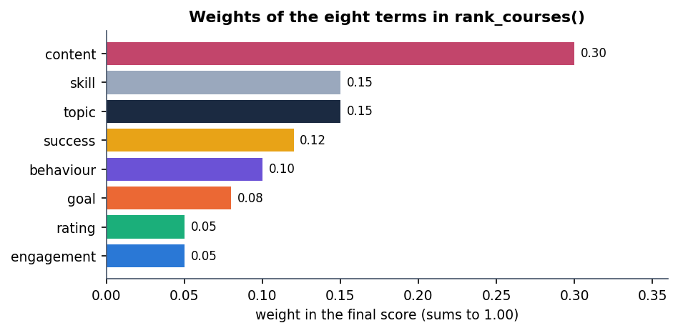
Figure 15: Weights of the eight terms in the hybrid score
Two of the eight terms (success and engagement, together 0.17 of the weight) are identical for every course of one learner, so they shift all scores together and cannot change the order; the order is decided by the other six terms. This is stated here because the "success estimate" shown beside each card is a property of the learner, not of the course.

Behavioural boost and engagement
Table 27: Event weights of the behavioural boost
Event | view | open | start | content | quiz | forum | save | complete | dismiss
Weight | 0.05 | 0.06 | 0.12 | 0.10 | 0.14 | 0.10 | 0.08 | 0.20 | -0.25

The boost of a course is the sum of the weights of the learner's events on that course, each multiplied by the event value (1.0 by default), clipped to [-0.3, 0.35]; an event type not in the table counts 0.03. The engagement score is computed from the last 200 events:
engagement = min(1, 0.25 + 0.04 x (view, open, start, content, quiz and forum events) + 0.03 x quizzes + 0.08 x completions) (5)
With no events the score is 0.25 (label "Getting started"); below 0.4 the label is "Getting started", below 0.7 "Steady learner" and otherwise "Highly engaged"; a learner who dismissed a course among the last five events and has a score under 0.45 is labelled "Needs a nudge".

Learner state for the models
The success and uplift models expect the eight training features, which learner_state_vector() builds from the profile and the logged events: cum_clicks is the number of events, recent_clicks that number capped at 20, quiz_count, forum_count and completions are the counts of those events, engagement is the score above, weekly_hours comes from the profile and skill_code is 0, 1 or 2. These definitions differ from the synthetic training weeks (where cum_clicks accumulates clicks), so the models are applied to a proxy of the state they were trained on; this is a limitation of the application, not something the offline metrics measure.

Explanations and the learning path
Each card carries up to three reasons chosen by rules: a content or topic reason ("Matches your interests (tag, tag)", "Aligned with your topic preferences in ..." or "Broadens your ... knowledge"), a skill reason ("Fits your current skill level", "Stretches you slightly beyond your level" or "A comfortable refresher"), "You have engaged with similar material before" when the boost exceeds 0.05, and "High estimated completion likelihood" when the predicted success exceeds 0.6. The learning path takes the top 12 courses, orders them by skill level (Beginner and All levels first, then Intermediate, then Advanced) and then by score, and keeps six; it uses no prerequisite graph.

6.9 Technology stack
Table 28: Backend and tooling (versions measured in the project environment)
Component | Version | Role
Python | 3.11.9 | Language of the backend and the training script
FastAPI [21] | 0.115.6 | Web framework and OpenAPI generation
Uvicorn | 0.34.0 | ASGI server
SQLAlchemy [22] | 2.0.36 | ORM over the SQLite file
Pydantic | 2.10.4 | Request validation (including e-mail check)
scikit-learn [13] | 1.5.2 | TF-IDF, logistic regression, random forest, metrics
XGBoost [12] | 2.1.3 | Gradient-boosted trees (one of the three candidates)
pandas / NumPy | 2.2.3 / 1.26.4 | Data table and arrays
joblib | 1.4.2 | Saving and loading the models
Matplotlib | 3.9.2 | Training plots and the documentation figures
Passlib | 1.7.4 | PBKDF2-SHA256 password hashing
pytest | 8.3.4 | Automated tests
Node.js / npm | v24.19.0 / 11.17.0 | Frontend build and development server

Table 29: Frontend dependencies declared in frontend/package.json
Package | Version | Role
react, react-dom | ^19.3.1 | User interface
react-router-dom | ^7.18.4 | Routing with lazy-loaded pages
recharts | ^3.10.1 | Bar charts of benefits, interactions and model metrics
vite, @vitejs/plugin-react | ^8.3.5, ^6.1.2 | Development server with proxy, production build
framer-motion, gsap, lenis | ^14.5.0, ^3.15.0, ^1.3.27 | Page transitions and motion
lucide-react | ^1.61.0 | Icons
@fontsource/* (Archivo Black, IBM Plex Sans, IBM Plex Mono) | ^5.3.0 | Self-hosted fonts

requirements.txt pins every Python package, including Jinja2 3.1.4, python-multipart, email-validator, requests, Pillow and Playwright 1.49.1, so the environment can be rebuilt. The machine used is a 12th-generation Intel Core i5-12500 (6 cores, 12 threads) with 15.7 GB of memory and no GPU, running Windows 11.

6.10 Backend implementation
app/main.py creates the FastAPI application, calls init_db(), fills the courses table from data/catalog/courses.json if it is empty, mounts /static and includes the router of app/api_routes.py. The routes are thin: each resolves the learner with require_user(), loads the profile and the 24 courses, calls into app/recommender.py and returns a dictionary. The model bundle is loaded lazily on first use by bundle() and cached in a module variable; POST /api/recommendations/refresh reloads it. rank_courses() is used by the recommendations route, by the learning-path route (top 12, then re-ordered) and by the course-detail route (top 50, to find the course's own score and reasons), and every recommendations call writes one recommendation_logs row per returned card.
def rank_courses(profile, courses, db, user_id, bundle, top_n=8):
sims = content_scores(profile, courses)
eng = engagement_level(db, user_id)
state = learner_state_vector(profile, eng)
p_success, feat_imp = predict_success(bundle, state)
upl = uplift_scores(bundle, state)
ranked = []
for i, c in enumerate(courses):
cs = float(sims[i]) if len(sims) > i else 0.0
sk = skill_compat(profile.get("skill_level", "Beginner"), c.get("skill_level", "Beginner"))
ti = topic_interest_score(profile, c)
beh = behavioral_boost(user_id, c.get("id", ""), db)
...
score = 0.30*cs + 0.15*sk + 0.15*ti + 0.12*p_success + 0.10*(0.5+beh) + 0.08*goal + 0.05*rating_f + 0.05*eng["score"]
score = round(float(max(0, min(1, score))), 4)
...
ranked.sort(key=lambda x: x["score"], reverse=True)
return ranked[:top_n], {"engagement": eng, "p_success": ..., "uplift": upl, ...}

The catalogue is small and hand-written (24 courses in nine categories, from Data Science with six courses to Design with one, rated 4.3 to 4.7 and lasting 4 to 30 hours), so everything is computed per request without a cache or an index; Chapter 7 gives the measured latency.

6.11 Training script and saved artefacts
python scripts/train_pipeline.py runs acquire_data(), split_learners() and train_eval() and writes: data/processed/learner_states.csv (the synthetic table); models/scaler.joblib, models/xgb_model.joblib (the selected model), models/feature_cols.joblib, models/all_models.joblib (all three models; it is large and git-ignored, and is never read at run time), models/uplift.joblib and models/ope.joblib; artifacts/metrics/model_metrics.json (metrics, confusion matrices, feature importance, policy evaluation, fairness); and three plots in artifacts/plots/, which are copied to app/static/ so that the analytics page can show them. run.bat trains automatically when the metrics file is missing.
A defect found while preparing the frontend shows why the artefacts must match the pinned library versions: files saved with a newer scikit-learn could not be used under scikit-learn 1.5.2, and because predict_success() and uplift_scores() catch every exception, the application silently fell back to a constant 55 % success estimate and zero action benefits. Re-running the unchanged script under the pinned versions fixed it (selected model and test AUC were unchanged). The silent fallback is deliberate so the pages never crash, but it hides this kind of fault; the smoke test now checks that the success estimate differs from 0.55.

6.12 Frontend implementation
The React application (frontend/src) has App.jsx with three layouts: public pages (landing, sign in, register), adaptive pages that use the signed-in or the public shell (catalogue, course detail, model analytics) and the protected /app area guarded by RequireAuth, which redirects to the sign-in page. Pages are loaded with React.lazy, so the chart library stays in its own chunks. lib/api.js wraps fetch with credentials: same-origin, turns FastAPI's string or list detail into one readable message and fires an event on a 401 so the session can be cleared; useApi runs a loader on mount, ignores stale responses and exposes {data, error, loading, reload}; lib/auth.jsx keeps the user from GET /api/me; lib/theme.jsx stores the light or dark choice. Shared components (cards, stat tiles, charts, forms, tables, toasts, skeletons) live in components/ui, and the design tokens (colours, fonts, borders, shadows, spacing) in styles/tokens.css. The Vite server proxies /api and /static to port 8407, so the HttpOnly cookie is never exposed to scripts and no cross-origin configuration is needed.

6.13 Security and error handling
Table 30: Controls
Threat or fault | Control in the code
Password theft from the database | Passwords are stored only as PBKDF2-SHA256 hashes (29,000 rounds, Passlib); the password is cut to 72 bytes before hashing
Unauthenticated access | Profile, recommendation, path, insight, activity and interaction routes depend on require_user() and answer 401
Token guessing | Tokens are secrets.token_urlsafe(32) values stored in auth_tokens; logout deletes the row
Script access to the session | Cookie lpq_token is HttpOnly and SameSite=Lax with a 72-hour lifetime
Malformed input | Pydantic: name 2-120 characters, e-mail format, password 6-100 characters; unknown event types answered with 400
SQL injection | All data access goes through the ORM with bound parameters
Missing or unusable model | The ranker falls back to a 0.55 success estimate and heuristic action scores; GET /api/health reports models_ready; /api/metrics answers 503

Known weaknesses: the tokens have no server-side expiry (the token_expire_hours and secret_key settings exist in app/config.py but no code uses them), a token is also accepted from a request header, each login adds a new token row, there is no rate limiting or password-reset flow, the transport is plain HTTP on localhost and the session is demonstration-grade. The application is intended for local use.

6.14 Installation and execution
run.bat reads the ports from .env (backend 8407, frontend 5407), creates a .venv if needed, installs requirements.txt, trains the models if the metrics file is missing, runs npm install in frontend/ on first use, starts the API (python -m uvicorn app.main:app) and the Vite server in two windows and opens the browser; the original server-rendered interface stays available on port 8407. A Dockerfile and docker-compose.yml are present in the project folder but were not run for these documents. Appendix B gives the full guide.

CHAPTER 7: SYSTEM TESTING

7.1 Testing strategy
Testing follows the layers of the system. A small pytest suite drives the FastAPI application in-process and checks the main flow and the input validation; a smoke test walks the same flow through the running React development server (so it also proves that the proxy reaches every route the interface uses); a browser check loads every screen at three widths in two themes; and two experiments written for this documentation check that the recommendation engine behaves sensibly on hand-written learners and that feedback changes the ranking. Each layer was run on the final code and its results are in the tables below.
Table 31: Test layers and results of the final run
Layer | Tool | What it checks | Result
Unit and API | pytest (FastAPI TestClient) | Health, home page, register / profile / catalogue / recommendations / interactions / refresh and six read routes, input validation, artefacts present | 5 of 5 passed in 10.3 s
System smoke | scripts/smoke_test.py (requests) | Running servers through the Vite proxy: register, profile, catalogue, ranking, feedback loop, path, insights, metrics, logout, login | 33 of 33 checks passed
User interface | scripts/check_responsive.py (Playwright, Chrome) | Horizontal overflow, console errors, failed requests, drawer and keyboard behaviour at 360, 768 and 1440 px, light and dark | passed
Recommendation behaviour | scripts/run_experiments.py | Ten personas against popularity and content-only baselines; a feedback-loop probe | reported in Section 7.5
Latency | scripts/measure_api.py | Response time of every route on loopback | reported in Section 7.7

7.2 Automated tests (pytest)
tests/test_app.py contains 5 tests and all 5 passed in the final run (10.3 s). They use FastAPI's TestClient, a real registered account and the real trained model bundle, against the project's own SQLite file; each registering test creates a new e-mail address, so tests do not depend on each other.
Table 32: The automated tests
Test | What it checks
test_health | GET /api/health returns 200 and ok is true
test_homepage | GET / returns 200 and the page contains "LearnPathIQ"
test_auth_profile_recs_interactions | Register returns a token; PUT /api/profile is accepted; the catalogue has more than five courses; one course detail loads; GET /api/recommendations?top_n=5 returns a non-empty list; a quiz interaction is accepted; refresh succeeds; learning-path, insights, activity, history, metrics and fairness each return 200 (or 503 if artefacts were missing)
test_invalid_inputs | A malformed registration (bad e-mail, one-letter name, short and mismatching passwords) gives 422; an unknown event_type gives 400; an unknown course id gives 404
test_artifacts_load | artifacts/metrics/model_metrics.json exists

The suite is deliberately small: it asserts status codes and shapes, not the numeric content of a ranking, and it has no separate unit tests for the individual scoring functions. Code coverage was not measured. The numeric behaviour of the ranker is covered instead by the persona experiment and the feedback-loop probe of Section 7.5.

7.3 System smoke test
scripts/smoke_test.py creates a throw-away account and runs 33 checks through the React server's proxy (port 5407) and the API (port 8407); all 33 passed. The checks fall into nine groups:
Table 33: Smoke-test checks
Group | Checks | Examples
Servers reachable | 3 | the React app is served; the backend health route; the proxy reaches the API and reports models_ready
Account and session | 3 | register; duplicate e-mail rejected; the cookie restores the user
Profile | 2 | save a profile; read it back
Catalogue | 3 | at least 20 courses; filter by category; search for "python"
Ranking and feedback loop | 8 | six ranked courses with explanations; open, start, quiz and complete accepted; a bad event type gives 400; the score of the interacted course changes; refresh works
Course detail | 2 | match score and explanation for a known course; 404 for an unknown one
Activity, history, path, insights | 5 | activity log has at least four events; recommendation history; one to six path steps with a next action; the five action benefits; the success estimate differs from the 0.55 fallback
Model transparency | 3 | three models with 2 x 2 confusion matrices; fairness audit present; the ROC plot is served as an image
Logout and login | 4 | logout; protected call is 401 afterwards; wrong password is 401; correct password logs in

7.4 User-interface and responsive check
scripts/check_responsive.py opens Chrome through Playwright with reduced motion on and visits, for each of three viewports (360 x 740, 768 x 1024 and 1440 x 900 pixels) and each of the two colour schemes, the five public pages (landing, sign in, register, catalogue, model analytics), registers a new learner through the real form, and visits the six signed-in pages (dashboard, recommendations, path, insights, activity, profile) and one course-detail page. It fails on any horizontal overflow greater than one pixel, any console error, any page error and any HTTP status of 400 or more. Below 1024 pixels it also opens the navigation drawer and checks that the Escape key closes it, and at 1440 pixels it checks that the first keyboard stop on the sign-in page is the skip link and that the focused element has a visible outline. The run took 142 s and ended with: 360 / 768 / 1440 px, light + dark: no overflow, console clean, drawer + keyboard OK.

Figure 16: The dashboard in the dark theme at 1440 x 900 pixels, one of the screens covered by the check
The check is automated and covers layout, errors and basic keyboard behaviour in one browser (Chrome). It is not an accessibility audit: contrast ratios, screen-reader behaviour and other browsers were not tested.

7.5 Recommendation behaviour

Persona check against two baselines
Ten learner personas were written by the authors, each with the course categories that would count as relevant for that learner; the categories were fixed before any ranking was run. For each persona the 24 courses were ranked three ways: by rating only (popularity), by the TF-IDF content score only, and by the shipped hybrid score. Precision at 1, 3 and 5 and the mean reciprocal rank (MRR) of the first relevant course were computed. This is a sanity check on a 24-course catalogue, not a user study, and not a measurement of precision and recall against real learner feedback.
Table 34: Persona check (10 personas, 24 courses)
Ranker | P@1 | P@3 | P@5 | MRR
popularity (rating only) | 0.20 | 0.200 | 0.20 | 0.314
content-only (TF-IDF) | 1.00 | 0.800 | 0.56 | 1.000
hybrid (shipped) | 1.00 | 0.733 | 0.54 | 1.000

The hybrid ranker is far better than the popularity baseline, but it is not better than the content-only baseline on these personas (P@3 0.733 against 0.800, P@5 0.54 against 0.56). What the extra terms add is behaviour that the content score cannot provide: an adjustment from the learner's own events, a skill-level fit and cold-start-safe defaults. The drop-one-term ablation is reported in Chapter 8.
Table 35: The ten personas and the hybrid's top three
Persona | Level | Relevant categories | Hybrid top 3 | P@3
Python beginner | Beginner | Programming | PY101, PY201, STAT101 | 0.67
Aspiring data scientist | Beginner | Data Science, Maths | DS101, ML101, DA101 | 1.00
Frontend web developer | Beginner | Design, Web Development | WEB101, WEB201, PY101 | 0.67
Backend / API developer | Intermediate | Data Science, Programming, Web Development | WEB201, PY201, WEB101 | 1.00
Cloud and DevOps learner | Intermediate | Engineering | CLOUD101, GIT101, PY201 | 0.67
Security awareness | Beginner | Engineering | SEC101, SQL101, AI101 | 0.33
Business analyst | Beginner | Business, Maths | EXCEL101, BUS101, PROJ101 | 1.00
Designer | Beginner | Design, Web Development | DES101, SQL101, AI101 | 0.33
Exam preparation | Beginner | Study Skills | ENG101, QUIZSKILL, FORUMSKILL | 1.00
Communication skills | Beginner | Communication | COM101, ENG201, AI101 | 0.67

Feedback-loop probe
To check that feedback changes the ranking in the right direction, a learner with the profile "python, data science, machine learning" (Beginner) was ranked, then received six events (start, quiz, quiz and complete on ML101, a view of DS101 and a dismissal of DA101) and was ranked again.
Table 36: Effect of six events on the ranking
Quantity | Before | After
Top three | ML101, DS101, DA101 | ML101, DS101, PY101
ML101 score and rank | 0.4867 (rank 1) | 0.5514 (rank 1)
DS101 score and rank | 0.4505 (rank 2) | 0.4852 (rank 2)
DA101 (dismissed) score and rank | 0.4169 (rank 3) | 0.4215 (rank 4)
Estimated success | 0.2019 | 0.3239
Engagement | Getting started (0.25) | Steady learner (0.55)
Suggested action | quiz | homepage

The course the learner worked on rose in score and the dismissed course fell one place, as intended. The probe also exposed two weaknesses that Chapter 8 discusses: the estimated benefit of every action changed sign after only six events, so the suggested action flipped from a quiz to a homepage visit, and the suggested action is the same on every card because it depends on the learner state only.

7.6 Input validation and security checks
Table 37: Validation and access-control cases that were run
Case | Expected | Covered by
Malformed registration (bad e-mail, one-letter name, short and mismatching passwords) | 422 | test_invalid_inputs
Registration with an e-mail that already exists | 400 | smoke test
Unknown interaction event type | 400 | test_invalid_inputs, smoke test
Unknown course id | 404 | test_invalid_inputs, smoke test
Protected route after logout | 401 | smoke test
Wrong password at login | 401 | smoke test
Training artefacts present | metrics file exists | test_artifacts_load, smoke test

Password hashing, token handling and the cookie attributes were reviewed in the code (Chapter 6) but have no dedicated automated test, and no penetration test, fuzzing or dependency audit was run.

7.7 Performance
scripts/measure_api.py registers one throw-away account on the running backend and times each route over the loopback address 127.0.0.1 (using the address avoids a 2-second IPv6 fallback seen with the name localhost on this machine). Read routes were called 30 times in sequence after three warm-up calls to the recommendations route; the first registration includes the first password hash and database write.
Table 38: API latency in milliseconds (loopback, development machine)
Route | n | Mean | Median | p95 | Max
POST /api/auth/register | 1 | 427.1 | 427.1 | 427.1 | 427.1
PUT /api/profile | 5 | 20.2 | 20.1 | 29.4 | 29.4
POST /api/auth/login | 10 | 31.1 | 30.7 | 38.0 | 38.0
GET /api/health | 30 | 2.7 | 2.6 | 4.0 | 4.2
GET /api/courses | 30 | 6.0 | 6.0 | 7.6 | 10.3
GET /api/courses/{id} | 30 | 24.6 | 23.5 | 32.3 | 37.2
GET /api/recommendations?top_n=8 | 30 | 32.8 | 32.0 | 42.4 | 43.7
GET /api/recommendations?top_n=24 | 30 | 38.3 | 34.3 | 65.7 | 75.6
GET /api/learning-path | 30 | 22.2 | 22.1 | 24.9 | 25.6
GET /api/insights | 30 | 8.8 | 8.7 | 10.3 | 10.4
GET /api/activity | 30 | 5.8 | 5.6 | 7.9 | 8.5
GET /api/metrics | 30 | 3.5 | 3.6 | 4.8 | 5.0

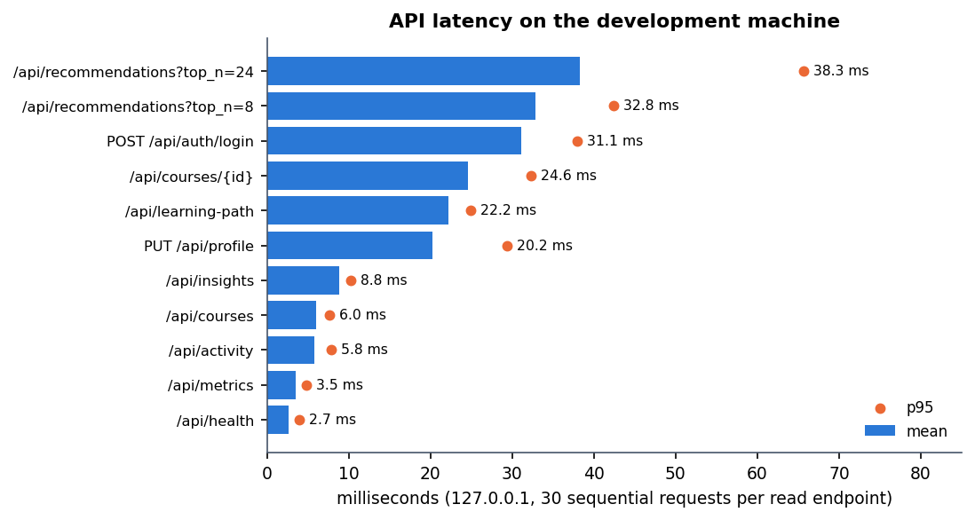
Figure 17: Mean and 95th-percentile latency of the API routes
Recommendations for eight courses take about 33 ms on average (p95 42 ms), although the TF-IDF matrix is fitted and all 24 courses are scored on every call without any cache. The figures come from one machine (a 12th-generation Core i5, no GPU), one client and a catalogue of 24 courses; they say nothing about many simultaneous users or a larger catalogue.

7.8 A defect found during testing
While the frontend was being verified the success estimate was always exactly 55 % and every action benefit was zero. The cause was that the stored model files had been saved with a different scikit-learn version than the pinned 1.5.2; predicting failed, and the application's catch-all handlers returned the fallback values silently. Re-running scripts/train_pipeline.py unchanged under the pinned versions restored the model (logistic regression, test AUC 0.6028 as before), and the smoke test gained a check that the success estimate differs from 0.55. The episode shows the cost of the design choice to fail soft.

7.9 Traceability to the objectives
Table 39: Objectives and the evidence collected
Objective | Evidence | Status
1. Learner profiles | PUT/GET /api/profile in the pytest and smoke tests; profile screens in the responsive check | Met
2. Course catalogue | 24 seeded courses; catalogue search and filter in the smoke test | Met (small, hand-written catalogue)
3. Collaborative filtering | No cross-learner model exists; only a per-learner behavioural boost | Not implemented
4. Content-based filtering | TF-IDF scoring; persona check P@3 0.800 for the content-only ranking | Met
5. Hybrid recommendation and learning path | Eight-term score; feedback-loop probe; path steps in the smoke test | Met (path is ordered by level and score, no prerequisite graph)
6. Evaluation with precision, recall and feedback | Model AUC and F1 on a synthetic test split; persona P@k and MRR; no real learner feedback | Partly met

7.10 What was not tested
• Load and concurrency: latency was measured with sequential requests from one client; no load test was run.
• Real data: every model result comes from the synthetic generator; the real OULAD data were never used.
• Users: no user study, no real-feedback precision or recall, no A/B test.
• Security: no penetration test, no fuzzing, no dependency audit and no automated test of hashing or cookie flags.
• Browsers and assistive technology: Chrome only; no screen-reader or contrast audit.
• Deployment: the Dockerfile and compose file were not run; only the local launcher was used.
• Coverage: line coverage of the Python code was not measured.

CHAPTER 8: RESULTS AND OUTPUT SCREENS

8.1 Experimental setup and data
Every number in this chapter was produced by this project's own code on this project's own data and is read from artifacts/metrics/model_metrics.json (the shipped training run) or from experiments/*.json (re-runs and measurements made for this report by scripts/run_experiments.py, scripts/threshold_sweep.py, scripts/measure_api.py and scripts/collect_env.py). Nothing was copied from another study except where a table says so and cites it.
The data are synthetic. The training script scripts/train_pipeline.py probes the Open University Learning Analytics Dataset page [4] but does not download or use it. It generates an OULAD-like table of learner-weeks with a fixed random seed (synthetic-oulad-like-fallback-v1). All model results below therefore describe how well the models recover a rule that this project's generator itself defined; they say nothing about real learners and no claim of external validity is made.
Table 40: Dataset and split used in the shipped run (seed 42)
Item | Value
Source | synthetic-oulad-like-fallback-v1 (generated; real OULAD never used)
Learners x weeks | 2,200 learners x 12 weeks = 26,400 learner-week rows
Success rate (label = 1) | 44.0%
Observable features (8) | cum_clicks, recent_clicks, quiz_count, forum_count, completions, engagement, weekly_hours, skill_code
Logged action | quiz 8,424, content 5,292, continue_course 5,185, homepage 5,172, forum 2,327
Split (learner level, 80/10/10) | train 21,120 rows (1,760 learners) / validation 2,640 / test 2,640 (220 learners)
Positive rate on the test split | 43.8%
Environment | 12th Gen Intel(R) Core(TM) i5-12500 (6 cores, 12 threads), 15.7 GB RAM, none used (CPU only); Python 3.11.9, scikit-learn 1.5.2, XGBoost 2.1.3

The label is generated as success = (assess_score >= 50) AND (U < 0.55 + 0.2 (assess_score - 50) / 50) with U uniform noise, so it is noisy by construction. The assessment score itself is not one of the eight features the deployed model receives.

8.2 Success-prediction performance
Three classifiers were trained on the same standardised features: logistic regression (max_iter=1000), a 200-tree random forest and a 300-tree XGBoost model [12], [15], [13] (depth 5, learning rate 0.05). The model with the highest validation AUC is saved as the deployed success model, which here is Logistic Regression. All figures below are on the held-out test split of 2,640 learner-weeks (220 learners never seen in training).
Table 41: Test-split results of the three success models (threshold 0.5)
Model | Val AUC | Test AUC | Accuracy | Precision | Recall | F1 | Brier
Logistic Regression (selected) | 0.6035 | 0.6028 | 0.5936 | 0.5605 | 0.3290 | 0.4146 | 0.2378
Random Forest | 0.5550 | 0.5439 | 0.5311 | 0.4616 | 0.4320 | 0.4463 | 0.2837
XGBoost | 0.6008 | 0.5994 | 0.5955 | 0.5569 | 0.3688 | 0.4437 | 0.2400

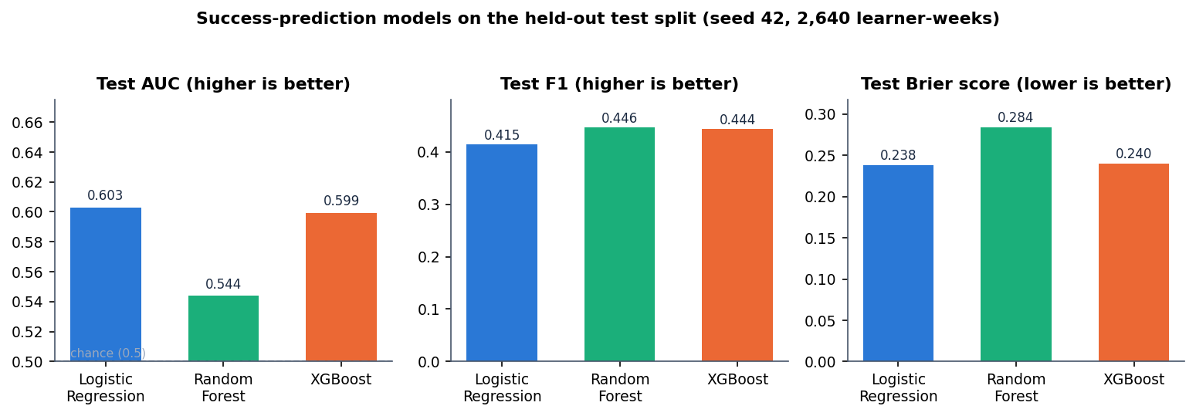
Figure 18: Test AUC, F1 and Brier score of the three success models
The ordering is Logistic Regression (0.603), XGBoost (0.599) and Random Forest (0.544). An AUC of 0.5 is chance, so the discrimination is modest: about 0.60 for the deployed model. The accuracy of 0.594 must be read against the majority-class rate: a model that always predicted "not success" would be right 56.2% of the time, so the deployed model is only about 3.1 percentage points better than that trivial rule. The Brier score (0.238 for logistic regression) is likewise close to what a constant prediction of the base rate would give (0.246).

Confusion matrices and ROC
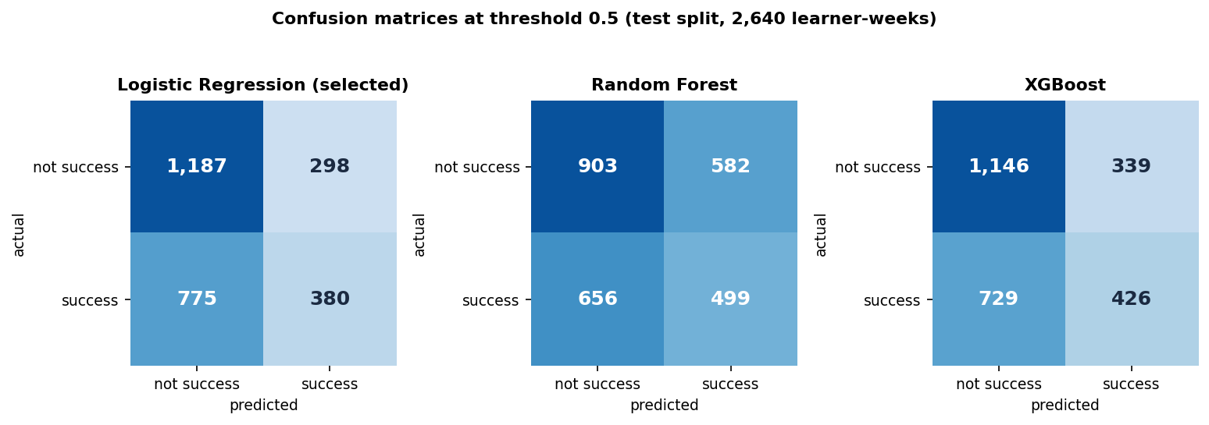
Figure 19: Confusion matrices of the three models on the test split at threshold 0.5
For the deployed logistic regression the matrix is [[1,187, 298], [775, 380]]: 1,187 true negatives, 298 false positives, 775 false negatives and 380 true positives. Recall is only 32.9%: the model misses 67.1% of the learner-weeks that did succeed, while 20.1% of the learner-weeks that did not succeed are wrongly flagged as likely successes. Random Forest has the highest recall (43.2%) but pays for it with the lowest precision and the worst calibration.
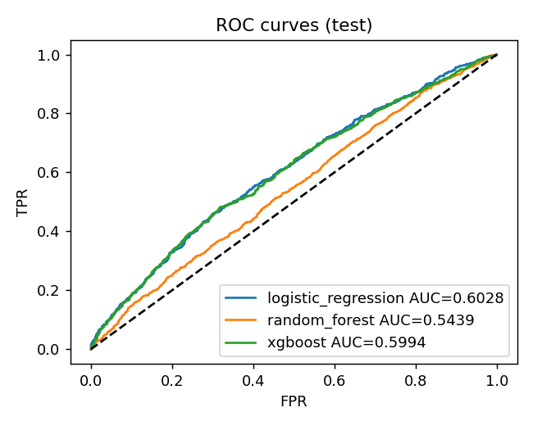
Figure 20: ROC curves of the three models on the test split (artifacts/plots/roc_curve.png, drawn by the training script)
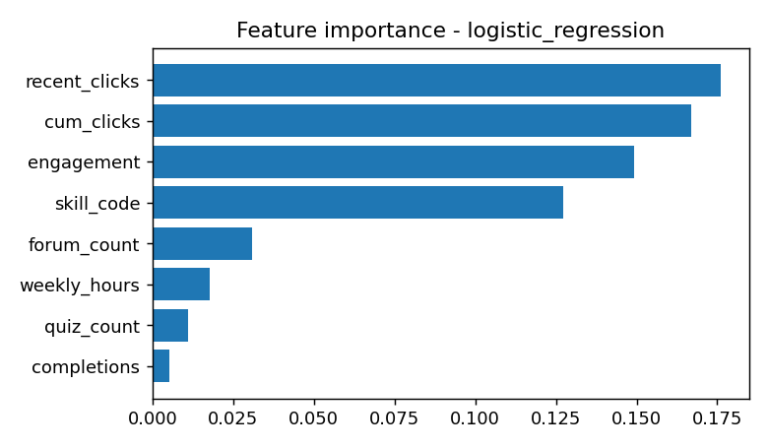
Figure 21: Absolute logistic-regression coefficients of the eight features (artifacts/plots/feature_importance.png)
The feature plot reports absolute coefficients on standardised inputs because the selected model is logistic regression and has no tree importances. The recent-click, cumulative-click, engagement and skill-code features carry most of the weight; quiz count and completions carry almost none. These coefficients appear only in this plot and on the Diagnostics tab: because predict_success() returns importances only for models that have feature_importances_, the contributing_features field of the API and the corresponding list on the Insights page are empty for the deployed logistic regression.

8.3 Stability across seeds and the information ceiling
The shipped run uses one seed, so a single AUC could be lucky. scripts/run_experiments.py re-generates the synthetic data and the learner split for 6 seeds (42, 1, 2, 3, 4, 5) with the shipped settings, without overwriting the deployed artefacts. Seed 42 reproduces the shipped metrics exactly.
Table 42: Test metrics over 6 seeds (mean +- standard deviation)
Model | Test AUC | AUC range | F1 | Accuracy | Brier
Logistic Regression | 0.6142 +- 0.0123 | 0.5948 - 0.6244 | 0.4254 +- 0.0298 | 0.5900 | 0.2366
Random Forest | 0.5512 +- 0.0127 | 0.5393 - 0.5716 | 0.4671 +- 0.0236 | 0.5434 | 0.2813
XGBoost | 0.6063 +- 0.0127 | 0.5845 - 0.6182 | 0.4578 +- 0.0266 | 0.5926 | 0.2389

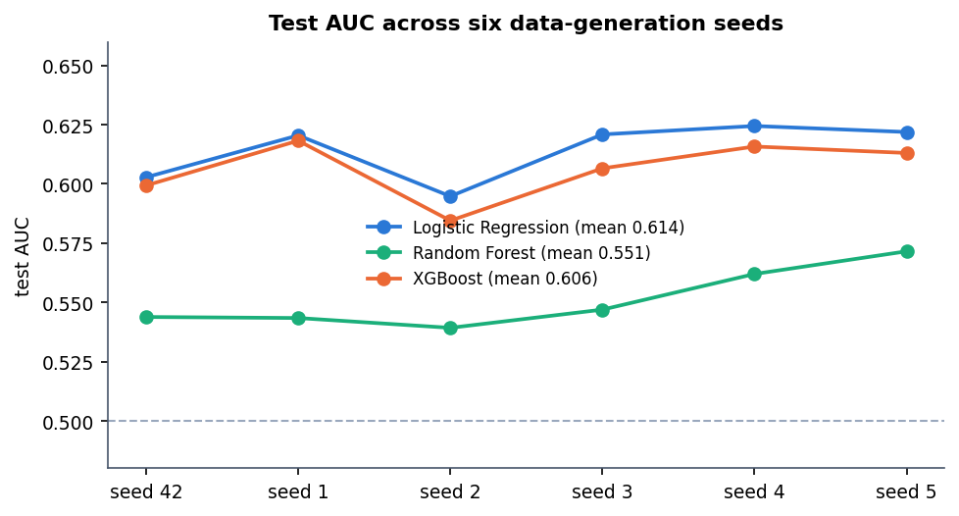
Figure 22: Test AUC of the three models for each of the six seeds
The ranking is stable: logistic regression and XGBoost are within about 0.008 AUC of each other and both beat Random Forest on every seed. Validation-AUC selection picked logistic regression on 4 seeds and XGBoost on 2, so the choice of the deployed model is not decisive. The mean test AUC of the deployed model family is 0.614 (standard deviation 0.012); a run takes about 6 s on this CPU.

Why the AUC is only about 0.6
To find out whether the weak result is a modelling flaw or a property of the data, the same pipeline was run with the hidden assessment score added as a ninth feature. The score is what the generator uses to decide success, so it shows how much of the label is recoverable at all.
Table 43: Test AUC with and without the hidden assessment score (seed 42)
Model | Shipped 8 features | + assessment score | Accuracy (+ score) | F1 (+ score)
Logistic Regression | 0.6028 | 0.8000 | 0.6867 | 0.6212
Random Forest | 0.5439 | 0.7858 | 0.7144 | 0.7129
XGBoost | 0.5994 | 0.7868 | 0.7337 | 0.7568

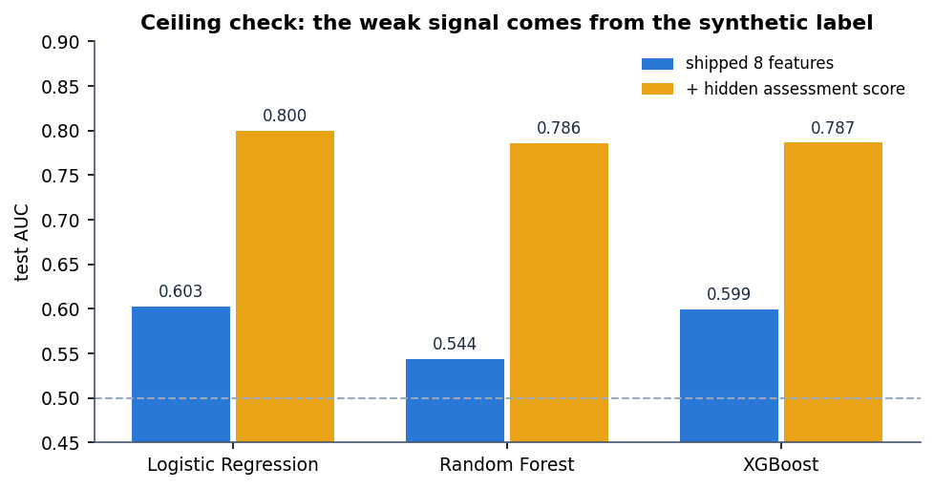
Figure 23: Ceiling check: adding the hidden assessment score lifts AUC to about 0.8
With the hidden score the logistic-regression AUC rises from 0.603 to 0.800. The gap is the information the deployed features do not carry: a learner's click counts, quiz counts and engagement only weakly reveal the assessment outcome in this generator. The low AUC is therefore a property of the synthetic data, not a coding fault, and the same weak signal would not be expected, or assumed, on real learner logs.

8.4 Threshold and parameter analysis

Decision threshold of the success model
The deployed model turns a probability into a label at 0.5. scripts/threshold_sweep.py re-fits the logistic regression with the shipped settings on the same split (its confusion matrix at 0.5 matches the shipped one exactly) and sweeps the threshold. The recommender itself uses the probability, not the label, so this sweep matters only for reporting.
Table 44: Logistic regression on the test split at different thresholds
Threshold | Predicted success | Accuracy | Precision | Recall | F1
0.30 | 2,439 | 0.475 | 0.453 | 0.956 | 0.614
0.35 | 2,080 | 0.506 | 0.464 | 0.836 | 0.597
0.40 | 1,578 | 0.553 | 0.492 | 0.672 | 0.568
0.45 | 1,100 | 0.584 | 0.525 | 0.500 | 0.513
0.50 | 678 | 0.594 | 0.560 | 0.329 | 0.415
0.55 | 339 | 0.586 | 0.593 | 0.174 | 0.269
0.60 | 160 | 0.581 | 0.656 | 0.091 | 0.160
0.65 | 56 | 0.572 | 0.714 | 0.035 | 0.066
0.70 | 17 | 0.568 | 0.941 | 0.014 | 0.027

Raising the threshold buys precision at the cost of recall: precision climbs from 0.453 at 0.30 to 0.941 at 0.70, but only 17 of 2,640 rows are then flagged. Accuracy is highest at 0.50 (0.594) and F1 is highest at 0.30 (0.614), where the model flags 2,439 of 2,640 rows and recall is 0.956. That F1 gain is mostly the effect of predicting success almost everywhere; accuracy at that threshold (0.475) is below the majority-class rate of 0.562. The default 0.5 is the accuracy-maximising choice and is kept.

Weights of the hybrid score
The ranker adds eight terms with fixed weights chosen by hand (0.30, 0.15, 0.15, 0.12, 0.10, 0.08, 0.05, 0.05); no weight search or learning was done. To see what each term contributes, each one was removed in turn and the remaining score was ranked again for the 10 personas of Section 8.5 (P@3 and P@5 against the author-defined relevant categories; the last column is how many of the full score's top three survive).
Table 45: Drop-one-term ablation of the hybrid score (mean over 10 personas)
Term removed | Weight | P@3 | P@5 | Top-3 overlap
none (full score) | 1.00 | 0.733 | 0.54 | 1.00
content | 0.30 | 0.667 | 0.46 | 0.80
skill | 0.15 | 0.767 | 0.54 | 0.83
topic | 0.15 | 0.600 | 0.44 | 0.80
success | 0.12 | 0.733 | 0.54 | 1.00
behaviour | 0.10 | 0.733 | 0.54 | 1.00
goal | 0.08 | 0.733 | 0.54 | 1.00
rating | 0.05 | 0.767 | 0.54 | 0.87
engagement | 0.05 | 0.733 | 0.54 | 1.00

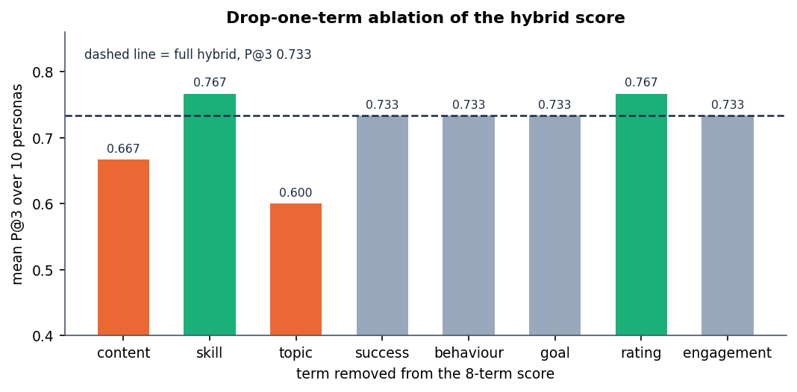
Figure 24: Mean P@3 after removing each term of the hybrid score
Removing content, topic lowers P@3, so these terms help on this persona set; removing skill, rating raises P@3 slightly, which means those terms, as weighted, do not help here; removing success, behaviour, goal, engagement changes nothing at the top of the list. The topic-overlap and content terms matter most (P@3 falls from 0.733 to 0.600 and 0.667). The success, behaviour, goal and engagement terms leave P@3 unchanged because, for a fresh persona, they are nearly constant across courses; their job is to react to a learner's history (Section 8.6), which this static test cannot show.

Settings that were not varied
• Importance weights and propensities in the offline policy evaluation: propensities are clipped to [0.02, 0.98] and importance weights are capped at 10. These were fixed in the training script and not swept, so the sensitivity of the IPS, SNIPS and doubly robust values to them is unknown.
• Behavioural boost limits (-0.3 to 0.35) and the event weights (view 0.05 ... complete 0.20, dismiss -0.25) are hand-set constants and were not tuned.
• TF-IDF uses max_features=2000 and English stop words, fitted on the learner text and the 24 course texts at every request; no vocabulary or n-gram setting was compared.
• Model hyper-parameters (random-forest and XGBoost depth, trees, learning rate) were fixed, not searched.

8.5 Recommendation quality on a persona check
The project has no log of real learners choosing real courses, so precision and recall against real feedback could not be measured (objective 6 is therefore only partly met). As a sanity check, 10 learner personas were written by the authors, each with the course categories that would be relevant to them, and these expected sets were written down before any ranking was run. A course counts as relevant when its category is in the persona's set; the catalog has 24 courses. Three rankers were compared: popularity (rating only), content-only TF-IDF similarity, and the shipped hybrid score.
Table 46: Precision@k and MRR over 10 personas
Ranker | P@1 | P@3 | P@5 | MRR
popularity | 0.20 | 0.200 | 0.20 | 0.314
content-only | 1.00 | 0.800 | 0.56 | 1.000
hybrid | 1.00 | 0.733 | 0.54 | 1.000

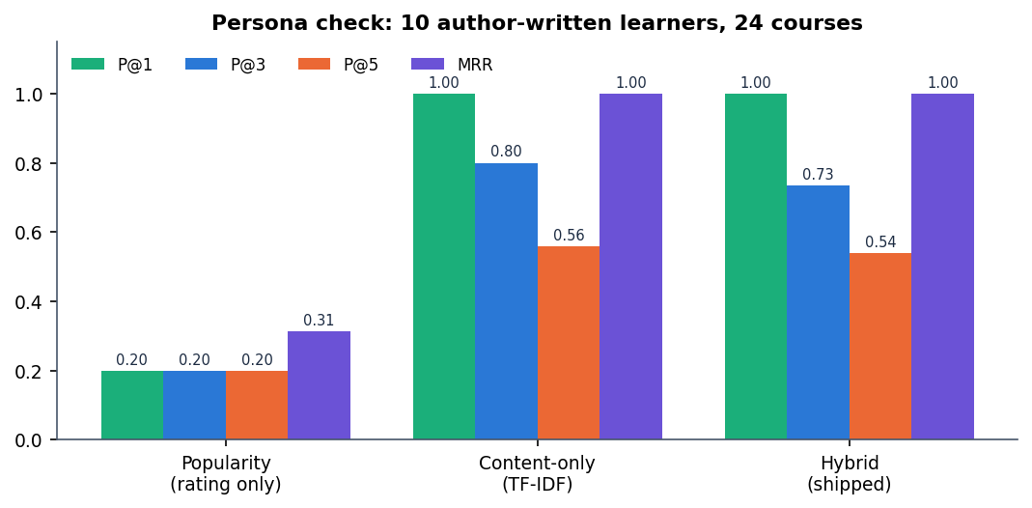
Figure 25: P@1, P@3, P@5 and MRR of the three rankers on the persona check
Both personalised rankers are far better than popularity (P@3 0.200 against 0.800 and 0.733), and both put a relevant course first for every persona (MRR 1.00). The hybrid score does not beat content-only TF-IDF on this check: its P@3 is 0.733 against 0.800, and its P@5 is 0.54 against 0.56. The extra terms (rating, skill fit, success estimate, engagement) pull a few generally popular or beginner-level courses into the top three for 2 personas (Security awareness, Designer). What the hybrid adds is behaviour that content-only ranking cannot have: cold-start-safe fallbacks and adaptation to a learner's own events, shown next.
Table 47: Persona-by-persona result (hybrid vs content-only P@3)
Persona | Skill | Relevant categories | Rel. courses | Hybrid top 3 | Hyb. P@3 | Cont. P@3
Python beginner | Beginner | Programming | 2 | PY101, PY201, STAT101 | 0.67 | 0.67
Aspiring data scientist | Beginner | Data Science, Maths | 8 | DS101, ML101, DA101 | 1.00 | 1.00
Frontend web developer | Beginner | Design, Web Development | 3 | WEB101, WEB201, PY101 | 0.67 | 0.67
Backend / API developer | Intermediate | Data Science, Programming, Web Development | 10 | WEB201, PY201, WEB101 | 1.00 | 1.00
Cloud and DevOps learner | Intermediate | Engineering | 3 | CLOUD101, GIT101, PY201 | 0.67 | 0.67
Security awareness | Beginner | Engineering | 3 | SEC101, SQL101, AI101 | 0.33 | 0.67
Business analyst | Beginner | Business, Maths | 5 | EXCEL101, BUS101, PROJ101 | 1.00 | 1.00
Designer | Beginner | Design, Web Development | 3 | DES101, SQL101, AI101 | 0.33 | 0.67
Exam preparation | Beginner | Study Skills | 3 | ENG101, QUIZSKILL, FORUMSKILL | 1.00 | 1.00
Communication skills | Beginner | Communication | 2 | COM101, ENG201, AI101 | 0.67 | 0.67

These numbers are a sanity check on a 24-course catalog with ten hand-written personas. They are not a user study, the relevance labels are category-level and chosen by the authors, and the differences between the two personalised rankers (one or two courses for a few personas) are far too small to rank them statistically.

8.6 Adaptation to learner feedback
The main behavioural claim of the system is that ranking changes as a learner acts. For one persona (Beginner; interests python, data science, machine learning) six events were logged through the same code path as the API: start ML101, quiz ML101, quiz ML101, complete ML101, view DS101, dismiss DA101. The ranking was recomputed before and after.
Table 48: Effect of six events on three tracked courses
Course | Rank before | Rank after | Score before | Score after
ML101 | 1 | 1 | 0.4867 | 0.5514
DS101 | 2 | 2 | 0.4505 | 0.4852
DA101 | 3 | 4 | 0.4169 | 0.4215

The top three changes from ML101, DS101, DA101 to ML101, DS101, PY101: the dismissed course (DA101) falls from rank 3 to 4 and is replaced in the top three, while ML101, on which the learner started, took two quizzes and finished, rises in score from 0.487 to 0.551. The estimated success probability moves from 0.202 to 0.324 and the engagement label from Getting started to Steady learner (score 0.25 to 0.55). Ranking adapts at once, without retraining, because the behavioural term and the engagement features are recomputed from the interaction table on every request.

8.7 Estimated action benefit
Beside the ranking, the application shows an estimated benefit for five learner actions (quiz, content, forum, homepage visit, continue course). It comes from a one-vs-rest T-learner [16], [8]: two logistic regressions per action, one fitted on learner-weeks where the action was taken and one where it was not, and the benefit is the difference of their predicted success probabilities. The interface calls it an estimate from observed patterns, not a proven causal effect, and the data support that caution.
Table 49: Estimated benefit of each action for the persona of Section 8.6
Action | Before six events | After six events
quiz | +0.0912 | -0.1798
content | +0.0110 | +0.1088
forum | +0.0084 | +0.1220
homepage (Visit course resources) | -0.0410 | +0.1629
continue_course | -0.0046 | +0.1314

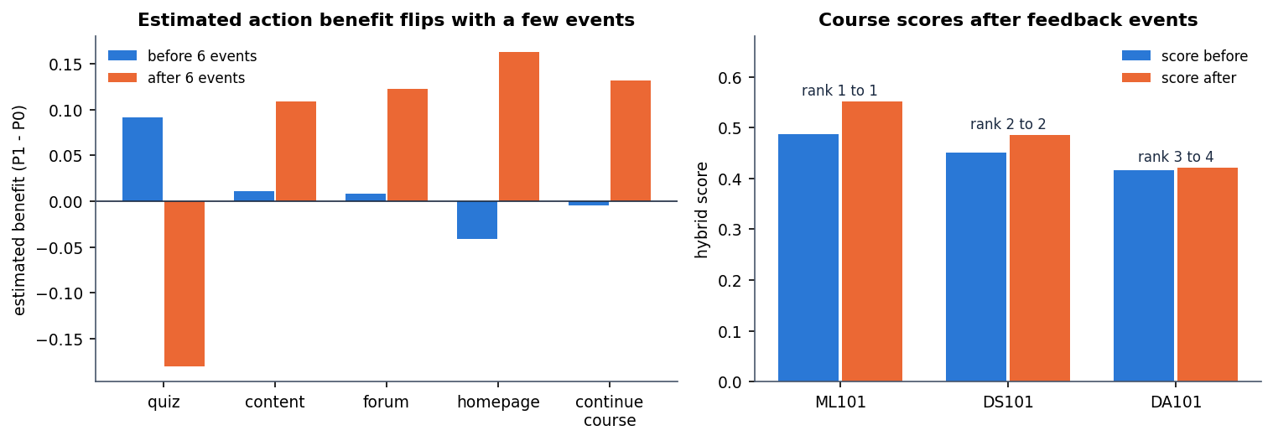
Figure 26: Estimated action benefit before and after six events (left) and the scores of the three tracked courses (right)
After only six events the sign of several estimates flips: the estimated benefit of a quiz goes from +0.091 to -0.180, and the best action changes from quiz to homepage. Across a grid of 45 learner states (three skill levels x weekly hours of 2, 6 and 12 x 0, 5, 15, 40 and 80 logged interactions) the best action is quiz in 9, content in 3, homepage (Visit course resources) in 7, continue_course in 23, forum in 3 states, and the predicted success probability ranges from 0.192 to 0.645 (mean 0.454). Two consequences follow. First, the estimates extrapolate from a confounded synthetic log and should not guide real decisions. Second, the suggested action depends only on the learner's state, not on the course, so every card in one learner's list shows the same suggested action (visible on the recommendation cards in Section 8.12).

8.8 Offline policy evaluation
To ask whether following the highest-benefit action would have helped, the training script estimates the value of that policy on the logged test rows with three off-policy estimators [5], [7]: inverse propensity scoring (IPS), self-normalised IPS (SNIPS) and the doubly robust estimator (DR). The behaviour policy is a multinomial logistic regression over the five actions, propensities are clipped to [0.02, 0.98], importance weights are capped at 10, and the reward is the observed success.
Table 50: Offline policy value estimates on the test split
Quantity | Value
IPS | 0.0088
SNIPS | 0.6652
Doubly robust | 0.4355
Effective sample size of the importance weights | 9.1 of 2,640 rows
Logged success rate on the same rows | 0.4375

These values must not be read as a gain. The IPS value (0.009) and the SNIPS value (0.665) disagree by a factor of about 76, and the effective sample size is only 9.1 of 2,640 rows: a handful of rows carry the whole estimate. The SNIPS value happens to be above the logged success rate and the DR value below it, so even the sign of the apparent effect depends on the estimator. The honest reading is that the logged data do not support any conclusion about the action policy; a live randomised test would be needed.

8.9 Fairness audit
The training script reports the deployed model's behaviour by age band and gender on the test split. This is an audit only: no mitigation is applied, and the groups come from the synthetic generator.
Table 51: Success model by group (test split)
Group | Learner-weeks | Observed success | Mean predicted | F1
age band 0-35 | 1,728 | 44.5% | 43.6% | 0.415
age band 35-55 | 708 | 44.5% | 43.5% | 0.437
age band 55<= | 204 | 34.8% | 41.5% | 0.305
gender F | 1,260 | 42.9% | 43.4% | 0.400
gender M | 1,380 | 44.6% | 43.4% | 0.428

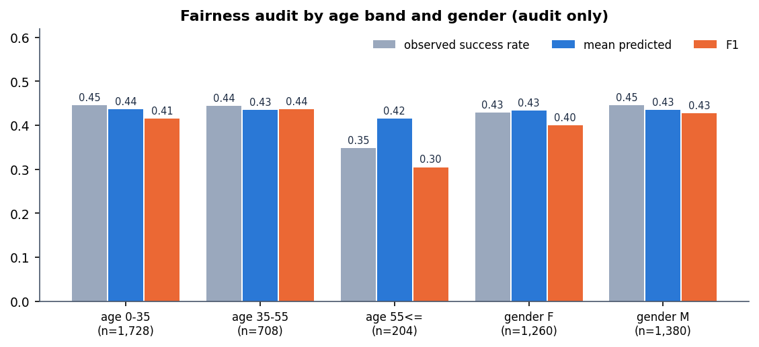
Figure 27: Observed success rate, mean predicted probability and F1 by age band and gender
The gender groups are close (F1 0.400 and 0.428). The oldest age band stands out: its F1 is 0.305 against 0.415 for the youngest, and the model over-predicts its success (41.5% predicted against 34.8% observed) on only 204 learner-weeks. With a group this small the gap could be partly noise, but it is the pattern an audit exists to flag. The base paper also reports a weaker policy value for older learners on real data (SNIPS 0.139) [1].

8.10 Performance and testing
scripts/measure_api.py calls the running service on the loopback address (127.0.0.1) with a freshly registered account, after a warm-up. It uses the real model bundle and the real SQLite file. Environment: 12th Gen Intel(R) Core(TM) i5-12500, 15.7 GB RAM, no GPU.
Table 52: API latency in milliseconds
Endpoint | n | Mean | Median | p95
GET /api/health | 30 | 2.7 | 2.6 | 4.0
GET /api/courses | 30 | 6.0 | 6.0 | 7.6
GET /api/courses/{id} | 30 | 24.6 | 23.5 | 32.3
GET /api/recommendations?top_n=8 | 30 | 32.8 | 32.0 | 42.4
GET /api/recommendations?top_n=24 | 30 | 38.3 | 34.3 | 65.7
GET /api/learning-path | 30 | 22.2 | 22.1 | 24.9
GET /api/insights | 30 | 8.8 | 8.7 | 10.3
GET /api/activity | 30 | 5.8 | 5.6 | 7.9
GET /api/metrics | 30 | 3.5 | 3.6 | 4.8
POST /api/auth/login | 10 | 31.1 | 30.7 | 38.0
PUT /api/profile | 5 | 20.2 | 20.1 | 29.4
POST /api/auth/register | 1 | 427.1 | 427.1 | 427.1

A ranked list of eight courses takes 32.8 ms on average (p95 42.4 ms). Recommendations are recomputed on every call, including fitting TF-IDF over 25 short documents and scoring 24 courses; there is no cache. The first registration is slow (427 ms) because it includes password hashing. The measurement is a single client making 30 sequential requests: it says nothing about concurrent load.
Table 53: Automated checks
Check | Result
pytest (tests/test_app.py) | 5 of 5 passed in 10.3 s (test_health, test_homepage, test_auth_profile_recs_interactions, test_invalid_inputs, test_artifacts_load)
Smoke test (scripts/smoke_test.py, through the Vite proxy) | 33 of 33 checks passed
Responsive check (scripts/check_responsive.py, Chrome) | 11 screens x 3 widths (360/768/1440 px) x light and dark: no horizontal overflow, no console errors, no failed requests

8.11 Comparison with the base paper
The base paper [1] studies personalised learning-path optimisation on the real OULAD data [4]. This project borrows three of its components (uplift scoring, off-policy evaluation, a fairness audit) and applies them to synthetic data with a much smaller model set. The two sets of numbers are therefore not comparable and the table is context, not a ranking.
Table 54: Base paper and this project
Aspect | Base paper | This project
Data | Real OULAD: 32,593 enrolments, about 1.7 million learner-week rows, 25,516 learners | Synthetic OULAD-like table: 26,400 learner-week rows, 2,200 learners; real OULAD never used
Outcome model | XGBoost, AUC 0.795, Brier 0.074 | Logistic Regression, AUC 0.603 (six-seed mean 0.614); XGBoost 0.599; Brier 0.238
Action benefit | Uplift / treatment-effect scoring for learning actions | One-vs-rest T-learner over five actions (two logistic regressions each)
Policy learning | Actor-Critic reinforcement-learning agent with causal regularisation; fitted Q-iteration baseline | Not implemented: greedy argmax of estimated benefit only
Policy evaluation | Greedy-Uplift SNIPS 0.619 (95% interval 0.613 to 0.625) against a logged pass rate of 0.589; IPS 9.956 vs SNIPS 0.643 shown to expose IPS instability | IPS 0.009, SNIPS 0.665, DR 0.435; effective sample size 9.1; logged rate 0.438; not evidence of gain
Fairness | Audit with weaker results for older learners (SNIPS 0.139) | Audit by age band and gender; F1 0.305 for the oldest band against 0.415 for the youngest
Recommendation layer | Learning-path recommendation as a policy | Eight-term hybrid ranker, learning path ordered by skill level then score, explanations on every card
Deliverable | Research study | Working web application with login, profile, catalog, dashboard, insights, analytics and tests
Hardware | Intel i7-6600U, 16 GB | 12th Gen Intel(R) Core(TM) i5-12500, 15.7 GB, no GPU

Two points need saying plainly. First, the base paper's AUC of 0.795 comes from real learner behaviour; this project's 0.603 comes from a generator whose label is only weakly tied to the eight features, so a difference of about 0.19 AUC says nothing about which method is better. Second, the base paper's SNIPS value of 0.619 is reported with a confidence interval and an agent that was trained to maximise it; this project's SNIPS value of 0.665 rests on an effective sample size of 9.1 and is no evidence at all.

8.12 Output screens
The screens below are captures of the running React front end at 1440 x 900 pixels. They were taken with real data: one registered learner (display name "Capture Learner") who filled in the profile form and then generated 12 interaction events (opens, saves, dismissals, quizzes, a discussion and a completion) through the interface. Every figure on these pages, including the 43% estimated success and the 0.244 estimated benefit, was computed by the backend for that learner; nothing is mocked.

Figure 28: Sign-in screen with the statement that suggestions ship with their reasons
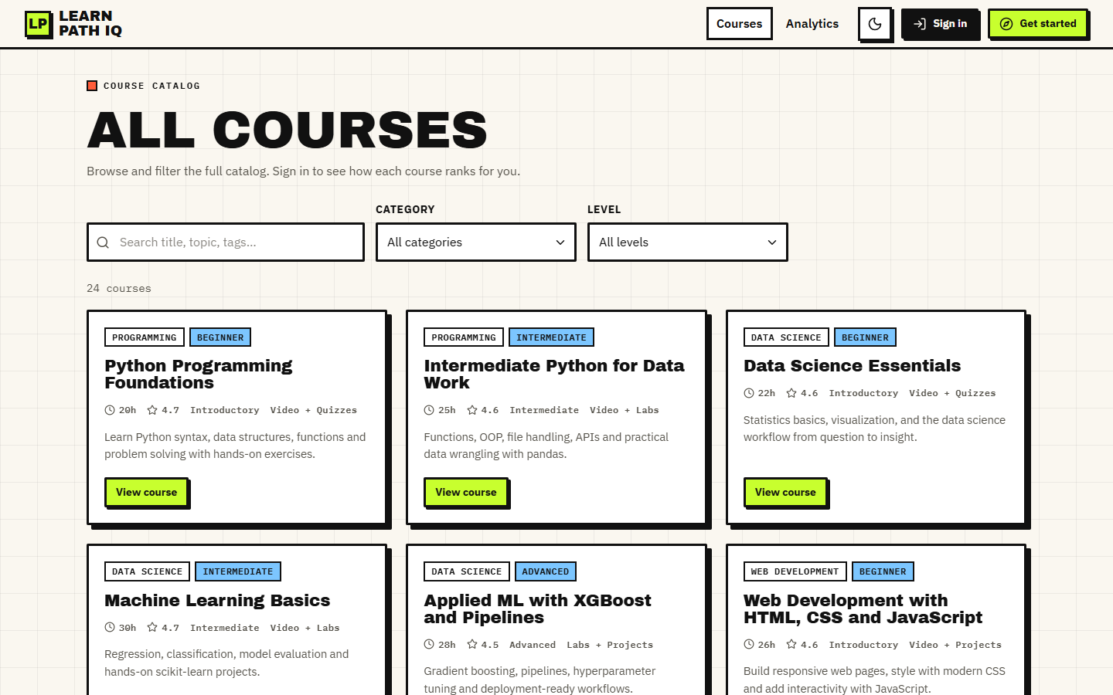
Figure 29: Public course catalog: 24 courses with category, level, duration, rating and search and filter controls
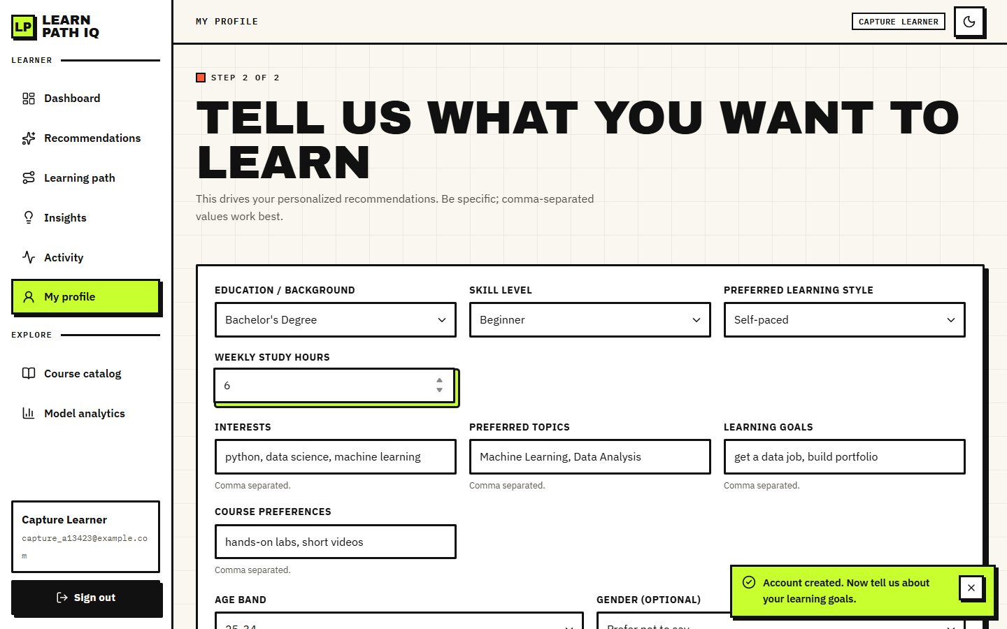
Figure 30: Learner profile form filled in during onboarding (education, skill level, learning style, weekly hours, interests, topics, goals, preferences, age band)
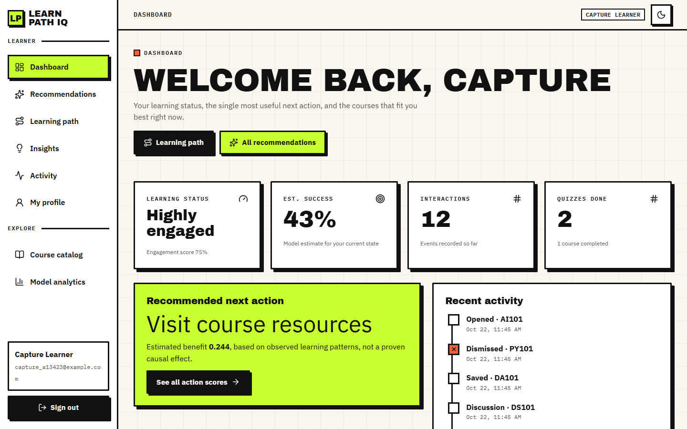
Figure 31: Dashboard after 12 events: learning status (Highly engaged, score 75%), estimated success 43%, 12 interactions, 2 quizzes, the recommended next action and recent activity
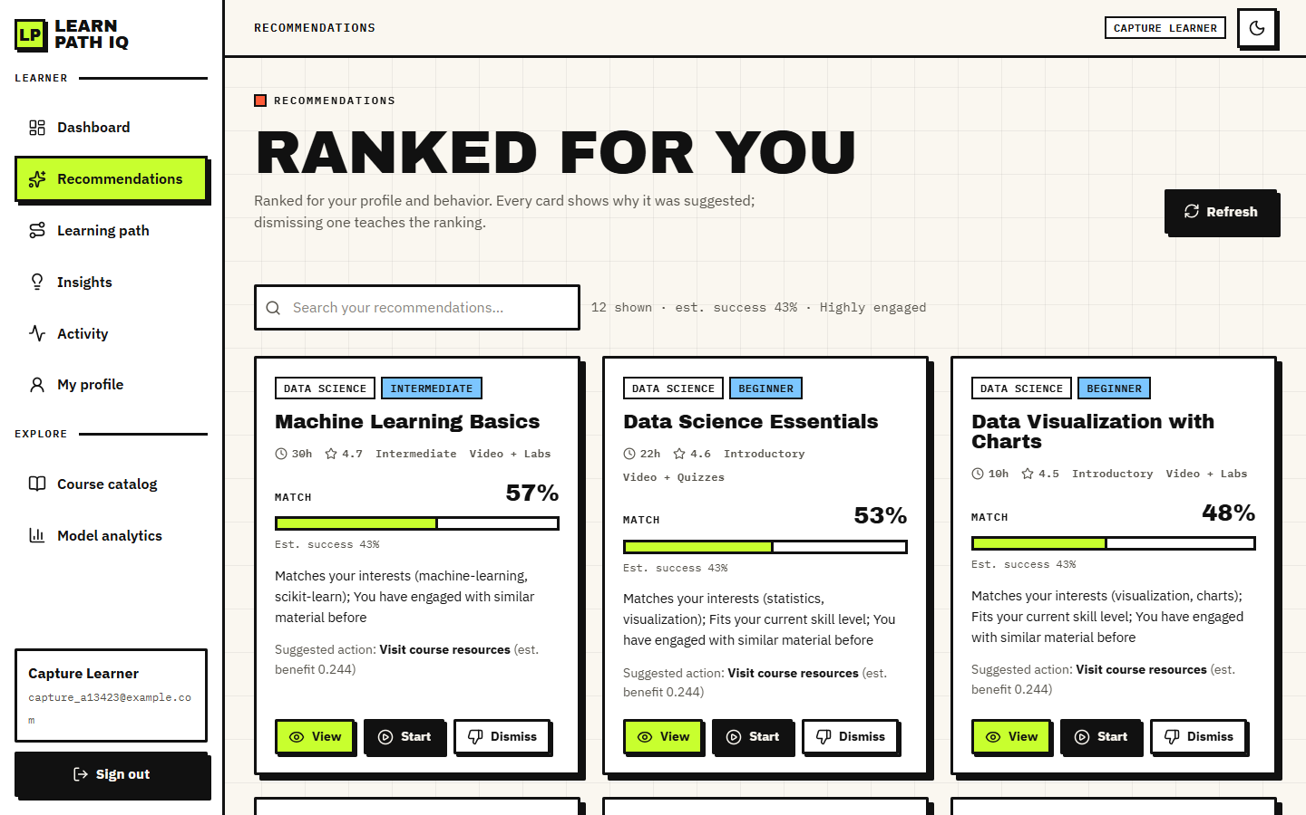
Figure 32: Ranked recommendations: match percentage, estimated success, a three-part explanation, the suggested action and the View, Start and Dismiss buttons

Figure 33: Staged learning path: beginner courses first, each step with match percentage and estimated benefit, and the next best action
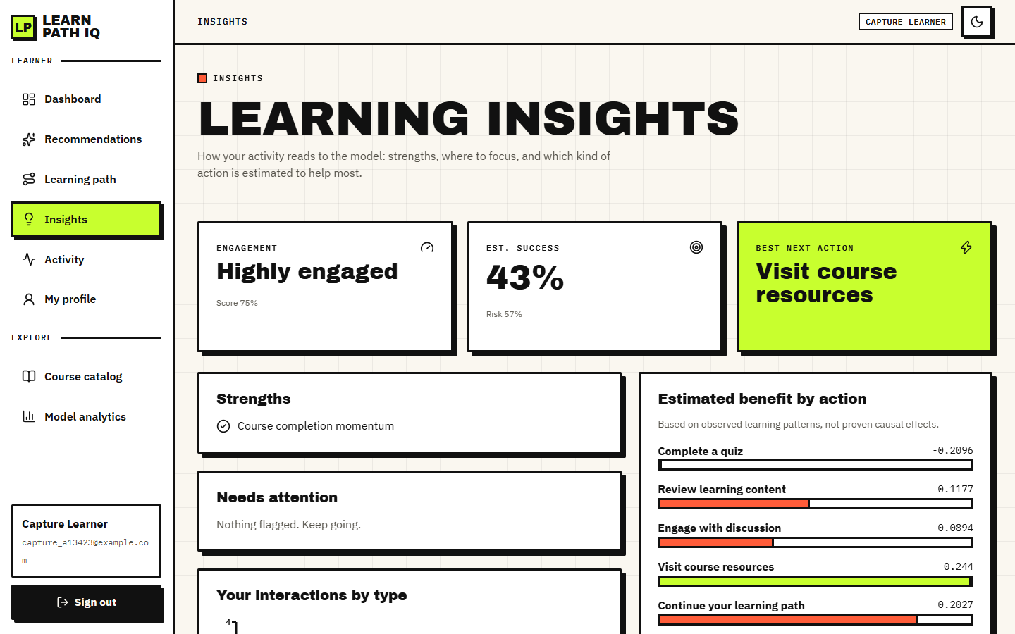
Figure 34: Insights: engagement, estimated success and risk, strengths, attention points and the estimated benefit of each of the five actions
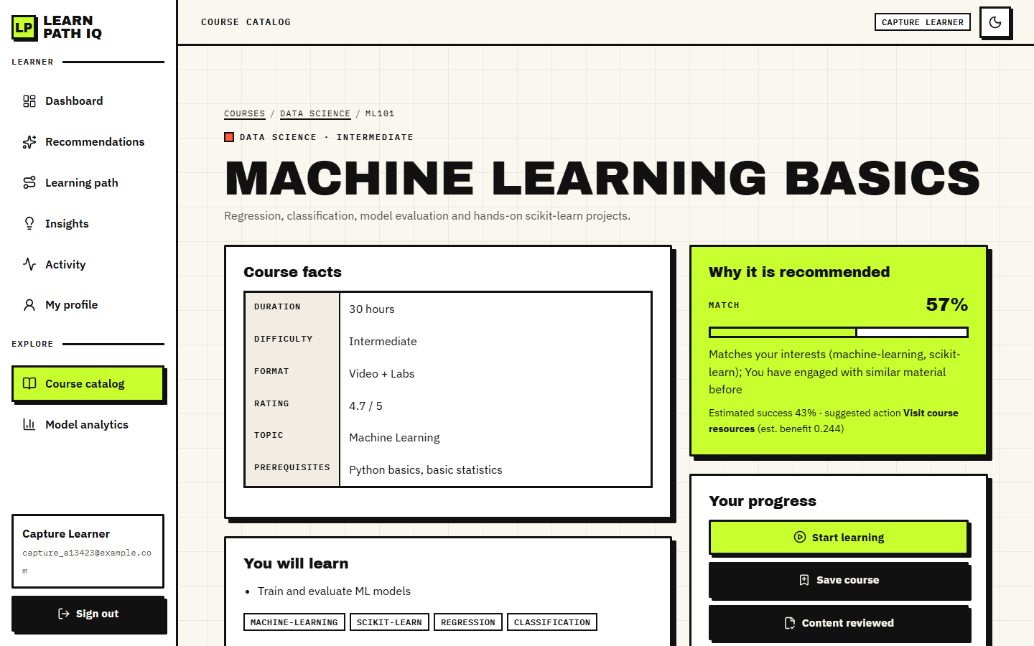
Figure 35: Course detail for Machine Learning Basics with the "Why it is recommended" panel (57% match, estimated success 43%, suggested action) and the progress buttons
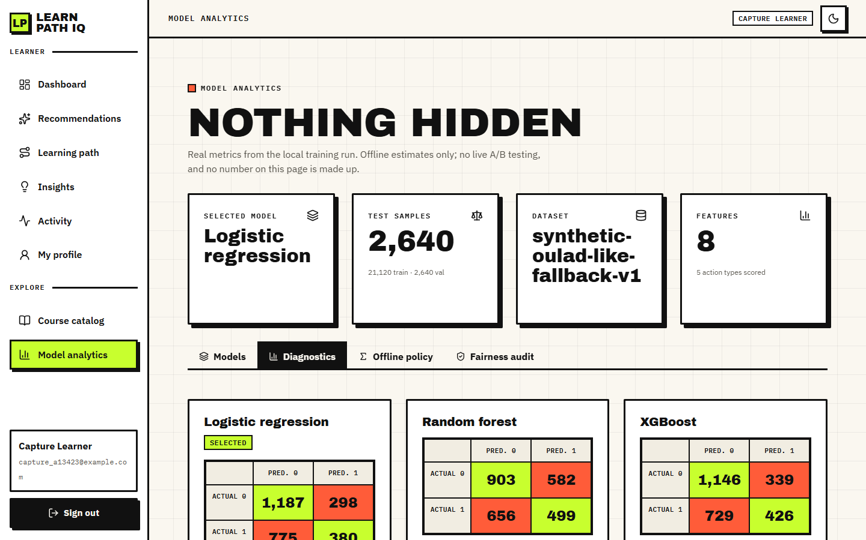
Figure 36: Model analytics, Diagnostics tab: confusion matrices of the three models on the test split
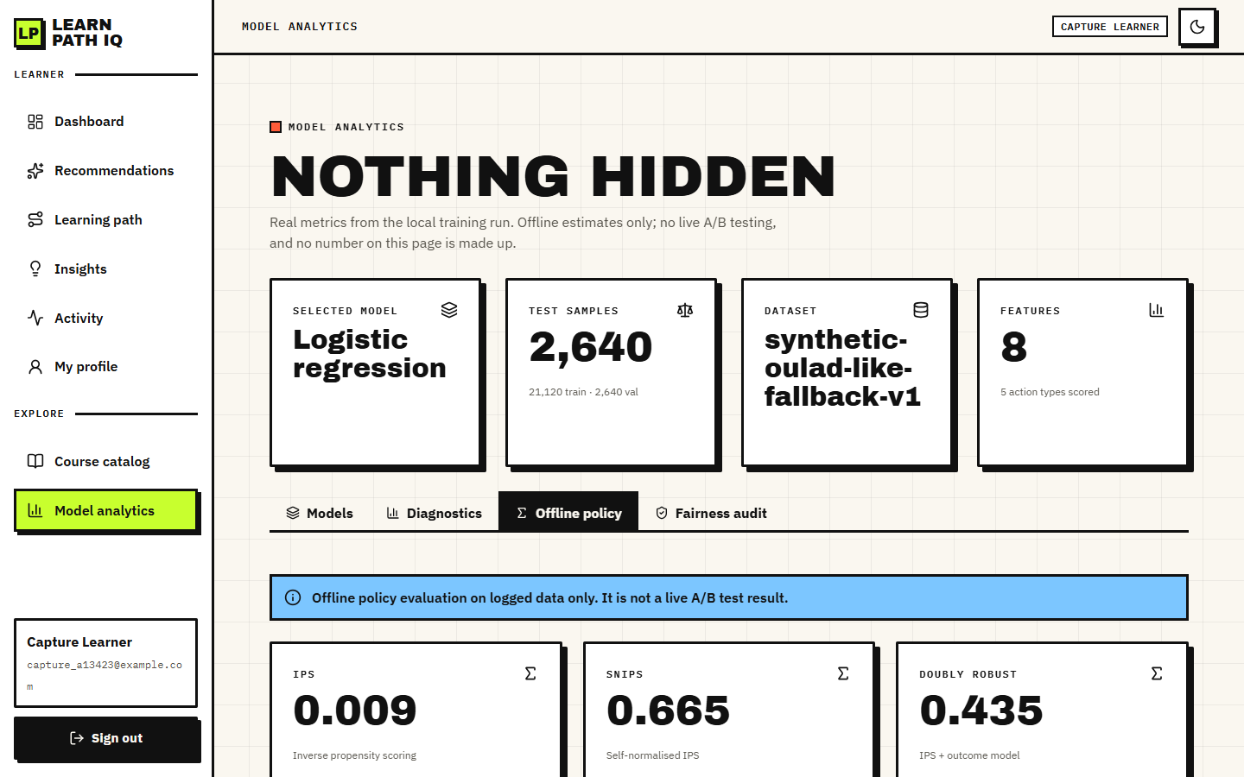
Figure 37: Model analytics, Offline policy tab: IPS 0.009, SNIPS 0.665 and doubly robust 0.435 with the statement that this is not a live A/B result
Three observations follow from the screens. The dashboard, recommendation cards, course page and insights page all quote the same 43% success estimate, because that value depends on the learner's state, not on the course. All recommendation cards show the same suggested action (Visit course resources, estimated benefit 0.244), which confirms the finding of Section 8.7. And the analytics pages show the same numbers as Tables in this chapter, because they read artifacts/metrics/model_metrics.json directly.

8.13 Limitations of the results
• All model results come from a synthetic generator; they measure recovery of a rule written by the authors, not behaviour of real learners, and the real OULAD data were never used.
• The success model's discrimination is modest (AUC about 0.60) and its accuracy is only a few points above the majority-class rate.
• The recommendation check uses 10 author-written personas and category-level relevance on 24 courses; it is not a user study, and precision and recall against real learner feedback were not measured.
• The hybrid score did not beat content-only TF-IDF on that check, and its eight weights were set by hand and never tuned.
• The offline policy values rest on an effective sample size of 9.1 and are not evidence that the action policy helps.
• Estimated action benefits are unstable (they change sign after a few events) and are not causal effects.
• Latency was measured with one client on one machine; no load test, cross-browser test or penetration test was done.
• No live A/B test was run.

CHAPTER 9: CONCLUSION

9.1 Summary
The project set out to build a personalised course-recommendation system that profiles a learner, matches the catalogue by content, adapts to feedback and orders the result into a learning path, and to evaluate it honestly. It delivers LearnPathIQ: a FastAPI and SQLite back end with eighteen JSON routes, a React front end with twelve screens and the original server-rendered interface, a 24-course catalogue, an eight-term hybrid ranker with a plain-language reason on every card, a measurable feedback loop, a learner-success model, an estimated benefit for five learning actions, an offline policy evaluation and a fairness audit. The work is backed by 5 automated tests, a 33-check smoke test and a responsive-layout check. All learned models are trained on a reproducible synthetic data set that imitates the structure of the Open University Learning Analytics Dataset; the real data were never used.

9.2 Objectives against outcomes
Table 55: The six objectives and their outcome
# | Objective | Status | Evidence
1 | Build learner profiles capturing interests, current skills, goals and completed courses. | Achieved | Ten-field profile stored per learner; completed courses recorded as complete events
2 | Construct a course catalogue with topic, level, prerequisite and outcome metadata. | Achieved | 24 courses, 9 categories, nine metadata fields
3 | Implement collaborative filtering over learner interaction history. | Not achieved | No real multi-learner history exists; the behavioural term is per learner
4 | Implement content-based matching between learner profile and course metadata. | Achieved | TF-IDF cosine plus skill, topic and goal terms; P@3 0.800 on the persona check
5 | Combine both into a hybrid recommender and order the output into a coherent learning path. | Achieved | Eight-term hybrid (P@3 0.733) and a six-step path ordered by level then score; no prerequisite graph
6 | Evaluate using precision, recall and learner feedback on recommendation relevance. | Partly achieved | AUC 0.603, F1 0.415, persona P@k and MRR; no real-feedback precision or recall, no user study

Four objectives were achieved (profiles, catalogue, content-based matching, and the hybrid score with its learning path, which is ordered by skill level and score and has no prerequisite graph), one partly (evaluation) and one not at all (collaborative filtering across learners). The reasons are stated plainly: no real multi-learner history was available, so the behavioural term in the score reflects only the one learner's own events, and no real learner feedback was collected.

9.3 Key findings
• The success model is weak. The deployed Logistic Regression reaches a test AUC of 0.6028 (six-seed mean 0.614 +- 0.012) and an accuracy of 0.594, only a few points above the 0.562 majority-class rate. Adding the hidden assessment score lifts AUC to 0.800, so the weak signal is a property of the synthetic data, not a coding fault.
• The hybrid beats popularity but not content-only matching. On ten author-written personas P@3 is 0.200 (popularity), 0.800 (content-only) and 0.733 (hybrid). The drop-one-term ablation shows that the topic and content terms matter most (P@3 falls to 0.600 and 0.667 without them).
• Ranking adapts at once. Six events raise the score of the studied course from 0.4867 to 0.5514, push the dismissed course from rank 3 to 4 and move the success estimate from 0.202 to 0.324.
• Action advice is unstable and weak evidence supports it. Estimated benefits change sign after a few events, and the offline policy values (IPS 0.0088, SNIPS 0.6652, DR 0.4355) rest on an effective sample size of 9.1 of 2,640 rows.
• The audit finds a gap. F1 is 0.305 for the oldest age band against 0.415 for the youngest, on a small group.
• The engineering is sound at demonstration scale. A ranked list of eight courses takes 32.8 ms on average (p95 42.4 ms) on the development machine; 5 of 5 tests and 33 of 33 smoke checks pass.
Figure 38: Summary of the success-model comparison on the held-out test split
Figure 39: Summary of the persona check: popularity, content-only and hybrid rankers

9.4 Practical applications
• A teaching demonstrator for how a hybrid ranking, a feedback loop and an explanation fit together in a small course platform.
• A research scaffold: the training script, the offline policy evaluation and the audit can be re-run on real OULAD data once it is loaded, and the persona check can be replaced by real feedback.
• A starting point for a recommendation module in a small learning portal, after the gaps listed below are closed.

9.5 Honest summary of what is missing
• Real data: nothing here is validated on real learners.
• Collaborative filtering across learners and a prerequisite graph.
• The base paper's reinforcement-learning agent.
• Real feedback: no user study and no live experiment, so precision and recall against real relevance were not measured.
• Production hardening: caching, identity, a server database and load handling.

CHAPTER 10: FUTURE SCOPE
Each item below is tied to a gap that the measurements in Chapter 8 exposed, so the order follows the strength of the evidence, not novelty.

10.1 Real data
• Train and evaluate on the real OULAD data [4] (CC BY 4.0). The synthetic generator caps the signal at AUC about 0.60; real behaviour may carry more or less. The existing script already probes the dataset page; the missing step is loading the student, VLE and assessment tables into the same eight features.
• Re-run the seed study, the ceiling check and the fairness audit on the real data and report the results next to the synthetic ones.

10.2 Better recommendation models
• Collaborative filtering over learner histories (objective 3), for example matrix-factorisation or graph models such as LightGCN [17], once a real interaction log exists; combine it with the content score, as the companion paper on time-to-event filtering does [3].
• Semantic content matching. Replace TF-IDF by sentence embeddings trained contrastively, as in the isotropy-optimised BERT approach [2], to match learners and courses that share meaning but not words.
• Learn the score weights from feedback (learning to rank) instead of the hand-set 0.30/0.15/0.15/0.12/0.10/0.08/0.05/0.05; the ablation already shows two terms (skill and rating) that slightly lower P@3 as weighted.
• Make the suggested action course-specific, so that the action line on each card differs, which the current learner-state-only estimate cannot do.

10.3 Policy learning and evaluation
• Implement the base paper's policy learner: a causal-regularised Actor-Critic agent [1], [9], [18] on top of the uplift estimates, with fitted-Q baselines.
• Make the offline evaluation trustworthy: sweep the propensity clip and weight cap, use an action-conditional outcome model for the doubly robust value, and report confidence intervals; the current effective sample size of 9.1 shows why.
• Run a live randomised test of the suggested action before any claim about its benefit.

10.4 Learning paths
• A prerequisite graph and knowledge tracing [19], [10] so that the path is ordered by what a learner must know, not only by level and score.
• Completed-course handling as a first-class profile field rather than a complete event.

10.5 Evaluation with learners
• A user study with real learners rating relevance, from which precision, recall and nDCG can be computed (objective 6).
• Larger persona and catalogue sets with relevance judged by more than the authors, and confidence intervals for the persona-check precision.

10.6 Fairness
• Investigate and mitigate the age-band gap (F1 0.305 against 0.415) with more data for the oldest group, group-aware thresholds or reweighting, and re-audit.

10.7 Engineering
• Caching of TF-IDF and per-learner rankings, invalidated on profile or event changes, and a load test of the API.
• Authentication hardening: token expiry checked on the server, rotation, rate limiting, and a managed identity provider.
• A server database, containers and monitoring for multi-user operation; per-endpoint tests beyond the current five pytest tests.

REFERENCES
[1] C. P. Isiwu, L. C. Nnadi, and Y. Watanobe, "From prediction to prescription: A Causal-AI for personalized learning path optimization in MOOCs," IEEE Access, vol. 14, pp. 29105-29118, 2026, doi: 10.1109/ACCESS.2026.3666619.
[2] A. Khreis, A. Nasr, and Y. Hilal, "Isotropy-optimized contrastive learning for semantic course recommendation," arXiv:2601.11427, Jan. 2026.
[3] A. Gharahighehi, A. Ghinis, M. Venturini, F. Cornillie, and C. Vens, "Enhancing collaborative filtering-based course recommendations by exploiting time-to-event information with survival analysis," arXiv:2503.00072, 2025.
[4] J. Kuzilek, M. Hlosta, and Z. Zdrahal, "Open university learning analytics dataset," Sci. Data, vol. 4, no. 1, pp. 1-8, Nov. 2017.
[5] M. Dudik, D. Erhan, J. Langford, and L. Li, "Doubly robust policy evaluation and optimization," Stat. Sci., vol. 29, no. 4, pp. 485-511, Nov. 2014.
[6] J. Pearl, Causality, 2nd ed. Cambridge, U.K.: Cambridge Univ. Press, 2009.
[7] G. W. Imbens and D. B. Rubin, Causal Inference in Statistics, Social, and Biomedical Sciences. Cambridge, U.K.: Cambridge Univ. Press, 2015.
[8] P. Gutierrez and J.-Y. Gerardy, "Causal inference and uplift modelling: A review of the literature," in Proc. Int. Conf. Predictive Appl. APIs, 2016, pp. 1-13.
[9] J. Zhang, B. Hao, B. Chen, C. Li, H. Chen, and J. Sun, "Hierarchical reinforcement learning for course recommendation in MOOCs," in Proc. AAAI Conf. Artif. Intell., vol. 33, 2019, pp. 435-442.
[10] T. Saito and Y. Watanobe, "Learning path recommendation system for programming education based on neural networks," Int. J. Distance Educ. Technol., vol. 18, no. 1, pp. 36-64, Jan. 2020.
[11] H. Yu, C. Miao, C. Leung, and T. J. White, "Towards AI-powered personalization in MOOC learning," npj Sci. Learn., vol. 2, no. 1, p. 16, Dec. 2017.
[12] T. Chen and C. Guestrin, "XGBoost: A scalable tree boosting system," in Proc. 22nd ACM SIGKDD Int. Conf. Knowl. Discovery Data Mining, 2016, pp. 785-794.
[13] F. Pedregosa et al., "Scikit-learn: Machine learning in Python," J. Mach. Learn. Res., vol. 12, pp. 2825-2830, 2011.
[14] G. Salton and C. Buckley, "Term-weighting approaches in automatic text retrieval," Inf. Process. Manage., vol. 24, no. 5, pp. 513-523, 1988.
[15] L. Breiman, "Random forests," Mach. Learn., vol. 45, no. 1, pp. 5-32, 2001.
[16] S. R. Kunzel, J. S. Sekhon, P. J. Bickel, and B. Yu, "Metalearners for estimating heterogeneous treatment effects using machine learning," Proc. Nat. Acad. Sci. USA, vol. 116, no. 10, pp. 4156-4165, 2019.
[17] X. He, K. Deng, X. Wang, Y. Li, Y. Zhang, and M. Wang, "LightGCN: Simplifying and powering graph convolution network for recommendation," in Proc. 43rd Int. ACM SIGIR Conf. Res. Develop. Inf. Retrieval, 2020, pp. 639-648.
[18] R. S. Sutton and A. G. Barto, Reinforcement Learning: An Introduction, 2nd ed. Cambridge, MA, USA: MIT Press, 2018.
[19] J.-Y. Chen, S. Saeedvand, and I.-W. Lai, "Adaptive learning path navigation based on knowledge tracing and reinforcement learning," arXiv:2305.04475, 2023.
[20] J. Rao and J. Lin, "RAMO: Retrieval-augmented generation for enhancing MOOCs recommendations," arXiv:2407.04925, 2024.
[21] S. Ramirez, "FastAPI framework, high performance, easy to learn, fast to code, ready for production." [Online]. Available: https://fastapi.tiangolo.com
[22] M. Bayer, "SQLAlchemy," in The Architecture of Open Source Applications, vol. 2, A. Brown and G. Wilson, Eds. 2012.
[23] S. Sujay, G. Harshitha, and M. Monisha, "EduGuide: A hybrid NLP-driven course recommendation system ... TF-IDF and ML," Int. J. Innov. Res. Technol., vol. 13, no. 3, 2026 (listing confirmed by web search; the batch survey records the title with an ellipsis).
[24] "Personalized course recommendation system using machine learning," 2025 (entry recorded in the batch literature survey; authors and venue not recorded).
[25] "Personalized course recommendation model based on LightGCN and learning behavior data," in Proc. ICIDML, 2025 (entry recorded in the batch literature survey; authors not recorded).
[26] "Literature review on course recommendation system for personalized e-learning," Int. J. Drug Delivery Technol., 2026 (entry recorded in the batch literature survey; authors not recorded).

APPENDIX A: IMPORTANT CODE
The listings below are read from the repository by the document build script, so they are the code that was tested and measured. File paths are relative to 8.ProjectCode. Lines longer than a printed line are wrapped, with the continuation indented; no token is changed.

A.1 Score terms (`app/recommender.py`)
Skill fit, text construction and TF-IDF content similarity:
def skill_compat(learner_skill: str, course_skill: str) -> float:
ls = SKILL_ORDER.get(learner_skill, 1)
cs = SKILL_ORDER.get(course_skill, 1)
d = abs(ls - cs)
return {0: 1.0, 1: 0.6, 2: 0.3}.get(d, 0.3)

def course_text(c: Dict[str, Any]) -> str:
return " ".join([str(c.get("title","")), str(c.get("description","")),
str(c.get("topic","")),
str(c.get("category","")), str(c.get("tags","")),
str(c.get("skill_level",""))])

def profile_text(p: Dict[str, Any]) -> str:
return " ".join([str(p.get("interests","")), str(p.get("preferred_topics","")),
str(p.get("goals","")), str(p.get("course_preferences","")),
str(p.get("education","")), str(p.get("skill_level",""))])

def content_scores(profile: Dict[str, Any], courses: List[Dict[str, Any]]):
docs = [profile_text(profile)] + [course_text(c) for c in courses]
vec = TfidfVectorizer(stop_words="english", max_features=2000)
X = vec.fit_transform(docs)
sims = cosine_similarity(X[0:1], X[1:]).flatten()
return sims

Topic overlap, behavioural boost and engagement level:
def topic_interest_score(profile: Dict[str, Any], course: Dict[str, Any]) -> float:
blob = (profile.get("interests","") + " " + profile.get("preferred_topics","") + " " +
profile.get("goals","")).lower()
ct = (course.get("topic","") + " " + course.get("category","") + " " +
course.get("tags","") + " " + course.get("title","")).lower()
keys = [w.strip() for w in blob.replace(",", " ").split() if len(w.strip()) > 2]
if not keys:
return 0.5
hit = sum(1 for k in set(keys) if k in ct)
return min(1.0, hit / max(3, len(set(keys)) * 0.5))

def behavioral_boost(user_id: int, course_id: str, db) -> float:
from app.models import Interaction
rows = db.query(Interaction).filter(Interaction.user_id == user_id).all()
if not rows:
return 0.0
w = {"view": 0.05, "open": 0.06, "start": 0.12, "content": 0.10, "quiz": 0.14, "forum":
0.10, "save": 0.08, "complete": 0.20, "dismiss": -0.25}
s = 0.0
for r in rows:
if r.course_id == course_id:
s += w.get(r.event_type, 0.03) * (r.value or 1.0)
return max(-0.3, min(0.35, s))

def engagement_level(db, user_id: int) -> Dict[str, Any]:
from app.models import Interaction
from datetime import datetime, timedelta
rows = db.query(Interaction).filter(Interaction.user_id ==
user_id).order_by(Interaction.created_at.desc()).limit(200).all()
total = len(rows)
recent = sum(1 for r in rows if r.event_type in
("view","open","start","content","quiz","forum"))
quizzes = sum(1 for r in rows if r.event_type == "quiz")
forums = sum(1 for r in rows if r.event_type == "forum")
completes = sum(1 for r in rows if r.event_type == "complete")
if total == 0:
return {"label": "Getting started", "score": 0.25, "total": 0, "quizzes": 0, "forums":
0, "completes": 0}
score = min(1.0, 0.25 + recent * 0.04 + quizzes * 0.03 + completes * 0.08)
label = "Getting started" if score < 0.4 else ("Steady learner" if score < 0.7 else
"Highly engaged")
if any(r.event_type == "dismiss" for r in rows[:5]) and score < 0.45:
label = "Needs a nudge"
return {"label": label, "score": round(float(score),3), "total": total, "quizzes":
quizzes, "forums": forums, "completes": completes}

A.2 Learner state and success model (`app/recommender.py`)
def load_ml_bundle():
mdir = Path(settings.models_dir)
bundle = {}
for k, f in
[("scaler","scaler.joblib"),("model","xgb_model.joblib"),("features","feature_cols.joblib"),("uplift","uplift.joblib"),("opecfg","ope.joblib")]:
p = mdir / f
if p.exists():
try:
bundle[k] = joblib.load(p)
except Exception:
bundle[k] = None
# tfidf catalog matrix
tp = mdir / "tfidf.joblib"
if tp.exists():
try:
bundle["tfidf"] = joblib.load(tp)
except Exception:
bundle["tfidf"] = None
return bundle

def learner_state_vector(profile: Dict[str, Any], eng: Dict[str, Any]) -> Dict[str, float]:
return {
"cum_clicks": float(eng.get("total", 0)),
"recent_clicks": float(min(eng.get("total",0), 20)),
"quiz_count": float(eng.get("quizzes", 0)),
"forum_count": float(eng.get("forums", 0)),
"completions": float(eng.get("completes", 0)),
"engagement": float(eng.get("score", 0.25)),
"weekly_hours": float(profile.get("weekly_hours", 5.0) or 5.0),
"skill_code": float(SKILL_ORDER.get(profile.get("skill_level","Beginner"), 0)),
}

def predict_success(bundle, state: Dict[str, float]):
try:
feats = bundle.get("features") or
["cum_clicks","recent_clicks","quiz_count","forum_count","completions","engagement","weekly_hours","skill_code"]
X = np.array([[state.get(f, 0.0) for f in feats]], dtype=float)
scaler = bundle.get("scaler")
if scaler is not None:
X = scaler.transform(X)
model = bundle.get("model")
if model is None:
return 0.55, {"note": "baseline"}
p = float(model.predict_proba(X)[0][1])
imp = {}
try:
if hasattr(model, "feature_importances_"):
fi = model.feature_importances_
imp = {f: round(float(v),4) for f, v in zip(feats, fi)}
except Exception:
pass
return p, imp
except Exception:
return 0.55, {}

A.3 Action scores: T-learner at prediction time (`app/recommender.py`)
def uplift_scores(bundle, state: Dict[str, float]):
actions = ["quiz","content","forum","homepage","continue_course"]
up = bundle.get("uplift") if bundle else None
feats = bundle.get("features") if bundle else None
out = {}
try:
if up and feats:
X = np.array([[state.get(f, 0.0) for f in feats]], dtype=float)
scaler = bundle.get("scaler")
if scaler is not None:
Xs = scaler.transform(X)
else:
Xs = X
for a in actions:
if a in up and isinstance(up[a], dict) and up[a].get("t1") is not None:
p1 = float(up[a]["t1"].predict_proba(Xs)[0][1])
p0 = float(up[a]["t0"].predict_proba(Xs)[0][1])
out[a] = round(p1 - p0, 4)
else:
out[a] = 0.0
else:
# predictive fallback ranking: heuristic from state
out = {
"quiz": round(0.02 + 0.05 * (1 - state.get("engagement", .5)) + 0.01 *
min(state.get("quiz_count",0),5), 4),
"content": round(0.03 + 0.03 * (1 - state.get("engagement", .5)), 4),
"forum": round(0.015 + 0.02 * (1 - min(state.get("forum_count",0)/5,1)), 4),
"homepage": round(0.01, 4),
"continue_course": round(0.04 + 0.04 * state.get("engagement", .5), 4),
}
except Exception:
out = {a: 0.0 for a in actions}
return out

A.4 The hybrid ranking function (`app/recommender.py`)
def rank_courses(profile, courses, db, user_id, bundle, top_n=8):
sims = content_scores(profile, courses)
eng = engagement_level(db, user_id)
state = learner_state_vector(profile, eng)
p_success, feat_imp = predict_success(bundle, state)
upl = uplift_scores(bundle, state)
ranked = []
for i, c in enumerate(courses):
cs = float(sims[i]) if len(sims) > i else 0.0
sk = skill_compat(profile.get("skill_level","Beginner"),
c.get("skill_level","Beginner"))
ti = topic_interest_score(profile, c)
beh = behavioral_boost(user_id, c.get("id",""), db)
goal = 0.7 if any(g.strip().lower() in
(c.get("title","")+c.get("description","")+c.get("tags","")).lower() for g in
(profile.get("goals","").split(",") if profile.get("goals") else []) if
g.strip()) else 0.4
rating_f = (float(c.get("rating", 4.5)) - 3.5) / 1.5
rating_f = max(0, min(1, rating_f))
score = 0.30*cs + 0.15*sk + 0.15*ti + 0.12*p_success + 0.10*(0.5+beh) + 0.08*goal +
0.05*rating_f + 0.05*eng["score"]
score = round(float(max(0, min(1, score))), 4)
reasons = []
if cs > 0.08: reasons.append(f"Matches your interests ({',
'.join((c.get('tags','').split(',')[:2]))})")
elif ti > 0.3: reasons.append(f"Aligned with your topic preferences in
{c.get('topic','')}")
else: reasons.append(f"Broadens your {c.get('category','')} knowledge")
if sk >= 0.9: reasons.append("Fits your current skill level")
elif sk < 0.6: reasons.append("Stretches you slightly beyond your level" if
SKILL_ORDER.get(c.get('skill_level','Beginner'),0) >
SKILL_ORDER.get(profile.get('skill_level','Beginner'),0) else "A comfortable
refresher for your level")
if beh > 0.05: reasons.append("You have engaged with similar material before")
if p_success > 0.6: reasons.append(f"High estimated completion likelihood
({p_success:.0%})")
best_act = max(upl, key=lambda k: upl[k]) if upl else "continue_course"
est_benefit = round(float(upl.get(best_act, 0.0)), 4)
ranked.append({"course": c, "score": score, "content_sim": round(float(cs),4),
"skill_compat": round(float(sk),3), "topic_fit": round(float(ti),3),
"success_prob": round(float(p_success),4), "behavior":
round(float(beh),4),
"est_benefit": est_benefit, "suggested_action": best_act,
"suggested_action_label": ACTION_LABEL.get(best_act, best_act),
"explanation": "; ".join(reasons[:3])})
ranked.sort(key=lambda x: x["score"], reverse=True)
return ranked[:top_n], {"engagement": eng, "p_success": round(float(p_success),4),
"feat_imp": feat_imp, "uplift": upl, "state": state}

A.5 Synthetic data and the learner-level split (`scripts/train_pipeline.py`)
Generation of one learner's twelve weeks, the label rule, the observed-action proxy and the split by learner:
for lid in range(n_learners):
age = rng.choice(ages, p=[0.6,0.3,0.1])
gender = rng.choice(genders, p=[0.52,0.48])
edu = rng.choice(educs, p=[0.3,0.3,0.25,0.15])
skill = rng.choice([0,1,2], p=[0.45,0.35,0.2])
ability = rng.normal(0,1) + (skill-1)*0.5 + (0.3 if "Post" in edu else 0) - (0.2 if
age=="55<=" else 0)
weeks = 12
cum = 0
for w in range(1, weeks+1):
base = 8 + ability*2 + rng.normal(0,3)
clicks = max(0, int(base))
quiz = int(rng.rand() < (0.25 + 0.1*skill + 0.05*ability))
forum = int(rng.rand() < 0.18)
homepage = int(rng.rand() < 0.5)
content_c = max(0, int(clicks*0.5 + rng.normal(0,2)))
cum += clicks
assess = np.clip(60 + ability*10 + rng.normal(0,12), 0, 100)
rows.append({"learner_id": lid, "week": w, "age_band": age, "gender": gender,
"education": edu, "skill_code": int(skill), "weekly_hours":
round(float(np.clip(3+skill+rng.normal(0,1.5),1,20)),1),
"clicks": clicks, "recent_clicks": clicks, "cum_clicks": cum,
"quiz_count": quiz, "forum_count": forum, "homepage_hits": homepage,
"content_clicks": content_c, "completions": int(w==weeks and
ability>0.5),
"engagement": float(np.clip(0.3 + clicks/30 + quiz*0.1 + forum*0.05,
0, 1)),
"assess_score": float(assess)})

df = pd.DataFrame(rows)
# Final outcome per learner-week: success = assess>=50 & engagement signal
df["success"] = ((df["assess_score"] >= 50) & (rng.rand(len(df)) < (0.55 +
0.2*(df["assess_score"]-50)/50))).astype(int)
# Treatment: dominant action that week (observational, for uplift)
conds = []
for _, r in df.iterrows():
if r["quiz_count"]>0: conds.append("quiz")
elif r["content_clicks"]>4: conds.append("content")
elif r["forum_count"]>0: conds.append("forum")
elif r["homepage_hits"]>0: conds.append("homepage")
else: conds.append("continue_course")
df["action"] = conds
return df, dataset_source

A.6 Model comparison and T-learner training (`scripts/train_pipeline.py`)
scaler = StandardScaler().fit(Xtr)
Xtrs, Xvas, Xtes = scaler.transform(Xtr), scaler.transform(Xva), scaler.transform(Xte)
models = {
"logistic_regression": LogisticRegression(max_iter=1000),
"random_forest": RandomForestClassifier(n_estimators=200, random_state=SEED,
n_jobs=-1),
}
if HAS_XGB:
models["xgboost"] = XGBClassifier(n_estimators=300, max_depth=5, learning_rate=0.05,
subsample=0.9, colsample_bytree=0.9, eval_metric="logloss", random_state=SEED,
n_jobs=-1)
results, fitted = {}, {}
for name, m in models.items():
m.fit(Xtrs if name!="random_forest" else Xtr if False else Xtrs, ytr)
fitted[name] = m
# validate AUC for selection
from sklearn.metrics import roc_auc_score as auc
try: va_auc = float(auc(yva, m.predict_proba(Xvas)[:,1]))
except Exception: va_auc = 0.5
proba = m.predict_proba(Xtes)[:,1]; pred = (proba>=0.5).astype(int)
results[name] = {
"val_auc": round(va_auc,4),
"roc_auc": round(float(roc_auc_score(yte, proba)),4),
"accuracy": round(float(accuracy_score(yte, pred)),4),
"precision": round(float(precision_score(yte, pred, zero_division=0)),4),
"recall": round(float(recall_score(yte, pred, zero_division=0)),4),
"f1": round(float(f1_score(yte, pred, zero_division=0)),4),
"brier": round(float(brier_score_loss(yte, proba)),4),
"confusion_matrix": confusion_matrix(yte, pred).tolist(),
}

uplift = {}
for a in ACTIONS:
y_t = ((tr["action"]==a) & (tr["success"]==1)).astype(int) # proxy; better: two
models per arm
# T-learner: model on treated (action==a) and control (action!=a) predicting success
tr_t = tr[tr.action==a]; tr_c = tr[tr.action!=a]
info = {"supported": False, "reason": ""}
if len(tr_t) > 200 and len(tr_c) > 200 and tr_t["success"].nunique()>1 and
tr_c["success"].nunique()>1:
m1 = LogisticRegression(max_iter=1000); m0 = LogisticRegression(max_iter=1000)
m1.fit(scaler.transform(tr_t[FEATURES].values), tr_t["success"].values)
m0.fit(scaler.transform(tr_c[FEATURES].values), tr_c["success"].values)
uplift[a] = {"t1": m1, "t0": m0}
info = {"supported": True}
else:
uplift[a] = {"t1": None, "t0": None}
info = {"supported": False, "reason": "insufficient treatment variation"}
uplift[a+"_info"] = info

A.7 Offline policy evaluation (`scripts/train_pipeline.py`)
beh = LogisticRegression(max_iter=1000, multi_class="multinomial")
beh.fit(Xtrs, tr["action"].values)
classes = list(beh.classes_)
Pbeh = beh.predict_proba(Xtes)
# target policy
import numpy as _np
t1m = {}
tgt_actions = []
for i in range(len(Xte)):
best_a, best_u = "continue_course", -9
for a in ACTIONS:
d = uplift.get(a, {})
if d.get("t1") is not None:
p1 = float(d["t1"].predict_proba(Xtes[i:i+1])[0][1]); p0 =
float(d["t0"].predict_proba(Xtes[i:i+1])[0][1])
u = p1-p0
if u > best_u: best_u, best_a = u, a
tgt_actions.append(best_a)
tgt_actions = _np.array(tgt_actions)
rewards = (yte).astype(float)
# propensities
cmap = {c:i for i,c in enumerate(classes)}
pi_b = _np.array([Pbeh[i, cmap.get(a, 0)] if a in cmap else 1e-3 for i, a in
enumerate(te["action"].values)])
pi_b = _np.clip(pi_b, 0.02, 0.98) # clipping
match = (tgt_actions == te["action"].values).astype(float)
w = match / pi_b
w = _np.clip(w, 0, 10)
ips = float(_np.mean(w * rewards))
denom = float(_np.mean(w))
snips = float(ips / denom) if denom > 1e-9 else None
# DR with outcome model = selected model
qhat = fitted[selected].predict_proba(Xtes)[:,1]
dr = float(_np.mean(qhat + w * (rewards - qhat)))
ess = float((w.sum()**2) / max((_np.square(w)).sum(), 1e-9))
ope = {"ips": round(ips,4), "snips": round(snips,4) if snips is not None else None,
"doubly_robust": round(dr,4), "clipping": [0.02, 0.98], "weight_cap": 10,
"effective_sample_size": round(ess,1), "test_samples": int(len(Xte)),

A.8 Password hashing, tokens and sign-in (`app/security.py`, `app/api_routes.py`)
from passlib.context import CryptContext
import secrets

pwd_ctx = CryptContext(schemes=["pbkdf2_sha256"], deprecated="auto",
pbkdf2_sha256__rounds=29000)

def hash_password(pw: str) -> str:
# bcrypt max 72 bytes
b = pw.encode("utf-8")[:72].decode("utf-8", errors="ignore")
return pwd_ctx.hash(b)

def verify_password(pw: str, h: str) -> bool:
try:
b = pw.encode("utf-8")[:72].decode("utf-8", errors="ignore")
return pwd_ctx.verify(b, h)
except Exception:
return False

def new_token() -> str:
return secrets.token_urlsafe(32)

def get_current_user(request: Request, db: Session):
tok = request.cookies.get("lpq_token") or request.headers.get("X-Token", "")
if not tok and "authorization" in [k.lower() for k in request.headers.keys()]:
auth = request.headers.get("Authorization", "")
if auth.lower().startswith("bearer "):
tok = auth[7:]
if not tok:
return None
at = db.query(AuthToken).filter(AuthToken.token == tok).first()
if not at:
return None
return db.query(User).filter(User.id == at.user_id).first()

def require_user(request: Request, db: Session = Depends(get_db)):
u = get_current_user(request, db)
if not u:
raise HTTPException(401, "Please sign in")
return u

A.9 Recommendation route (`app/api_routes.py`)
@router.get("/api/recommendations")
def recommendations(request: Request, top_n: int = 8, db: Session = Depends(get_db)):
u = require_user(request, db)
p = profile_dict(db.query(Profile).filter(Profile.user_id == u.id).first())
courses = [course_dict(x) for x in db.query(Course).all()]
ranked, ctx = rank_courses(p, courses, db, u.id, bundle(), top_n=top_n)
for r in ranked:
db.add(RecommendationLog(user_id=u.id, course_id=r["course"]["id"], score=r["score"],
explanation=r["explanation"]))
db.commit()
return {"recommendations": ranked, "engagement": ctx["engagement"], "success_probability":
ctx["p_success"], "uplift": ctx["uplift"], "feature_contrib": ctx["feat_imp"]}

APPENDIX B: INSTALLATION AND USER GUIDE

B.1 Requirements
• Windows 10 or 11 (also works on macOS and Linux with the manual start), Python 3.11 or newer on PATH, Node.js 20 or newer on PATH.
• The versions used for every measurement in this report: Python 3.11.9, Node.js v24.19.0, npm 11.17.0.
• About 500 MB of free disk space and 4 GB of memory (8 GB recommended), and a modern browser. No graphics card and no internet connection are needed after installation.

B.2 One-click start
1. Open the folder 8.ProjectCode and double-click run.bat, or run it from a terminal in that folder.
2. On the first run it creates .venv, installs requirements.txt, trains the models if artifacts/metrics/model_metrics.json is missing, and runs npm install in frontend/.
3. Two console windows open, LearnPathIQ API (port 8407) and LearnPathIQ Web (port 5407), and the browser opens http://localhost:5407.
4. The original server-rendered interface stays available at http://localhost:8407.
5. Stop everything by closing the two windows.
The ports are set in .env (copy .env.example if it is missing): BACKEND_PORT=8407, FRONTEND_PORT=5407 and a SECRET_KEY placeholder. The React server proxies /api and /static to the API, so no CORS setting is needed.

B.3 Manual start
# terminal 1, from 8.ProjectCode
.venv\Scripts\python -m uvicorn app.main:app --host 127.0.0.1 --port 8407

# terminal 2
cd frontend
npm install
npm run dev

On the first run of a fresh checkout the models must exist: python scripts/train_pipeline.py writes models/*.joblib, artifacts/metrics/model_metrics.json and three plots.

B.4 Using the application
Table 56: Walk-through
Step | Action | Result
1 | Open http://localhost:5407 and choose Create account; enter a name, an e-mail address and a password of at least six characters | The account is created and the profile form opens ("Tell us what you want to learn")
2 | Choose education, skill level, learning style and weekly hours; type interests, preferred topics, goals and course preferences (comma separated); optionally age band and gender; save | The profile is stored; the toast confirms
3 | Open Recommendations | Courses appear under "Ranked for you" with match percentage, success estimate, suggested action and reasons
4 | Press View, Start or Dismiss on a card, or open a course and use its action buttons | The event is stored; the next ranking changes
5 | Press Refresh on the recommendations page | The model files are reloaded and the ranking recomputed
6 | Open Learning path | Up to six staged steps and the next best action
7 | Open Insights | Engagement level, success estimate, action-benefit bars, strengths and areas to attend to
8 | Open Activity | Two tabs: the interaction log and the recommendation history
9 | Open Course catalog (works without signing in) and Model analytics | Search and filter 24 courses; four tabs: Models, Diagnostics, Offline policy and Fairness audit
10 | Use the moon button at the top right | Switch between light and dark themes

B.5 Retraining the models
python scripts/train_pipeline.py # a few minutes at most; fixed seed 42
python scripts/run_experiments.py all # seed study, ceiling, personas, ablation, feedback loop
# then press Refresh on the recommendations page, or restart the API

The pipeline writes the metrics file that the analytics screen shows. Re-running it with the same seed reproduces the stored metrics exactly.

B.6 Running the tests and checks
python -m pytest tests -q # 5 tests
python scripts/smoke_test.py # 33 checks, needs both servers running
python scripts/check_responsive.py # needs: pip install playwright; playwright install chromium
python scripts/capture_screens.py # regenerates docs/screenshots
python scripts/measure_api.py # latency on 127.0.0.1

B.7 Troubleshooting
• The page shows a connection error: the API window is not running. Check the LearnPathIQ API window, then reload.
• Port already in use: change BACKEND_PORT or FRONTEND_PORT in .env and start again.
• `/api/metrics` answers 503: the models have not been trained; run python scripts/train_pipeline.py.
• Slow requests when using `localhost`: on some Windows machines localhost falls back from IPv6 and adds about two seconds per call; use 127.0.0.1 instead.
• `ModuleNotFoundError`: install requirements.txt into the Python that runs the API (the .venv created by run.bat).

APPENDIX C: ADDITIONAL SCREENS
All screenshots are captures of the running application at 1440 x 900 pixels, taken with Playwright from one registered learner who has a filled profile and twelve recorded interaction events. Chapter 8 shows the login screen, the catalogue, the first-run profile form, the dashboard, the recommendations, the learning path, the insights, the course detail and the four model-analytics tabs; the screens below add the landing page, the registration form, the recommendation history and the dark theme.

Figure 40: Landing page in the light theme: headline, call to action and live catalogue statistics

Figure 41: Registration form: name, e-mail, password and confirmation, with validation messages
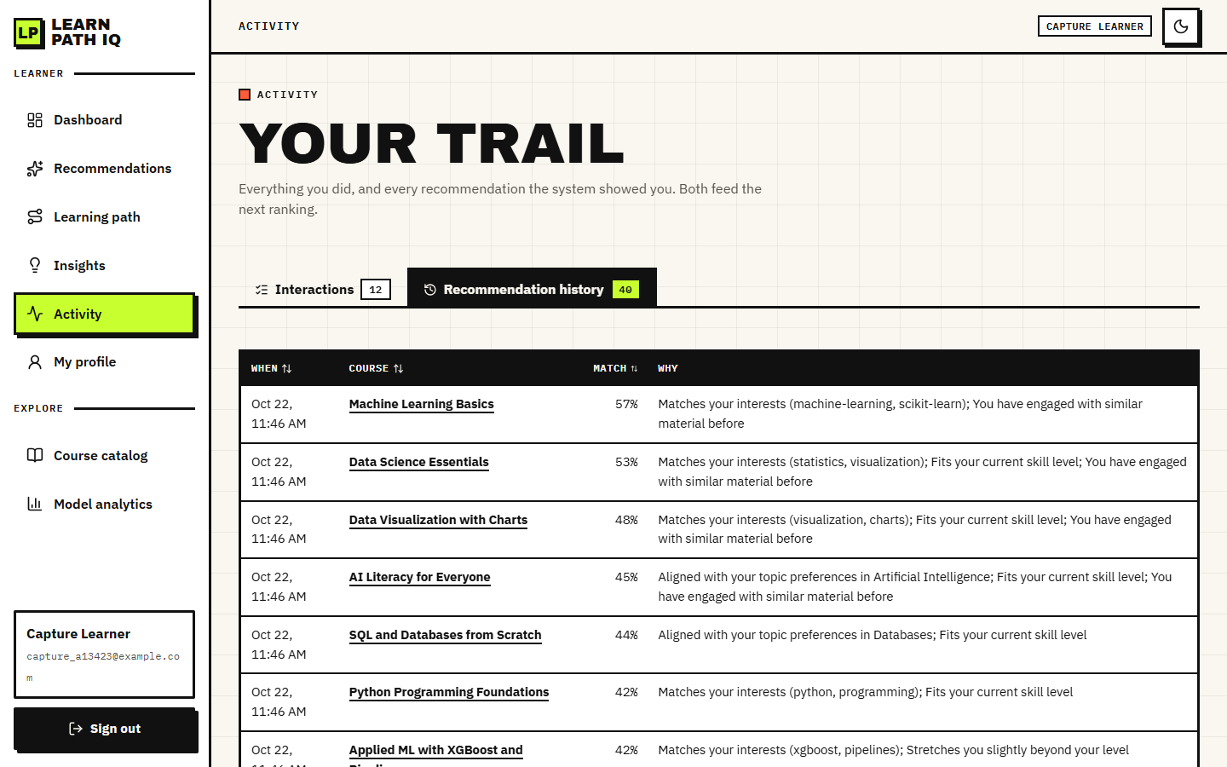
Figure 42: Activity page, recommendation history: forty logged recommendations, each with its match percentage and the reasons given at the time
Figure 43: Dashboard in the dark theme: engagement, success estimate, event counts, next action and top recommendations

